Attendance Management Software User Manual

Version: 1.8
Date: May 2011

About this Manual:
This manual provides software operation instruction, for example install and uninstall program, collect data, assign shift and output report, ect.
CONTENTS

CHAPTER 1 1
1. Install and Uninstall Program 1
1.1 Before Installation 1
1.2 Install Program 2
1.3 Uninstall Program 7
1.3.1 Uninstall the Software 7
1.3.2 Uninstall Fingerprint Sensor Driver 7
1.4 Work Flow of the Software 7
CHAPTER 2 1
2. Program Management 1
2.1 Exchange Data between Device and Program 1
2.1.1 Device Management 1
2.1.2 Upload and Download Data 4
2.1.3 Real Time Monitor 14
2.1.4 U Flash Disk Management 15
2.1.5 Short Message Management 23
2.2 Maintained/Setting 28
2.2.1Department Management 29
2.2.2 Employee Maintain 30
2.2.3 Administrator Setting 50
2.2.4 Time Period Maintenance 57
2.2.5 Shift Management 64
2.2.6 Assign Staff Shift 66
2.2.7 Holidays Maintenances 75
2.2.8 Leave Setting 78
2.2.9 Attendance Rule 81
2.2.10 Database Option 85
2.2.11 System Option 90
2.3 Handle Attendance 95
2.3.1 Employee Leaving on Business / Asking for Leave 95
2.3.2 Handle Staff’s Forgetting to Clock In/Out 102
2.3.3 Coming Late /Leaving Early Collectively 106
2.4 Search/ Print 107
2.4.1 Attendance Record 107
2.4.2 Attendance Exception Searching and Record List 114
2.4.3 System Operation logs 145
2.5 Data Management 145
2.5.1 Initialize System 145
2.5.2 Clear Obsolete Data 146
2.5.3 Back up Database 148
2.5.4 Import Attendance Data 149
2.5.5 Export Attendance Data 151
2.6 Access Control Setup 152
2.6.1 Period Time 153
2.6.2 Group 154
2.6.3 Unlock Combination 156
2.6.4 User Privileges 157
2.6.5 Upload Setting 167
CHAPTE 3 169
Appendices 169
3.1 Set Date 169
3.2 Select Employee 170
3.3 Select Department 170
3.4 Select Employee in Department 171
3.5 Data Table Tool Bar 171
3.6 Export Data 173
3.7 Advanced Export 174
3.8 Downloading Photos Automatically 178
3.9 How to Generate License Files 181
CHAPTE 4 184
4. End-user License Agreement fir This Software 184
CHAPTE 5 188
Trouble Shooting 188

CHAPTER 1

Install and Uninstall Program

1.1 Before Installation
Please install on-line fingerprint sensor driver if you want to enroll fingerprint through the Attendance Management software.
1.If the 4000 or previous version driver (Biokey200/URU4000/URU40000B) have been installed before, you must uninstall it first, the operation steps as below:
- Run "Add/Delete program" in control panel, uninstall fingerprint sensor driver;
- Run "Regedit.exe" in "Run" on the Starting menu, and delete the key values of HKEY_LOCAL_MACHINE\Software\DigitalPersona, if the value exists;
- Delete all "DP*.dll" under the directory of windows\system32 "windows\system in win98 ";
- Delete the folder "biokey200" under the directory of Program files\zksoftware, if the folder exists.
Restart your computer after uninstall, then install on-line fingerprint sensor driver.
2. If fingerprint sensor driver wasn't installed before, install the driver directly.

1.2 Install Program
You had better turn off all the other programs before installing, to avoid collision during the installing process.
Note: the following demonstration software version may be not identical with your CD contents, please follow the CD installing process.
- Insert the CD into your CD-ROM, the installation program will run automatically;
- The software supports Simplified Chinese, Traditional Chinese and English, select the language you want to install, and click "Next";
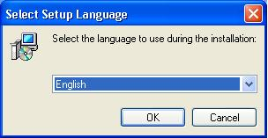
Tips: click "Cancel" button to abort installation.
- The next step is "End user software license agreement" dialog, please read carefully. Click on "I Agree" enter the next installing process;
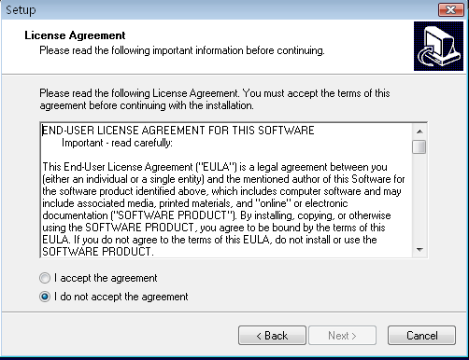
- In this interface you can select the installing directory of the software, Click "Next", enter the next step;
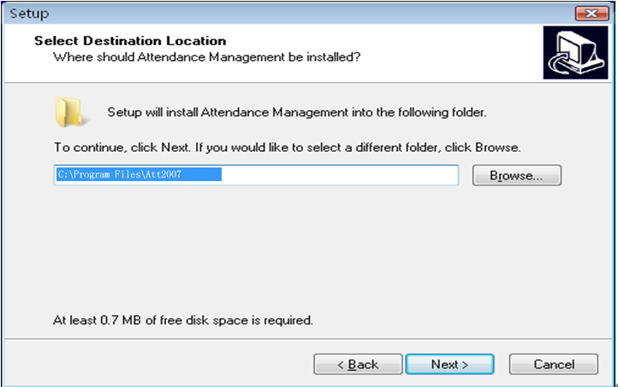
- In this step you can choose the component which you want to install, such as fingerprint sensor driver, attendance management program and user manual. Click on""if you need it (recommend to select all components except it has been installed), then click on "Next", go to the next page;
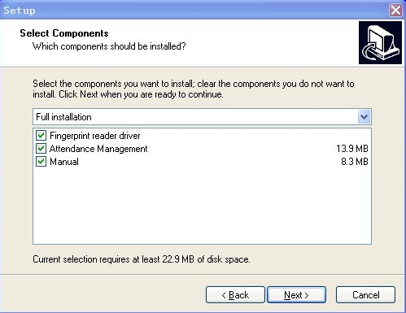
- In this interface, you can change the name and decide where to place the program's shortcuts. Click "Next", turn to the next step;
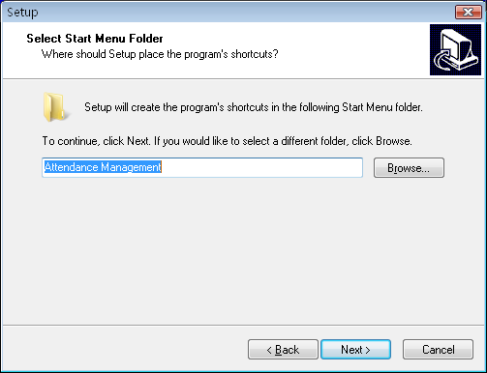
- Click "Install" the software start to install and copy the files to the hard disk until the fingerprint sensor driver start to install. If you didn’t select to install it at step 5, the process will turn to step 10 and end the installation.
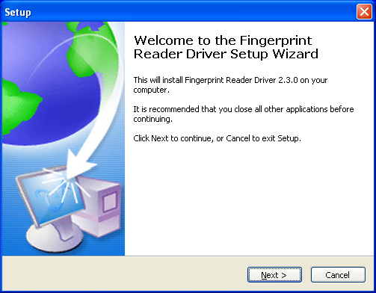
- This interface will inquire you to select components to install, we recommend to select them all, then click on "Next", enter the next step;
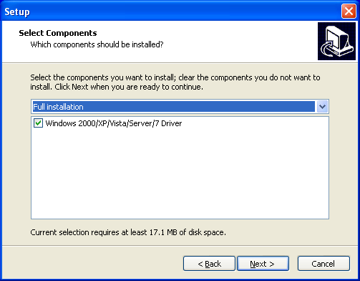
- The fingerprint sensor driver start installing, when the process is completed, the dialog box will inquire you to restart the computer now or later. The driver will work when the computer restarted;
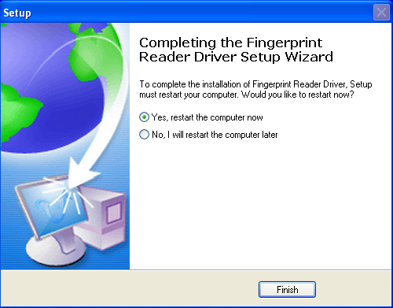
- Click" Finish" to complete the installation.
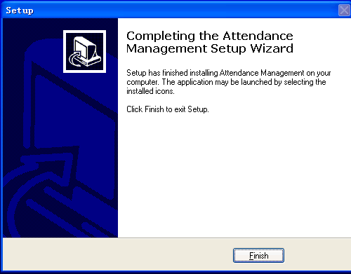
The shortcuts will appear on the windows, click this icon "" on the desktop to enter software.

1.3 Uninstall Program

1.3.1 Uninstall the Software
If you do not need this software anymore, you can uninstall it from computer as below:
Close the attendance management program.
Run "Add/Delete program" in control panel, choose attendance management system and uninstall it.
Alternatively, choose Start > Program > Standard version of attendance management system > Uninstall the attendance management software
For clear all the software, you need to enter directory to delete the folder where the software installed.

1.3.2 Uninstall Fingerprint Sensor Driver
If you do not need to use the fingerprint sensor anymore, you can uninstall it. Run "Add/Delete program" in control panel, uninstall fingerprint sensor driver.

1.4 Work Flow of the Software
1. Downloads user's fingerprint or the card which have been enrolled in the Device to software "Connection Device -Downloads personnel data from Device"
2. Upload staff's name and other materials which have been modify in Device in the Employee maintained "Connection Device –Upload personnel information to Device"
3. Assign Employee to department "enter Department management"
4. Setup Shift Schedule and Time Period"enter Shift Schedule and Time Period maintenance"
5. Setup Shift Schedule "enter Shift schedule management"
6. Assign the staff Schedule "enter Employee Schedule"
7. Download attendance data to software in "connection Device – download record data from Device"
8. Examine Attendance report form "enter Time Attendance report form"

CHAPTER 2

2. Program Management

2.1 Exchange Data between Device and Program

2.1.1 Device Management
Before downloading or uploading data from the Device with software, ensure that the communication between Device and PC has established. So connect the device to the system firstly, input the related parameter, after create connection successful, uploading or downloading data is available.
Device Maintenance
Click "Device Maintenance" in the main interface or click "Device Maintained" in My Device List, in here you are able to complete to add, cancel, and modify Device.
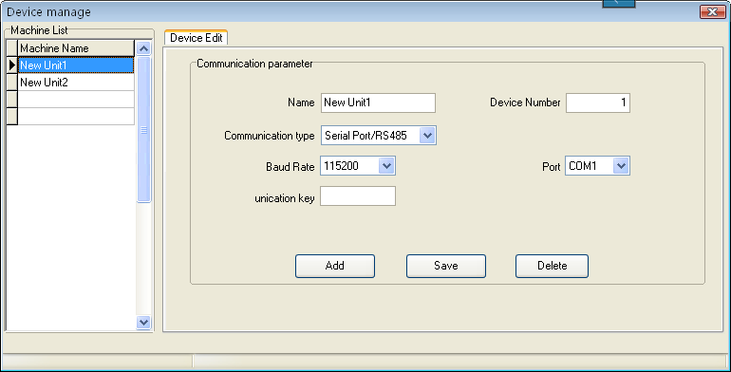
There are two default communication mode provided in the system, one is RS232/RS485, another is Ethernet. Some specify machine is designed with USB communication mode (such as H2), for more detail, please refer to corresponding "User Manual", the using method please view the explanation below:
- Add: User may newly add device, input the corresponding connection parameter of Device, save it, the device name will display on the left side list.
- Device name: named the device, which machine has been connected with system.
- Communication mode: which way is used in communication between the device and computer.
- Baud rate: the baud rate is same with it in the machine, Here.
- IP address: device IP address
- Communication password: if there is the communication password to be set in the machine option, you must fill the same one password , otherwise, not need to fill in
- Serial number: Device identity number.
- Port: The port is used by computer. The RS232/RS485 mode is "com" port; the default port number of Ethernet is 4370.
- Deletion: If the Device will not be in use any more, single-click the device of your choice in the left side list, click on "Cancel" to delete this Device from the system.
- Save: If after selecting and modifying connection parameter of the Device of your choice, click "Save" to save the information.
Note: Some machine does not support the Ethernet communication. It is unable to use the Ethernet mode to connect the machine
Serial number: If the communication mode is the RS232, please input a random number which between 1 ~ 100, 133 ~ 255 in blank enough. If the RS485 mode is used, inputs the machine address.
Connection Device: the Device which reside in the system will display in the " My Device list", single-click the Device to choose it, then click "Connect Device" button, or right-click the Device that want to be connected, select the attached Device from following menu appeared.
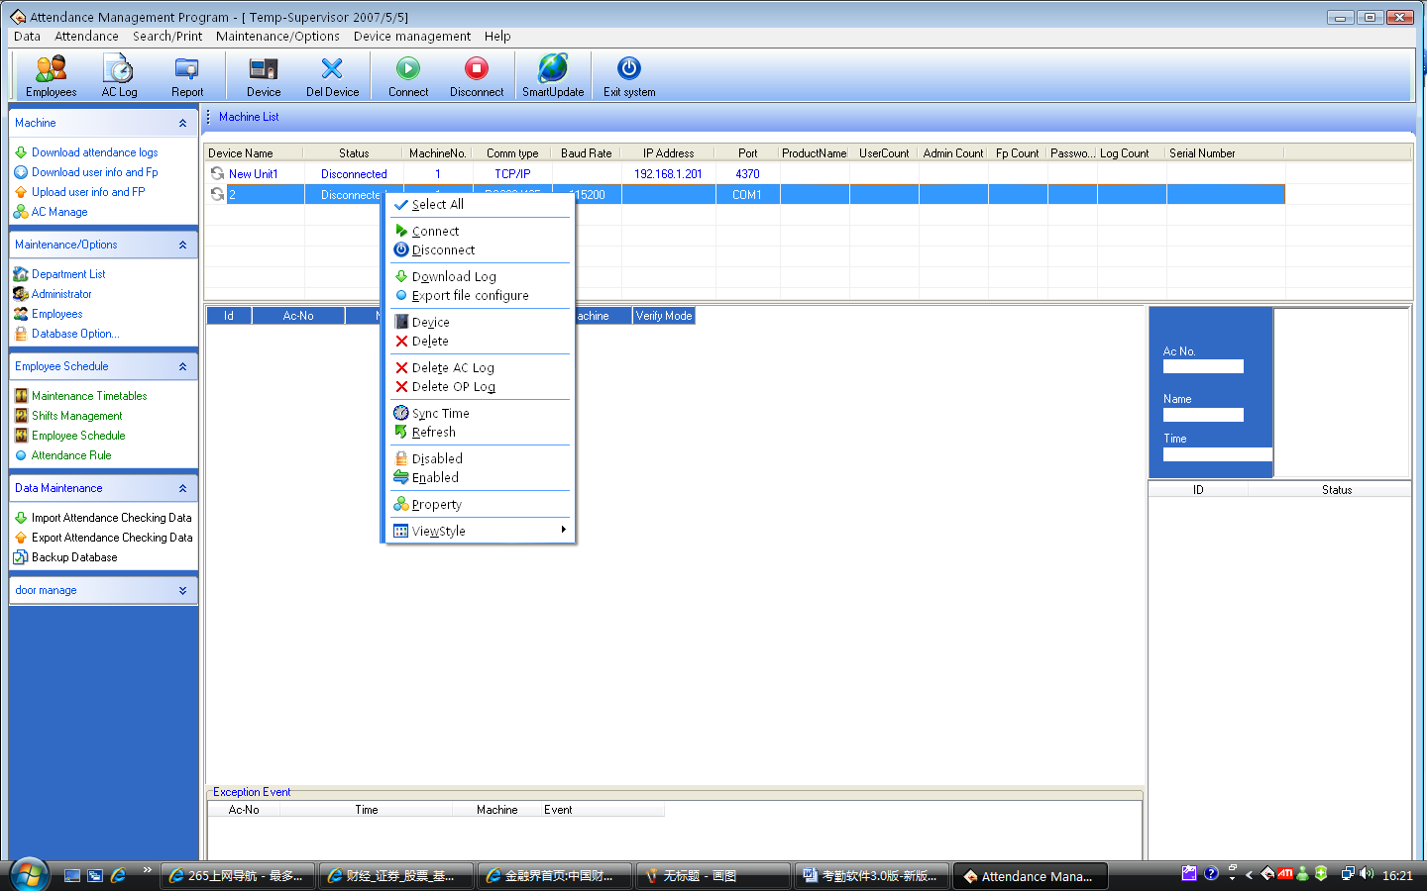
When the system connect with Device, the prompt＂connecting, please wait will appear on below right side status column, weather the link success or not will inform you.
If fail to connect, please check
1) Whether the Device connecting parameters equipped with communication parameters of the menu option
2）whether the communication line linking well
Disconnect
When the system and Device continue to upload and download data, the Device is in a "work" status, so it is unable do other operating at this time. after uploading and downloading data, disconnect Device, and click "Disconnect" to disconnect the Device communication.

2.1.2 Upload and Download Data
This is data exchanging windows for between the management software and Device. The exchanging windows utility is used to download or upload recorded data and the user's information. The following procedures demonstrate how to use the windows utility to download and upload data. Before come to operation, the first to connect the device.
Download Attendance log from Device: Download all records which have pass verification from the Device;
Download staff information and fingerprint from Device: Download staff information, the staff’s fingerprint can be download at same time
Upload staff’s information and fingerprint to Device; upload the staff’s information and fingerprint together at same time.
Device management: Examined the Device information and modify the Device option through software.
1. Download attendance log from Device: It is unable to download data from the Device unless the system and the Device are at the connection condition. Directly click on "Device Machine" in the main interface right side to download data record from the Device Or enter management menu, chooses data to be download from the Device.
The system could prompt "is working", by now please wait for moment, after the completion of data downloaded, the prompts will appear in the right side of table below, informing you that the to download data was successfully, the communication between the Device and the software already has disconnected. The downloaded data should be added to the system, if data is too bigger, it is possible need to take much more time.
The downloading record can completely display in the circle record region like as above figure. At the same time, the new data record will be stored in the staff’s record data list in the system, you will be allowed to view it from the attendance record; The new user will be stored in the staff information table of the system , it is allowed to view through the staff’s maintenance. After downloading data, the system still cannot automatically clear data which is stored up in Device. under this option -> maintenance/setting-> Downloads record -> you choose item as that download the record and delete the record data on the Device together at same time, system can automatically remove data record from Device
Note: If the machine model is M100 please note! maybe the M100 machine does not need to enroll the user first directly through slip the card to verify user identity, therefore the corresponding user information does not possibly along with downloading recorded data, after the downloading, the software can prompt whether add these user who hasn’t been registered but still has the recorded data to the database.
2. Download the personnel information from the Device: only when the system and the Device are at the connection condition, the downloading data is available, directly click on "Device Management" the main interface right side, the column to download the personnel information from the Device, access Device management menu, choose download the personnel information from the Device
View user on the Device: Click on "View User" button. For new users, it will display in the "New User" column. Meanwhile, it will suggest new users added to the system database.
Downloading: When the data has to directly download, click the button to downloads
If there is a new user in "New User" the column, it will prompts whether add the new user to the system database. If user on the Device were a user which already existed in the system database, then these users could display in "there is a user in the local database" column.
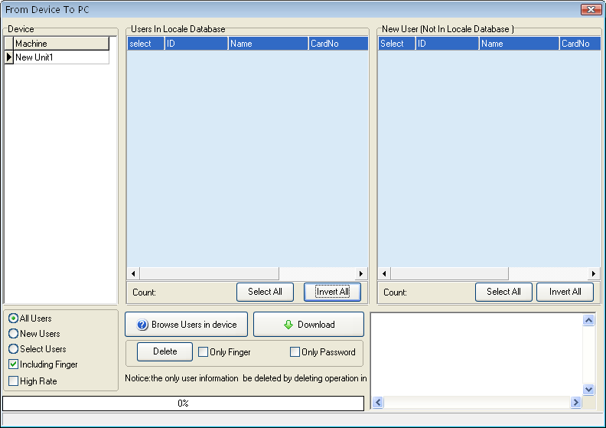
High-speed download: When the device was connected with Ethernet, and the data is rather much, you can use the high-speed download function to increase the transmission speed (if you use the ZKFinger10.0 and facial recognition algorithms equipment, this function is unavailable).
Delete: Choose user who want to be canceled from the list area, also can choose all users. Delete fingerprint, face, or password only, just need to put the tick in front of the corresponding item, then click "Delete" button, if want to select many item record, may hold down "Ctrl" key and click with mouse at same time.
3. Upload the personnel information to Device
When it was careless of user to cancel personnel information or many Device are in use together at same time, for convenient use, reduce the enrolling work, the software provide to upload personnel information from the database to machine.
The upload data operation is unable to execute till system and Device is in connection status. Directly click upload personnel information to device in the "Related Device Operation" column, or enter Device management menu, select upload personnel information to Device.
Select staff by department: E.g. there are mare many departments in a company, if some staffs of the department need to be uploaded, you can click this department with mouse, the all staff in this department will display in the list. Shown as following figure
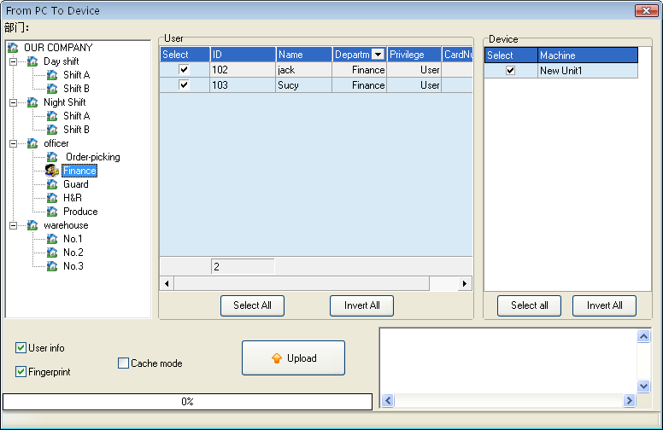
Upload:
1) Choose the staff to be uploaded in the "User" column
2) Choose the staff who will be uploaded to assigned machine in the "Fingerprint Machine" column.
User information/ Fingerprint/Face: Put the tick in the information which will be uploaded.
Upload in High Speed: When if these machine hookup by Ethernet, and have large quantity of data to upload (if you use the ZKFinger10.0 and facial recognition algorithms equipment, this function is unavailable).
Delete: Choose this user which want to be canceled, and then choose "Cancel" button.
4. Device Management
Only when the system and the Device are at the connection condition, the downloading data is available, Directly click "Device Management" in the column "Related Device Operation" on the main interface right side, choose the "Device Management", access Device management menu, choose download the personnel information from the Device
1) If the device is a M100 you connect, then "Advance Option" will appear.
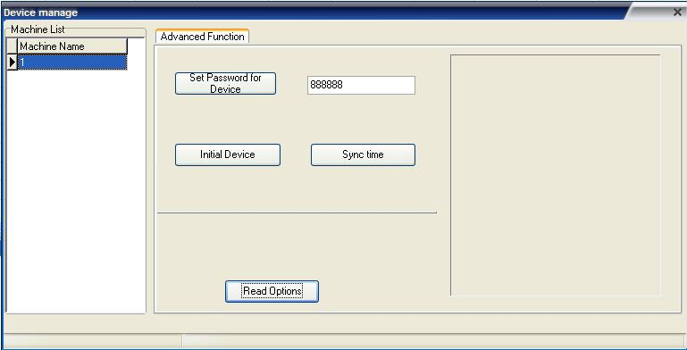
Set Password for login : if want to enter the machine management interface, you must input the management password firstly, the default password is 888888. Many pitfall can be avoided by changing this password (the password consist of 6 digital figure. Other format is invalid).
Clear all data in the equipment: system will clear up all data in the equipment , that include User and record.
Notice: if you clear up all data, the data will be damage and unable to be restored. To help avoid possible lost, download all data and keep in system before performance this operation
Sync Device time: may synchronize the Device time to the computer.
2) Connect Machine of Fingerprint and Face
a.this page describes the fingerprint machine information, though this page you can view the information about this product type, product module, serial number, firmware etc. click "Read Setting", you can know detail about the device.
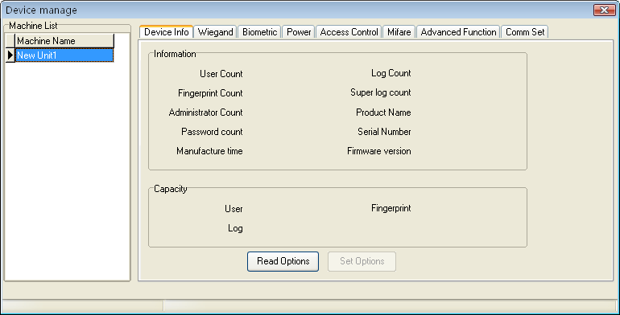
Note: it is unable to modify this information ,view these only
B. In odder to guarantee machine reliability run for long time, some machines support power management function, such as timing sleep, timing shutdown, etc.
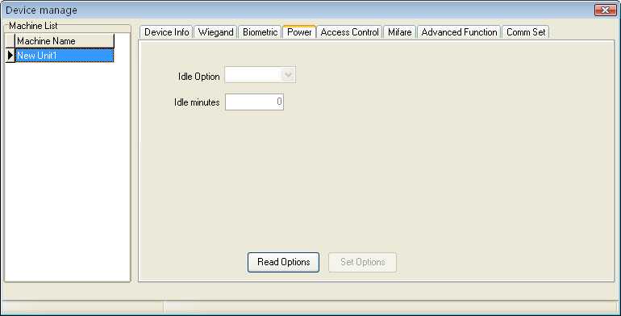
Click "Read setting", the machine idle setting will appear on the main interface:
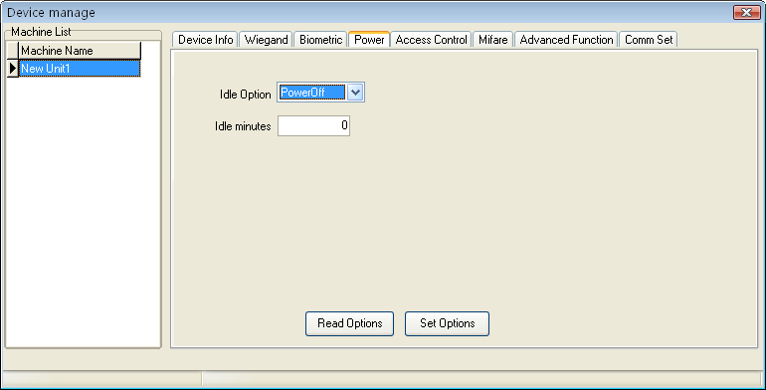
Modify the setting you want to use, after doing this. Click "Apply Setting".
C. Click other function pagination, view other function of Device :
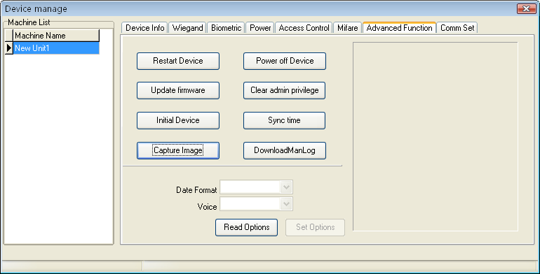
Clear all data in the Device: System will clear all data in the device, include fingerprint and record.
Notice: if you clear up all data, the data will be damage and unable to be restored. To help avoid possible lost, download all data and keep in system before performance this operation
Eliminate administrator privilege : if the operator forget the name and password in the device, and fail to enter the option menu, you can use this order to eliminate old administrator, then re-register the administrator.
Sync time: Synchronize Device time to PC, keep that the Device represent time is same as PC .
Upgrade firmware: may click " Upgrade Firmware" button to upgrade firmware, following prompt appear
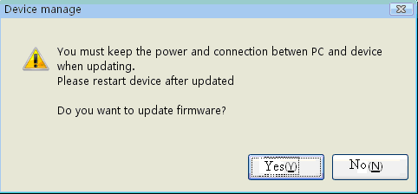
Click "Yes" to upgrade firmware, click "No" to give up. If after clicking yes, upgrade file is wrong, informing you that the firmware in the Device is the newest one.
Note: User do not voluntarily upgrade the firmware, you must contact and be allowed by the dealer before to upgrade the firmware, maybe these trouble and problem which affect normal use occur cause you voluntarily upgrade.
Capture Fingerprint Image: Capture the fingerprint image which present by you currently press finger on the machine sensor face.
Note: this function some machine don’t support this function
Download Management Record: download management record from fingerprint machine to system.
D. Click communication setting pagination, view the device communication setting, click "Read in" to lookup all communication setting.
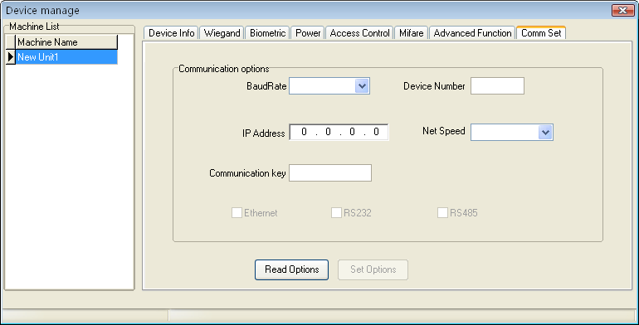
If you want to fast modify this setting, may directly input corresponding item in the text box, after modifying it, click "Apply" to save in device.

2.1.3 Real Time Monitor
The real time Monitor function make management software to known staff attendance or door controlling status in time, may find and deal with the exception status.
Run this function, It is need to open this software only, and attach the fingerprint machine to the network, if there are many fingerprint machine you connect, just need to hookup all fingerprint machine, after normal user verify successfully, its verification record will appear in the displaying area:
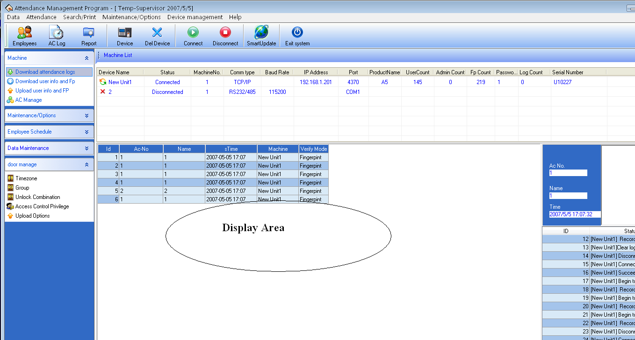
Note: some devices does not support this function

2.1.4 U Flash Disk Management
In general, you can use RS232, Ethernet, RS485 and other way to download data
When if it is difficult to communication or fail to communicate, you can use U flash disk to upload or download staff’s information and fingerprint, save these downloading data in the software.
Choose the system option from the Maintained /Option, put tick in U flash disk in "Function Configuration" box, so U flash disk management in the data menu become valid.
Because the machine type is different, the data construction which has been downloading to U flash disk also is different, so before using the U flash disk, firstly choose the machine type you use.
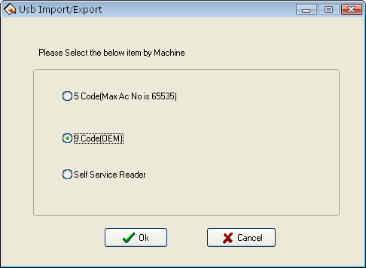
After choosing, press the "OK" to enter U flash disk management, maybe the error occur while download data is downloading cause of the mistake choice
If multiple USB flash disks are available, enter the Select U Disk interface.
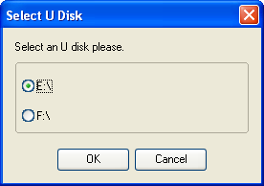
If only one USB flash disk is available, enter the USB flash disk management interface directly.
Import user data to PC
Select put U flash disk into the USB slot of the fingerprint device, choose "Menu" –"U flash disk management"—"Download User Data", Press "OK", when the window inform that system copy data successfully, take out U flash disk, and then plug it into PC USB slot, enter software "Data"-"U flash disk management", choose "import user into PC, Following interface will appear.
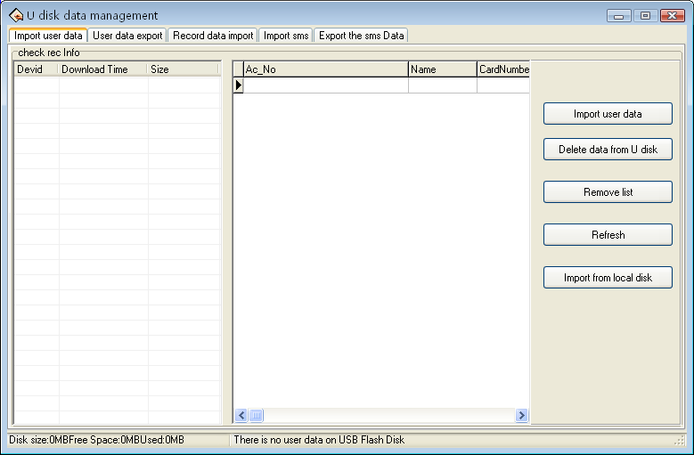
The current user data file which have been in U flash disk will display in "examine record information" left column, after choose this file, click "Import user data to U flash disk", system will import data, this data will display in the middle list to inform that download data successfully.
Clear Data from U flash Disk: Erase all data from the U flash disk.
Clear List: Clear staff‘s information in the current list.
Refresh: Refresh Staff’s information in the current list
Import from local disk: Import user data from PC other disk.
Export User Data to U flash disk
Export user data in the software to U flash disk for saving it or transferring other Device, here you can select user you want to upload, shown as following figure.
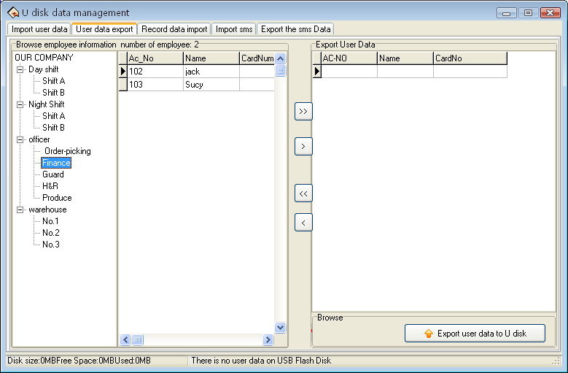
You can view all staff’s information in the left staff’s brown column; click the button for moving data in the middle area to import data "Export User data to U flash disk" area.
: Move all record in the left side "Export User Data to U flash disk" area.
: Move the staff that has been selected to "Export User Data to U Flash disk" area.
: Remove all record in right side from "Export User Data to U Flash disk" area.
: Remove the staff that has been selected to "Export User Data to U flash disk" area
Import the record data to PC
Plug U flash disk into Device, select "Menu"—"U flash Disk Management", Press "OK", the window will inform that download data successfully. Take out U flash disk from Device , then plug it into USB slot of PC, enter "Data" – "U flash disk Management" and select "Import Record to PC" option card, shown as following interface.
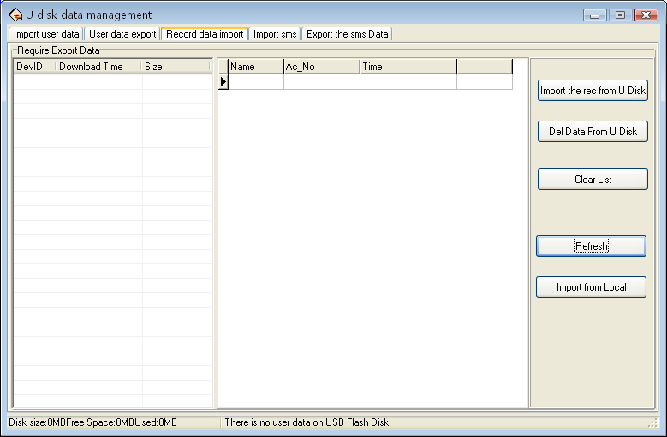
The information of user data which has been saved in U Flash disk will display in the left side wait for importing data list. choose this file, Click "import record from U flash disk" system will import data, this data will display in the middle list to inform that download data successfully,
Clear Data from U Flash Disk: Erase all data from the U flash disk
Clear List: Clear short message in the current list.
Refresh: Refresh Staff’s information in the current list
Import from local disk: Import user data from other disk of PC.
Import Short Message
Plug U flash disk into Device, select "Menu"—"U flash Disk Management"—"Download SMS", Press "OK", the window will inform that download data successfully. Take out U flash disk from Device, then plug it into USB slot of PC, enter "Data" – "U flash disk Management" and select "Import SMS to PC" option card, shown as following interface
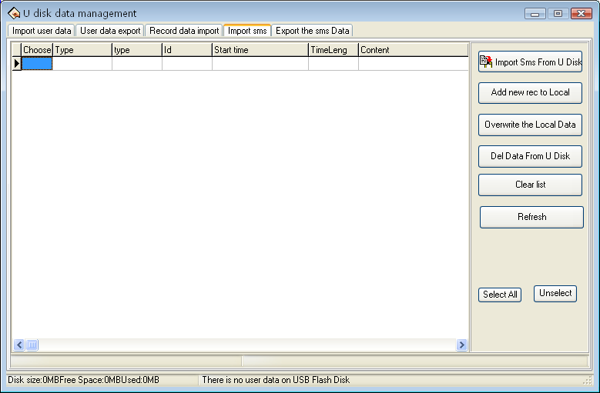
Click "Import Short Message from U flash disk", the data will be imported system, after import data successfully, this total of data will display in the following prompt, all content of short message which has been imported will display on the list.
Add new short message to PC: Add the short message which has not existed in the software into the software.
Overlay PC data: Use the imported data to overlay the data in software.
Delete data from U flash disk: Cancel the short message data in the U flash disk.
Clear Up list: Clear the short message in current list.
Refresh: Refresh Short message in the current list.
Export short message
Export short message in the software to U flash disk or upload this message to other Device, here, may select this short message you want to upload, shown as following figure.
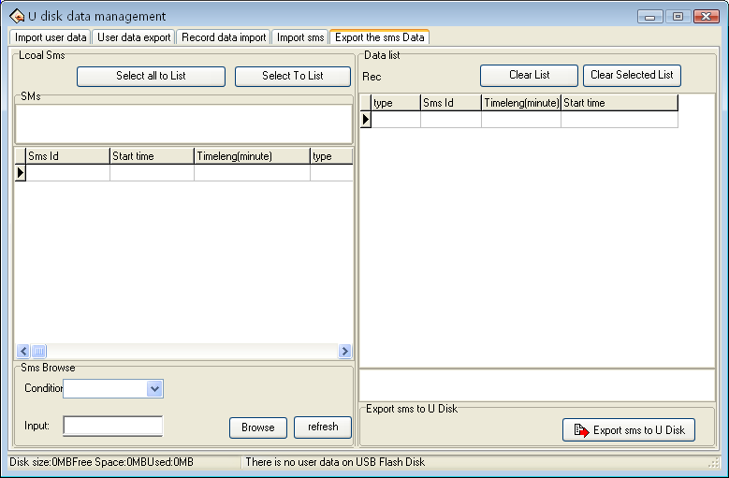
You can view all short message in the software from the left side column, this short message still exist in the "Short Message Box" after it is selected, when if there are lot of short message to search for, you many utilize following way to find it, such as short message serial No., content, Public short message, User short message.
Move the record to right side list: choose the short message that want to be uploaded, click "Move" the record to right side list, the short message will be transferred to "wait for moving to U flash disk list" area.
Move all record to right left list: choose and remove all short message in the system to "wait for moving to U flash disk list" area.
Clear all record in the list; erase all record in the "wait for moving to U flash disk", it is unable to upload the short message or reselect the short message to upload.
Clear all record of your choice: Choose this record which doesn’t need to be uploaded, and then click "Clear" to clear the record from this list, then this short message will be deleted from "wait for moving to U flash disk".
Note: this function is valid only for the machine with U flash disk
Images taken into machine
U will be preserved after the attendance photos downloaded to the software (download only the attendance by the photo, that is, after the U pass in a folder of all the photos). Attendance blacklist photos "bad folder of all the photos" can only be read after the U.
Import machine photographs: U session will be kept by the attendance through the photos, download software to view.
U-Data: delete U intraday attendance through the preservation of the photos.
Note: The software supports attendance cameras can use this feature
.
Import Images that is taken by machine
Download the attendance checking photo contained by the U flash disk to the software (only the attendance photo is available to download, that is all the photos in a passed folder). Attendance blacklist photos "all the photos in the bad folder" can only be read through the U flash disk.
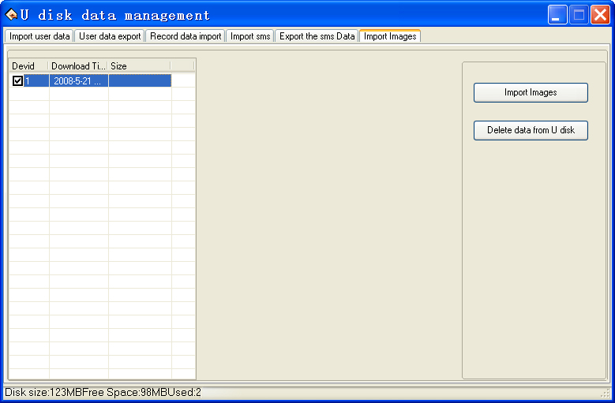
Import attendance checking photos that is taken by machine: downloaded the attendance photos in the U flash disk to software to view.
Delete Data in the U flash disk: delete passed attendance checking photos in the U flash disk.
Note: The software supports attendance cameras can use this feature.

2.1.5 Short Message Management
Some type product provide a function which can send a message to appointed person through public to person way, before using the function, it is need to setup short message, customize the short message according to staff. Then upload the short message into the device. The device fully support two way to upload the message. one is to directly upload by connected attendance device, anther way is to utilize the U flash disk to upload it, follow we take an example to illustrate how to upload it :
Enter the attendance software "System Option" under maintained /setting menu— put the tick in front of U flash disk management in function configuration box, then U flash disk management take effect and may use it.
Short management "SMS"
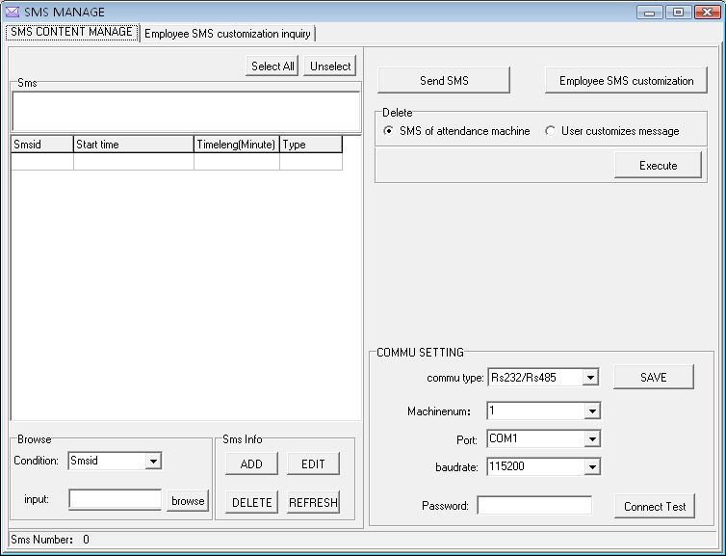
1. Communication setting
we offer two connection ways: serial port/ Ethernet, determining mode of communication depend on the connection way of your device and PC, according to the machine setup, complete to fill the number of device and communication password, click "Test Connection", if the connection is successful, this item will translate "Disconnection", if the connection is failure, the system will prompt "Fail to connect".
2. Inquire short message
This system support four inquiring way: rely on serial number, contents, public and person short message, you may select a needful way via the "Condition" drag-down box, click "Inquire" button, the qualification result will appear on the list area
3. Maintenance short message
This page also supports to maintain basics information of the short message. The four functions that include adding, deleting, modifying, refresh
Add: Click "Add" key, the following interface appear:
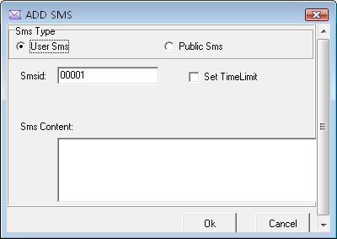
Public short message: for public short , as soon as the attendance machine start the short message will be saw, it will appear for ever；
Personal short message: for a personal short message, it will not show until the user verification is positive；
Period of validity setting: After choose the item, a line will add on the interface, define the starting time and term of period of validity is available
Cancel: Click "Cancel" key, the system will prompt "Are you sure to cancel the selected short message?" after confirming, the system will appear prompt again "Whether delete the short message in the attendance machine together or not" click "OK" the short message will be deleted absolutely.；
Modify: after select a topic message in the list, click "modify", ability to modify the serial number, period of validity setting, and short message contents ；
Refresh: after to perform "Inquire SMS", there are only short message which accord with the inquiring condition on the list area.
4. Send short message
From the short message list in left side; choose a topic message you want to send, click "Send SMS".
5. Customize staff’s short message
Click "Employee SMS Customize", appear following interface
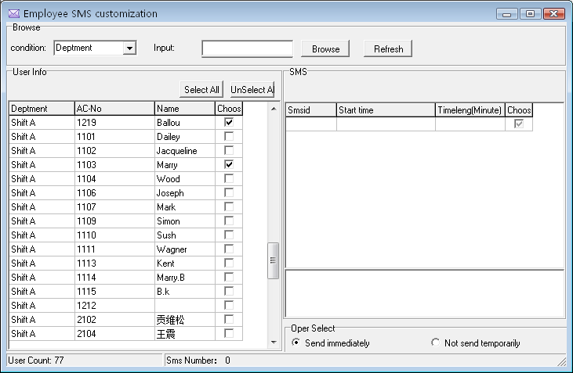
Staff’s information: This list shows the staff information that customizes short message. ；
Short message: This list display the shot message which is customized by staff;
Operation : if the software link with the machine, can click "Send immediately", if the software has not been linked with the attendance machine, "Not send temporarily", and return the main interface of the short message management, then choose the topic of the short message which has not been send, click "Send SMS" to achieve exporting user’s information or use a U flash disk to export the short message which has been save in U flash disk,
6. Cancel
Select "All short message in the attendance machine", click "Execute", may cancel all short message in the attendance machine, select a topic message form the short message list in the left side, click "Execute" to delete all short message in the T&A device, If a short message is selected in the left-side, click "Execute", the selected message will be canceled.
Select "All staff customized short message", click "Execute" to cancel all user short message in the T&A device
Inquire the Customize staff’s short message.
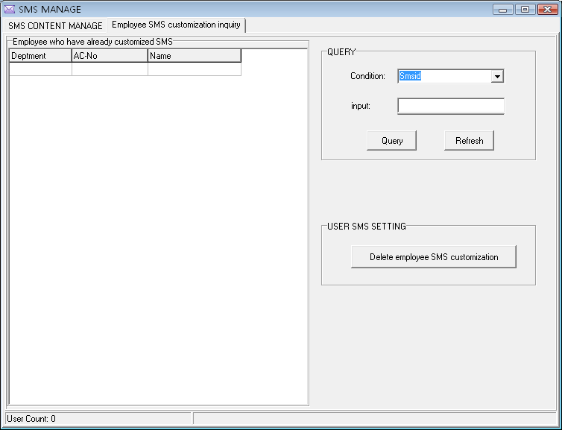
Inquire: This system support four inquiring way: rely on serial number of the short message, the department, Attendance No. Name, you may select a needful way via the "Condition" drag-down box, click "Inquire" button, the qualification result will appear on the left side area list, click "Refresh" the all user’s customized short message will appear on left-side list area.
Cancel staff’s short message by defined condition: Select a staff who want to be delete in the customized short message left side list, click "Execute" to cancel "The short message by define condition" completely to delete the customization..
Note: Only the function is valid for this device with SMS function

2.2 Maintained/Setting
In order to get correct and accurate Time Attendance result, you must configure Maintained/Setting in the main windows, here you can set up software database and system setting. firstly enter department management setting and assign staff to department, then performance First set up database password, then set up holiday, leave style and attendance rule, department, staff maintenance and administrator setting, at the finals, maintenance timetable, maintenance shift schedule, staff shift assignment
Note: unless the staff has been assigned shift schedule, the system don’t produce Time Attendance report
This system provide with enrolling fingerprint or card by after connecting with PC, it is avoid the trouble that personnel don’t match the fingerprint and fingerprint, please see 2.2.2 Staff maintained.

2.2.1Department Management
This module provide with convenient to manage each department, mainly add, cancel department, enroll staff, for more detail as following
Click on the "Department list" sub-item on the menu "Maintenance /Setup", the windows appear:
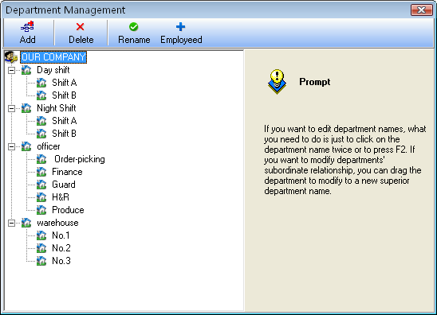
In adding department, you first left-click the superior department of the new department, click on the "Adding department" button , input the name of new department in the dialog box, click "Confirm" to save.
In deleting department, you only firstly left-click the department selected, click the "Cancel department" button, select "Confirm" in the display caution box, OK.
If you want to modify a department's subordination relationship, first selected the department to modify, left-click, hold, drag the name within the new superior department. Then follow the instruction to operate.
Click on the "Enroll staff’ button. the following appear:
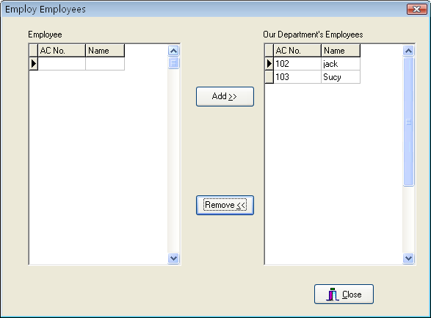
Staffs in the Employees box are those who don’t belong to any department, that is, who have left their posts. This is the same as on leave No salary
In the box of staffs select those employees that your department wants to employ, and click "Add" button, and then those selected employees will be added into your department.
In the box of Our Department’s Employees select those employees that will leave your department, and click "Remove" button, and the select employees will leave your department (leave their posts).
After operations, click "Close" button or to return to Department Management main Window

2.2.2 Employee Maintain
Select the "Maintenance/Setup", click staff maintenance item, open "Staff list", within this window, maintenance staff's various information and attendance setting. Through the staff list you can view the department the staff belongs to, here to view and modify staff’s information is available, at here attendance setting privilege is superior to Assign Staff Schedule.
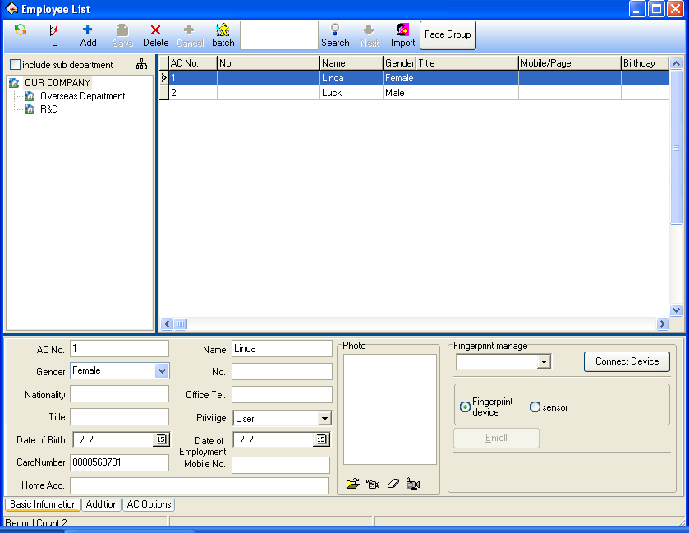
The upper half of the window of Employee List is a list of employees, and the lower half is designed to select and set staff’s varied information. The lower half is paginated to three pages; click the pagination label on the bottom to enter different pages. performance corresponding operation.
When if there are many staff, you can use this way to search for, input condition you inquire, click "Inquire" button so you can get detail information about this staff.
- Must fill the blank of the staff’s information list with the staff’s name, enrolling number, according to the actual need you can add other information about staff.
Note: it is different with old software, we have increased a new function in maintained/setting item , the User number distinguish from enrolling number, the enrolling number is suit for Device, and according to normal Device, the enrolling number don’t more than 65535 ,but the user number have not limit to its size number.
Addition New Staff
When usual execute this management program at first time, after registering the user in the Device, than directly downloads it to software, and revise name, as well as save it, upload it the machine to use again. If have to directly add the staff in software, in order to guarantee the user information and the fingerprint or the card one to one correspondences, connect with Device to go on the real-time registration fingerprint and the card is available in this interface. After connects the Device, every time while add a staff the corresponding person's fingerprint or the card will be registered simultaneously. Avoids the trouble which the fingerprint or the card and the personnel does not correspond appears.
A, registration fingerprint
Under in "Fingerprint or card registration" drag-down box, choose the fingerprint device that have attached to system, after connects successfully, starts to add the staff. Select the department which the staff is at, after click "" button, input staff's register number, name and other related information. Single-click "register" button to start the fingerprint registration.
Fingerprint machine registration: register the fingerprint with the standalone fingerprint Machine.
Fingerprint device registration: register the fingerprint through the on-line fingerprint device to t.

Attention: when you choose fingerprint sensor to enroll, there are two choice: ZkFinger9.0 and ZkFinger10.0, for the operation detail refer to Appendices 3.8 How to Generate License Files.
Registration flow:
Single-click "Register" button, shown as figure:
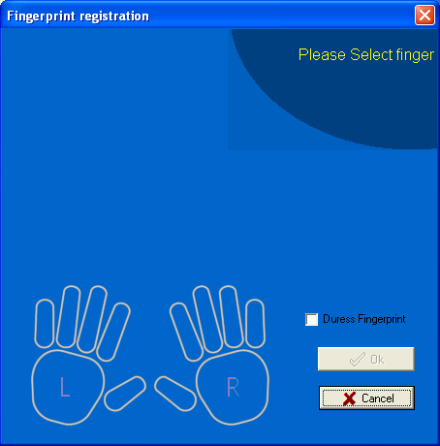
Start to register, click any finger in the interface with the mouse, the fingerprint Device that has been connect with is in the registration condition:
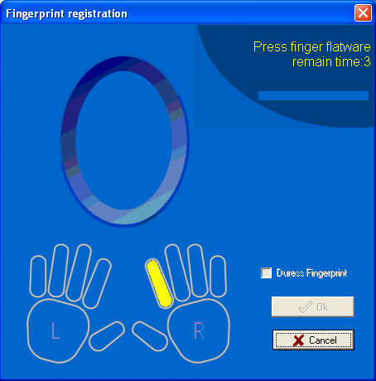
Attention: You can choose to enroll duress fingerprint, but it is only effect when the device supports the function, otherwise it is just a general fingerprint.
follow prompts or press fingerprint on sensor face of the fingerprint device or fingerprint scanner, after press 3 times, prompt inform you registers successfully, then fingerprint registration finish. If want to backup fingerprint for system, then chooses a finger registration. After the registration complete, press "OK" to return add the staff interface, continue to add the staff.
B, registration card
Under "Fingerprint or card registration" drag-box, choose the Device with radio frequency card function, after connects successfully, and starts to add the staff. Selects department which the staff is at, Click "" button, wave the card which want to be registered on the radio frequency card machine, after waving the card, this staff's register number and the card number can display the corresponding card the information, according to needs to change the serial number and the name, the card number do not change at random. The cursor locates in the name column
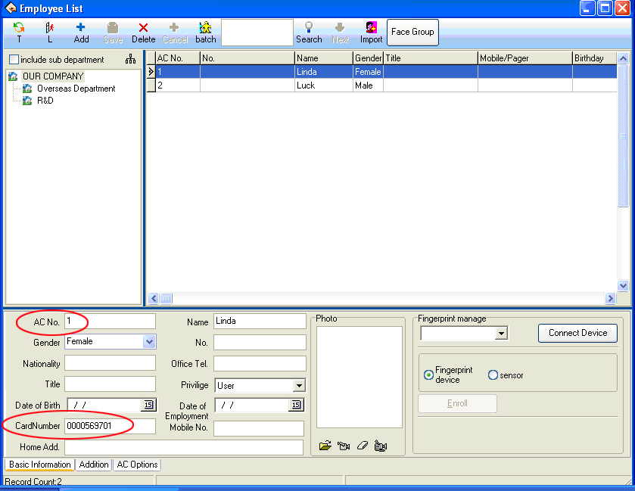
If want to add new staff, press "" button to repeat above this operation.
2）Add Batch Staffs:
When some departments enroll a lot of staff, you can use this function to add staffs, lighten an operator work. E.g., a lot of staffs want to be added to the bill department, first select a department; click on the "Add batch staffs" button, the adding batch staffs’ window appears.
If there are not staffs in this department, the following appear
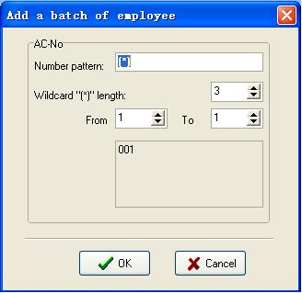
If there are staffs in the department, the following appear
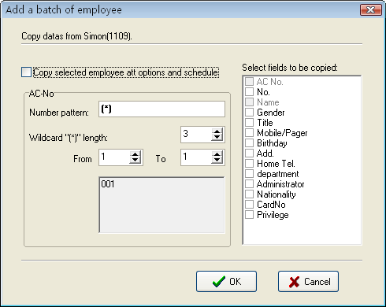
The backup data of staffs witch select from bill department display on the left-up corner, if the new added staffs and selected staffs own the same the shift and attendance setup, left-click "Copy selected employee attendance option and schedule", if there are other same words, select relating to words from the selected words box.
Attendance No batch increase that department on adding batch staff. through the "*" wildcard, it is easy to add staff No.
The number format: That means a attendance serial number, for example, the staff No of this department is the figure 1 at the first, so its serial number is 1***, input 1"*" to the serial box, the window display following:
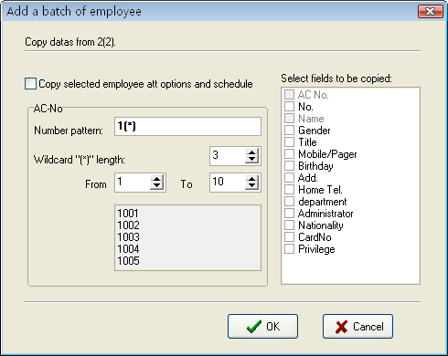
The asterisk wildcard length: That is mean, how many figure the symbol indicates? E.g. the forward section of the serial number is 1???, its asterisk wildcard range is 3, if the serial number is ?? , so its asterisk wildcard length is 2. After the asterisk wildcard width has been defined; by use the "From" box, "To" box to create serial number range. E.g. create the serial number range from 106 to118; input 6 to "From" box, import 18 "To" box, the symbol wide is 2, but from 6to9 width is one figure. at this, the system will add zero automatically. Shown as following interface:
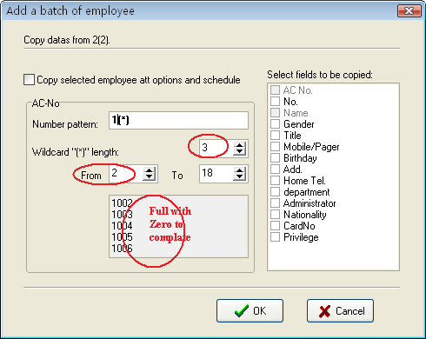
Click on the "OK" button, add staffs, and click on the "Cancel" button, return the staff interface.
3）Modify Staff
Do not modify Staff’s enrolling No. or name modified randomly. Avoid there information don’t match corresponding information in the Device. Click "" button, enter new data in the corresponding input box, and then press "Save" button.
4）Transfer Employee
Click the "Transfer Employee" button to transfer employees from one department to another department and this dialog box will pop -up
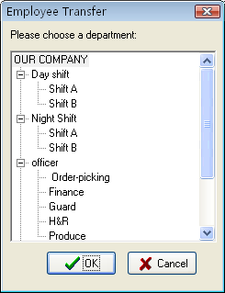
In the box of Fold Department select the department to add new employees in, and click "OK" to transfer the employee, or "Cancel" to cancel this action.
5) No pay leave: Some employees may remain in the company, but who don’t belong to any department now, which is similar to the currently quite popularized lay-off phenomenon. Leaving-post employees can be re-employed through Employ Staff in Department Management. Click "" button to present this dialog box
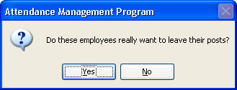
Press "Yes" button to transfer the employee to a new department, or press "No" to abandon this action.
6）Import user data: Import user data from the local disk.
Click , and the Import User Data interface pops up.
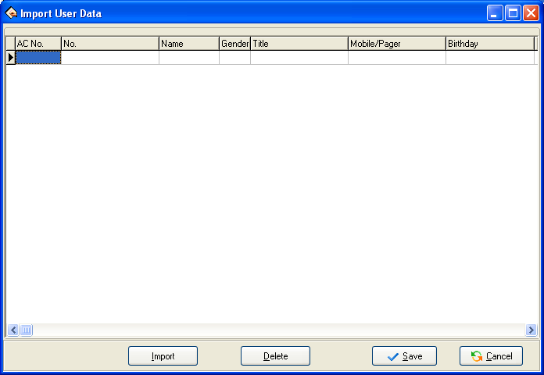
Click Import and the Import data wizard interface pops up. Then, add the user data stored in the local disk.
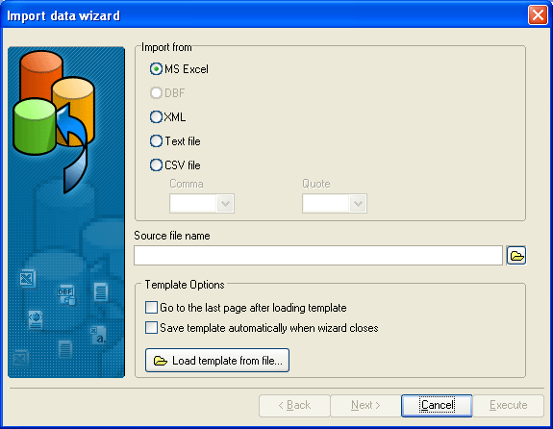
7) Face group: To use a face device and enter a face group, proceed as follows:
Click 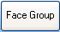, and select the users who have registered faces for grouping. For the users who have not registered any face, do not perform this operation.
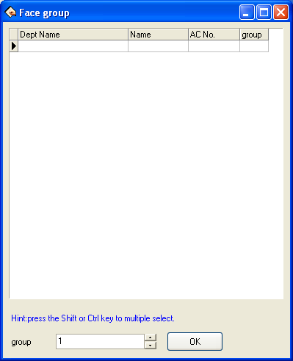

2. Right shortcuts key operation
Right click a region of the staff’s list to export staff's basic information, production report is available; entire rank data also can be hideaway or showed in the current interface. Shown as following figure:
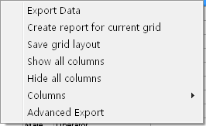
Export data: export all staffs' information of the current department. Operation step like as Time Attendance port.
Create report: all staffs' information in current department will display by report form. .the operating method likes to export the data in Time Attendance report.
Save Grid layout: After change setting of data rank, save the data rank setting, it is allowed to use after through directly write down the data rank setting.
Show all columns: After click this option, staff’s all information appears.
Hide all columns: After using this option, staff's all information will be hided.
Columns: show the name of composition rank of staff information in the staff view
3. Click "Department setting" button, it is allowed to set the department setting. Its method is the same with the operation in department management.
4. Click the pagination label of other information. The windows will appear as follow:
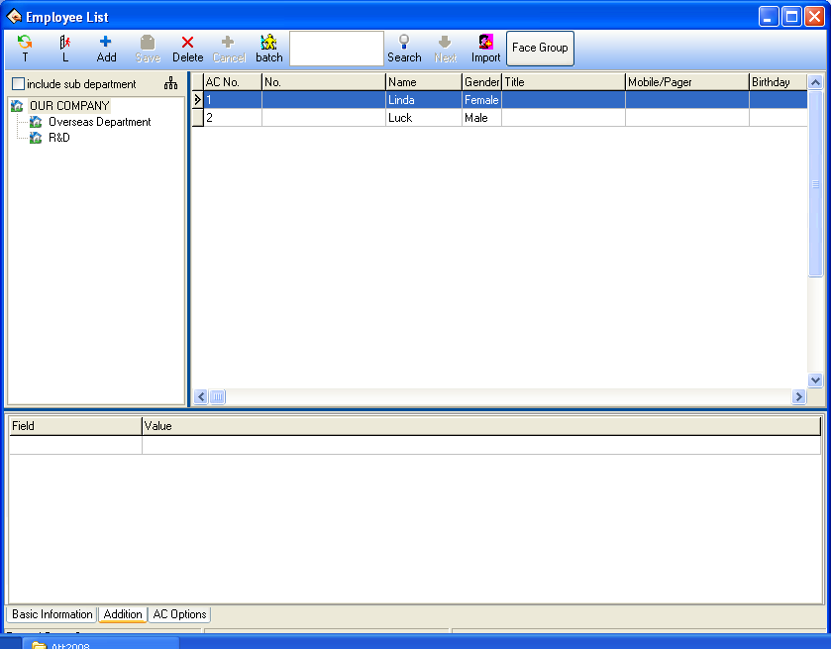
At here be allowed to input the important staff’s related information About the staff important information is input in relating page, select department, select staff, press"" button, add an item record, type information style in words row, input relating material to contents, then save it, select department, and choose staff, input information in the field column, as well as input related content in content column, than just save this information only.
5. Attendance rule option
Click the pagination label of AC option. The windows will appear as follow figure:
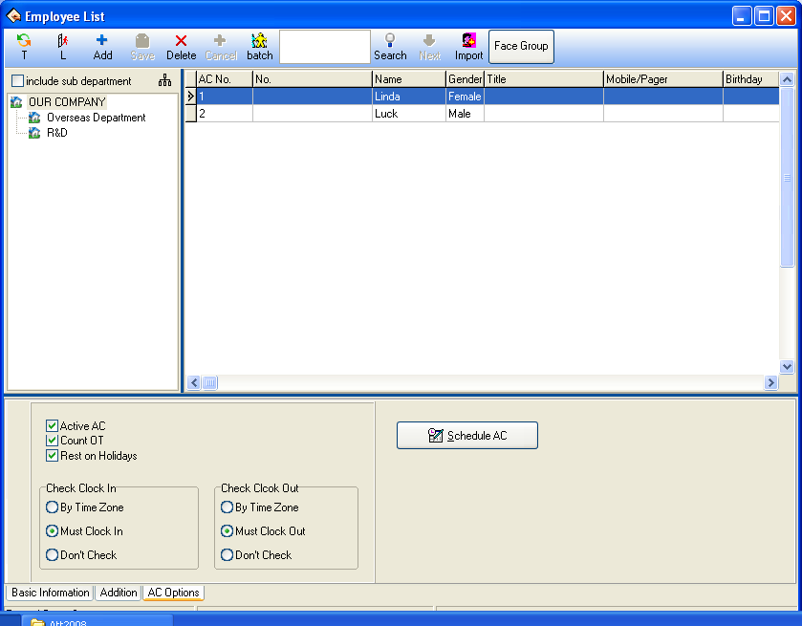
Active AC: The item means weather the attendance is valid, if this item is defined, the staff will be accounted and statistic attendance in accordance with the attendance rule and other select item, otherwise, this staff doesn’t need to keep the attendance record, and regard his record as normal on-duty, E.g. A leader of the department doesn’t go to attendance, but his attendance is accounted on normal duty.
Count OT: Sign this item, counted by the staff over time.
Reset Holiday : Sign this item , the staff will have a rest on holiday, if the staff is on duty, it will be signed to over time. Otherwise, the staff have to be on duty, if the staff is off duty, he will be accounted to absent.
On duty check-in/off duty check-out: This item can control the staff must check-in or check-out, the setup privilege in the item is super than it in the shift schedule.
Staff Time Attendance setting
Click "Time Attendance schedule"; enter staff’s Time Attendance setting widows, shown as following widows
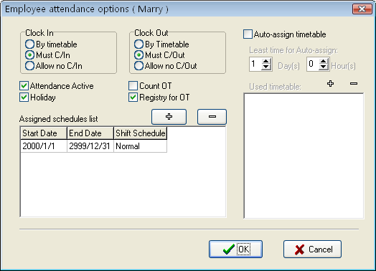
The method of attendance statistics is similar to the method of attendance setup, it is only that there increase optional which the over-time has to be registered and examined, In the option, all over-time must be registered and examined, otherwise, the over-time will be no pay.
A current shift list indicate the staff on duty scheduler, the box show that the staff shift include beginning , stopping date and shift name, if need to modify the staff shift, first select the shift item in the current shift list, it will turn blue, then click on "-" button, cancel the current shift, after this , click on "+" button, add a new shift, the window is following:
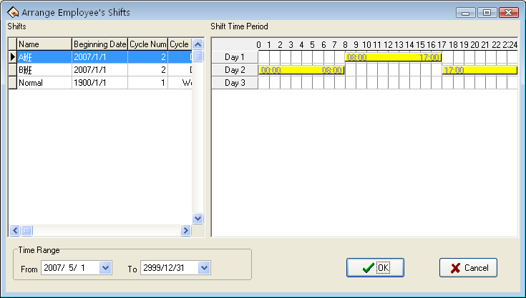
Select a new shift from shift that has setup, definite starting and stopping date, click on "OK" button to confirm action, click on "Cancel" button to cancel operation, return attendance setup window.
While a staff shift in Normal work hours, you can add a lot of item of schedule. E.G.: Starting date stopping date shift
03-3-1 03-5-30 springs
03-6-1 03-9-1 summers
The intellect assignment staff's shift be selected, the window will appear.
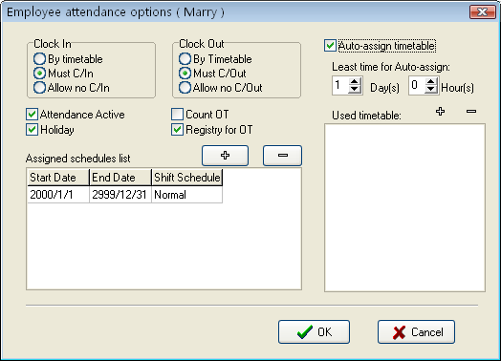
The auto-assignment staff’s shift function is that, while staff who does not assign shift to Time Period, but he/she has attendance record, the system will can define automatically the Time Period. This function main use in more changes shifts.
Min auto- assignment shift time: when you setup a time period, example one day, at this time the system will accord with setup time period to determine after it expire more one day, otherwise Not to determine.
Used timetable: that is, this staff is able to on-duty time period, click on "+" button, the selecting period of time appear, this shift Time Period is shift name list which has been set up in shift management. The windows following
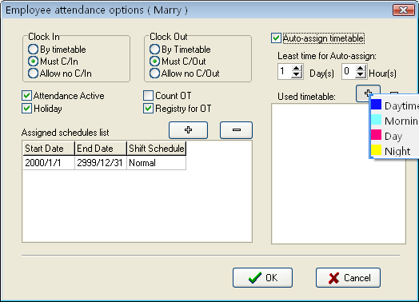
Left-click shift names that select from display shift name list add selected shift. If want to cancel shift where there are used period of time, first define period of time, click on "-" button, it will be canceled.
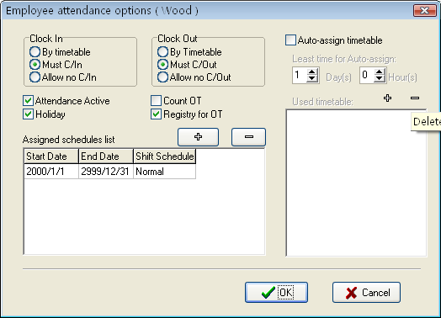
After set up, click on "OK" to save setup, click on "Cancel" to give up action, return attendance setting label

2.2.3 Administrator Setting
Set administrator
To help protect you system from security, to prevent the data are changed by unauthorized personnel, this management program provide with the function to set administrator, click the "maintenance/setting" sub-item on the menu of administrator setting, this window will pop up following dialog box
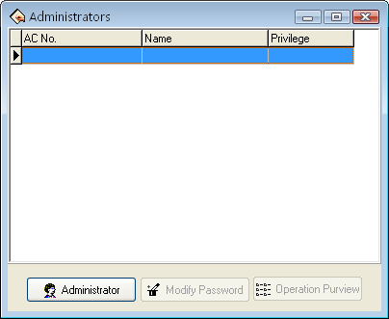
Click on the "Administrator" button, the display is following
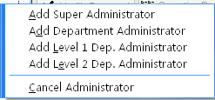
Select the administrator type you want to add (it is better to add supper administrator), after click, following interface appear
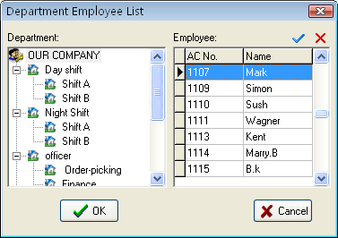
Choose the administrator you want to add in the interface, all administer must be a company’s staff.
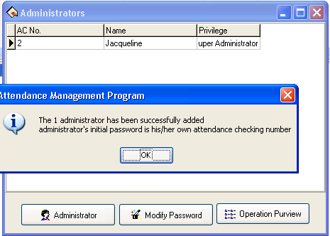
Administrator's initial password is himself/herself register number, click "OK" to enter the administrator privilege interface, may set this administrator is allowed to software in this interface be allowed to software
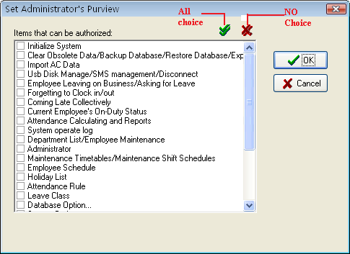
Single-click each item of front selection box , this item is able to switch from choice to no choice , indicated this item has been selected, all no choice express that the system give each kind of administrator privilege by default setting. After choosing, click "OK" to complete the setting, if click "Cancel" to be allowed to set the privilege in the next time again (administrator which will have to revise in administrator interface, click "Operation privilege" button to reset). For more detail please see authorized the item
Note: administrator is unable to revise own privilege, delete oneself, only the upper of administrators is allowed to revise, add or delete next level of administrators. Be unable to change the privilege or cancel the administrator unless when there is only an administrator.
For more detail, please see administrator's classification and the privilege.
After set the administrator, the system default administrator's password is this staff's register number, it is better to revises the individual password to guarantee system data security. After the administrator has been set in the system, the system prompt will appear, unable to enter the system until input the administrator to login umber and the password.
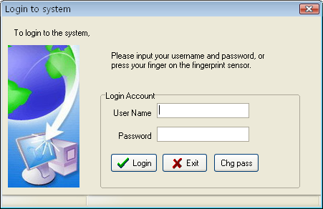
Administrator's privilege and classification
1. Administrators' classifications
There are four kinds of administrators in the system, depending on the privilege height Sequence: Super administrator, second levels of departments’ administrators, first level of departments’ administrator, department administrators
2. Administrator’s privilege: the super administrator may manage all staffs; the department administrators only can manage this department staff.
  - Super administrator privilege: The super administrator is highest level of administrators in the system, the super administrator own privilege to add, revise, delete administrator besides oneself, it is allowed to initialize the management system and set the database. His/her default privilege is allowed do any operation for the system. If any the option is in no choice in the interface of administrator privilege , then the default privilege will be used; If only several items has been selected, then this administrator who has the operation privilege can select the corresponding project only.
  - Second levels of departments administrators privilege: second levels of departments administrators is allowed to add this department administrator, and same level perhaps the low level of administrators revise privilege, delete this department besides oneself, who is not allowed to operate other departments' any administrators. If only several items have been selected, then this administrator, who has the operation privilege, only can select the corresponding project.
  - First level of department’s administrator: first level of departments administrator may add this department administrator, and same level perhaps the low level of administrators revise privilege, delete this department besides oneself, who is not allowed to operate other departments' any administrators. If several items have been selected, then this administrator, who has the operation privilege, can select the corresponding project only.
  - Department administrators: The department administrators may add this department administrator and the same level administrator revise privilege, delete this department in besides oneself, who is not allowed to operate other departments' administrators. If several items has been select, then this administrator, who has the operation privilege to select the corresponding project only.
Authorized project
Clear the expired data/backup database/export the Time Attendance data:
There are 3 projects under the data menu, the administrator own this privilege to save and examine the data.
- Import the Time Attendance data: it is able to import recording data in the file to the system through Import AC data under the data menu.
- Leave on business/asking for leave: click "Employee leave on business/ asking for leave" sub-item under Attendance menu, may set the staff leave on business / asking for leave condition, and produce the corresponding data sheet.
- Forgetting to clock-in /out: if the staff forgets to clock-in/out, add clocking –in/out record for this staff through this sub-item under Attendance menu.
- Coming late/leaves early collectively: if staff have forget collectively to clock-in/out, then neglects assigned time clock-in/out record, or add the clock-in/out record again this sub-item under Attendance menu.
- Going out on duty record: may search staff's going out on duty record examination system and revises the diary through this sub-item under Search/printing menu.
- Current staff at-post situation: ability to Search the staff current time in the At-post/not At-post situation through Sub-item.
- Attendance exception inquires and report: Under search/printing menu, also may click on "Attendance Calculation report" icon to enter, may inquire each kind of exception, statistics the Time Attendance, produce report, and print the report.
- Department management/Employee maintenance: may set the department in the department management; revises the staff information and staff's Time Attendance setting in the Employee maintenance through sub-item Department list/ Employee maintenance under the Maintenance/Option menu.
- Administrator setting: Under the maintenance/setting menu, set up the administrator and assign the privilege.
- Time Period maintenance/Shift Schedule management: through sub-item under the Maintenance/Option menu, create the working Time Period in the Time Period maintenance, manages the shift schedule, chooses properly working Time Period or the Time Period combines to establishes the different shift schedule.
- Assignment staff shift schedule: Under the Maintenance/Option menu, assign the Shift Schedule which already set to staff.
- Holiday Maintenance: set the holiday under the Maintenance/Option menu.
- Leave setting: Under the Maintenance/setting menu, go on a leaves setting, and leaves statistical rule in report form.
- Time Attendance rule: set up the Time Attendance rule, and statistical rule for Time Attendance project in report.
- Database setting: Set up the database connection through this sub-item under the Maintenance/Option menu.
- System setting: Be able to carry on the setting to software some options under the Maintenance/Option menu.
- Connection Device: Be able to connect with Device through this sub-item under the Device Management menu.
- Download data record from Device: To download the data record is available through the Device Management menu.
- Upload the personnel information to the Device: ability to upload the personnel information through the Device Management menu.
- Downloads Employee and his/her fingerprint: Under the Device management menu can download the staff fingerprint information.
- Clear the data record in the Device: eliminates the Time Attendance data recording in machine through sub-item Delete AC log under the Device management menu
- Device Management: Be able to examine the Device information and carries on some operations to the Device through this menu.
- Device Edit: can add , delete, revise the Device the communication information through this sub-item under the Device Management menu
- Sync Device time: synchronize Device time with Computer time through Under Device Management menu.

2.2.4 Time Period Maintenance
Before shift schedule are assigned schedule, the Time Period must be set up to complete, select "Maintenance/Option" menu, click on the "Time Period Maintenance" in the main menu, can set Time Period which is used to arrange staffs shift, the interface is following
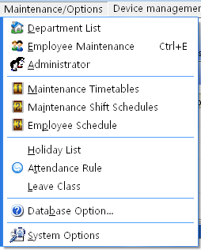
If you has not set the shift schedule while set the Time Period, the system will auto-prompt you should go on shift scheduled management setting, shown as following figure.
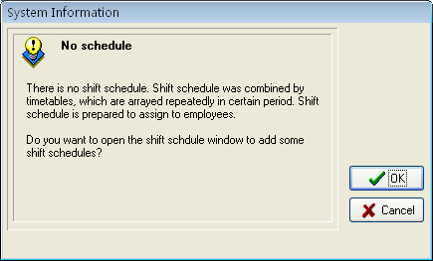
Click "Cancel" button, return main menu windows, click on "OK" button, start to set Time Period, the window is following
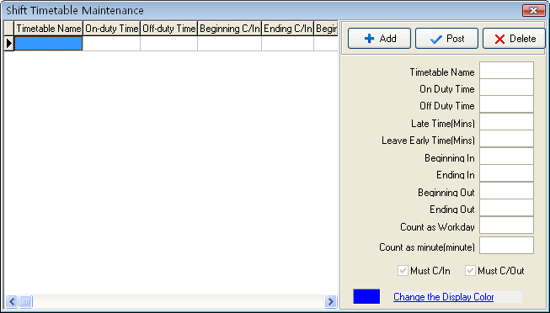
Select Add to enter Times for on/off duty Guide interface, follow the guide to set Time Period and shift schedule.
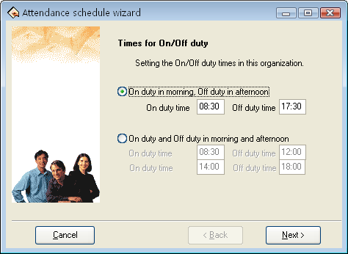
According to the company real condition, the method of on-duty and off-duty is selected, is twice attendance (morning and evening), or is four times (morning, Noon, Noon ,evening), input correspond to on- duty and off-duty time, click "Cancel" button, return main windows click "Next" button to continue setting, the window is following
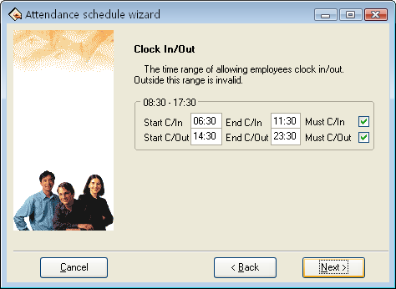
This windows may set the beginning times for clock-in/out, definite the time range of clock-in and clock-out, and whether at this time employee must be clock-in and clock-out, if want to select this item, just put tick in the selection box, also can set different option depending on different department and employee ,click "Next" the window is following
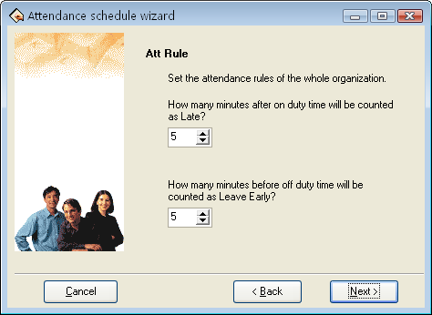
On the window, set regard as coming lately time and regard as leaving early time, click on "Next" button to enter next window
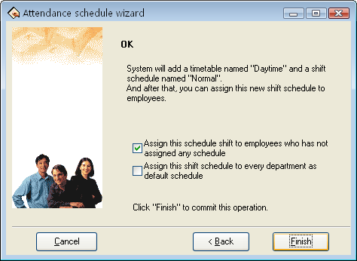
On the window, the system prompt that it will add named "day" a time period and named "Normal shift" a shift, because, before we selected method that is twice attendance in a day, system will add two new Time Period, each is "A.M" and "P.M". There are three options on the window, according to need to select, then click on "Finish" button, complete setup. If selected open "Period of time maintenance window to detail setting", click on "finish", enter period of time maintenance window.
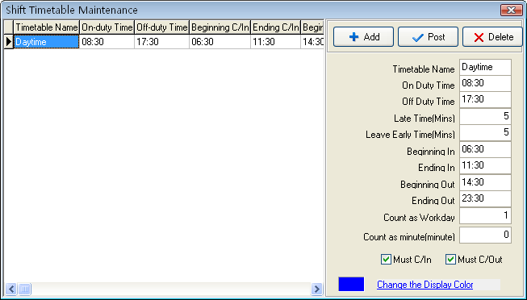
the Shift Time Period maintenance interface may be divided into two parts, left part mainly are the Shifts Time Period list, right side is the Shift Time Period management. May add, delete,and revise Shift Time Period.
- Add: Single-click "Add" button to add a new Time Period, then input the Time Period name, the coming and going to work time, the hour of Clocking in/out, recording the time as coming lately, recording the time as leaves early as well as how many working day are records, the Time Attendance record is the effective record only within the hour of Clocking in/out, take these recording as standard to statistics logs . Simultaneously definite this Time Period, whether employee must Clock in/out or not. The input time format is hh:mm, which separately corresponds the hour, the minute.
- Deletion: Selects the Time Period which has already existed, single-click "Delete" button to delete the Time Period which has been selected.
- Save: Single-click "Save" to renew, when revised or add a Time Period, click this button to save the Time Period setting information.
- Record the hour "minute" as coming lately: as above figure show, the setting value is5 minutes, E.g. Illustration is on-duty time at7: 50, A. at 7: 53 check-in time, B. at 8: 00check in time, so the A is not coming late, because he check-in time is not over 5 minute, the B is coming late for 10 minutes, because he check-in time is over for 5 minute.
- Records hour as leaves early "minute": it is the same as record coming lately, depend on the difference between the clocking out time and the rush hour time.
- Beginning /Ending in: Must input. within check-in range of This Time Period the record regard as validity, outside this scope checking record is the invalid record.
- Beginning/Ending out : Must input. within check-in range of This Time Period the record regard as validity, outside this scope checking record is the invalid record. Begin and End Clocking out time can not overlay.
- How many working days to records : Refers to each Shift record how many working day, if here the value has been set, the program will defer to the setting value to statistics working day, otherwise according to Time Attendance rule in option statistics.
- How long time "minute" to records: the period of this Time Period will be recorded how long time in the statistical report , may set it by user. For example: When some o'clock Time Period the reality length is 9 hours, may record it as 8 hours, also records in the Time Attendance statistics this o'clock Time Period is 8 hours.
- Must checking in/out: According to the different post and the different request may definite the Shift Time Period whether have to check out/in.
- Changes the demonstration color of Time Period : May change each Shift Time Period color, used to differentiates each different Shift. just left-click the color with the mouse ,which the color region want to be modified.

2.2.5 Shift Management
After setting Time Period, Be able to set Shift Schedule, Select "Maintenance/option" menu, click "Shift management" sub-item, and then you can enter shift menu with the following window:
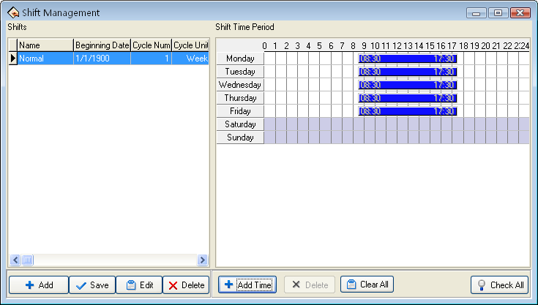
This interface may be divided into Shift name and Shift Time Period, the Shift name box include Shift name, Shift Cycling Periodicity, Periodicity unit
The shift name can’t be repeated, and all the fields in the form can’t be empty.
Application Beginning Date is in the form of yyyy-mm-dd, for example, November the 15th, 2003 is recorded as 2003-11-15, and March the 6th, 2003 is recorded as 2003-03-06.
Shift cycling periodicity = periodicity count * periodicity unit
Periodicity unit consist of day, week, months
Can set empty shift that is no no-duty?
Shift Management Tool Bar to add, cancel, modify shift. Under the status of adding or modifying shifts (when "√" button is valid), you may Add/Modify/Delete Shift Time Periods.
Single-click "" button to add a new Shift, the blank Shift Time Period will appear in the right side, then add a Time Period, Following window will pop up:
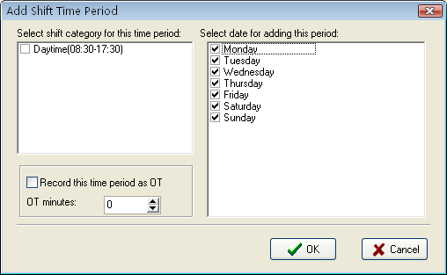
Select a Time Period which has been setup in down -drag menu, add shift Time Period directly. Which day are you on duty, you make a mark "√" on the day you selected. At same time sign the day as over time or not, then click "OK" button to save setup, click on "Cancel" button to give up the action.
Cancel Shift: choose a Shift that want to be deleted, click "" button to delete.
Modify: Choose a Shift that want to be modified, click "" to complete revise
Cancel Time Period click on ""button , selected Time Period will be cancel, display all Time Period will be cancel.
Save: After a Shift has been modified or added, click "" to save related information

2.2.6 Assign Staff Shift
If staff has not been scheduled, then at finally system is unable to statistic the Time Attendance records, if a staff did not belong to shift the system will be unable to distinguish his Time Attendance record which was goes to work or gets off work, and fail to count his Time Attendance.
After setting the Time Period and the Shift Management, Select Maintenance/Option menu, click "Employee Schedule", open the window of schedule employee's A C Here, you can maintain data related to staff's shifts.
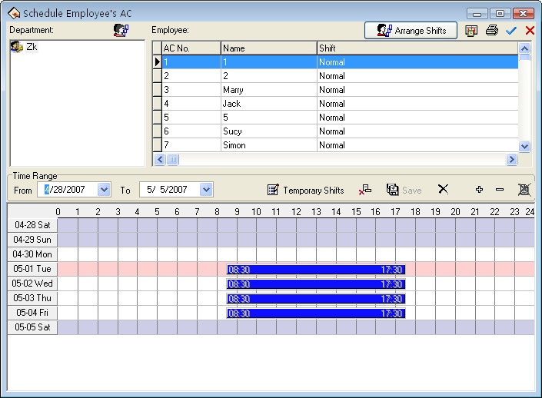
Left side of the page demonstrates that shift schedule depending on the department . click department name with mouse , can show all staffs and its Shift Schedule in the right side staff module.
Assign Staff Shift by department : according to the different department's characteristic to assign staff shift, Single-click "Department Schedule" button on the left angle, the following dialog box appears
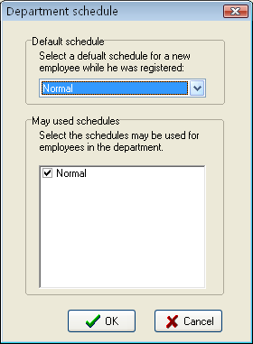
Default Shift schedule: select a shift from down-drag menu, make it as default Shift which is used for enrolling new staff, after enrolling new staff it will give new staff a shift.
May used Shift schedule: able to display name of current setup shift in the shift schedule list, when arrange department shift, the shift will not display list until selected shift.
Normal Assign staff Shift
The part of the page in right side is the assignment staff shift the module. Assign staff shift not only individual all, but also by the batch. Click "all choice" button to assign all staffs shift. in the staff’s list interface, hold down the "Ctrl" key and with the mouse single-click the staff to complete the multiple-choice, choose the staff who needs to be assigned to shift ,then click "Arrange Employee’s shifts" button, the following interface appears
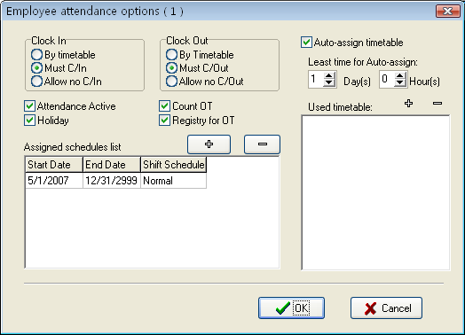
Clock in/out: May set whether staff has to Clock in/out, according to the corresponding time Period to judge whether need to Clock in/out the setting privilege in this project is higher than one in Shift Time Period setting.
Count Time Attendance: Refers whether Time Attendance is effective or not, after choosing this item, according to the Time Attendance rule and the shift schedule, total of Time Attendance record is available, otherwise, this staff will not participate in Time Attendance, whose records regard as normal work. For example some leaders do not need to count the Time Attendance for normally go to work.
Records regard as working overtime: After choosing this item, ability to calculate this staff’s working overtime.
Holiday Valid: after choosing this item, this time the staff who has been assigned shift will rest in the holiday, if he/she will go to work, his/her record will regard as working overtime, otherwise, this time the staff who has been assigned shift have to go to work in the holiday, if he/she does not go to work, his/her record will regard as absence from work without an excuse records.
Working overtime needs obtain approval or the verification: Refers to staff's all working overtime which is this time to assign staff shift must pass through the registration or the verification only ,then it take effective.
In current arrange shift under the option to be allowed to examine this staff's staff’s entire shift, may add and delete change staff's shift. Click "" add key, the following interface appear
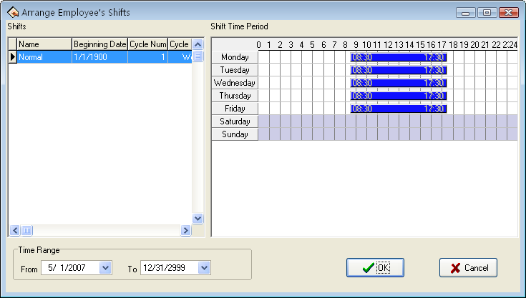
All shifts and the shift Time Period display in this interface. Chooses a new shift from these shifts which have been set, determine its beginning and ending time, single-click "Confirmed" button to confirm the operation, single-click "Cancel" button to give up operation, returns to the assignment staff shift window. After arranges successfully, the corresponding shift name will display in staff's shift column, and time list can show on-duty Time Period in the interface.
Auto- assign timetable
If assignment staff shifts or changing shifts schedule is too frequently, and there is not the rule to follow, auto- assigning staff shifts is available, auto- assign staff shift refers to staff does not has fixed shift schedule in the definite time, but he /she has the Time Attendance record, the system may automatically judge the Time Period which record belong to. After choosing the auto-assigning staff shift, the following interface appears
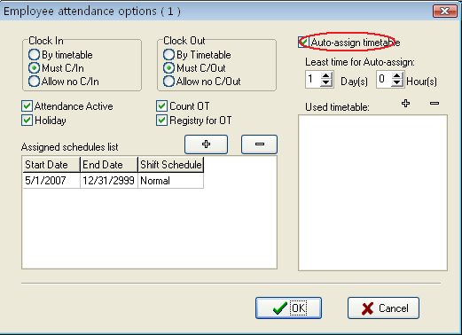
Then choose the least hour of the intelligences to assign staff shifts, the least hour of intelligences to assign staff shifts refer to after you have set the time, for instance 1 day, the system only could not carry on the judgment by the shift Time Period until the time which the staff has not arranged in groups is more than 1 day, otherwise did not judge. Finally chooses the shifts Time Period which may be used to assign staff shift from the Time Period. Possibly Time Period: this staff possibly shift Time Period, single-click "" button, the choice shift Time Period appears, these shift Time Period are the name list of the set shift which have already been set in shift management. Interface as follows
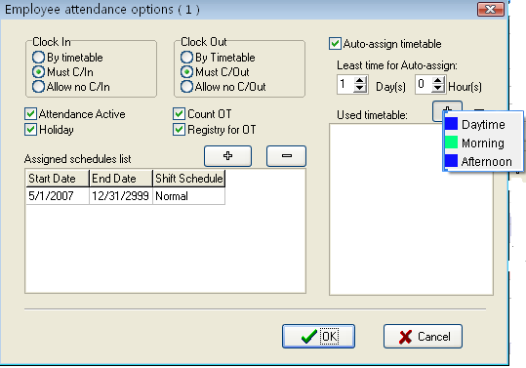
Be able to click "" key in the Time Period which need to delete it
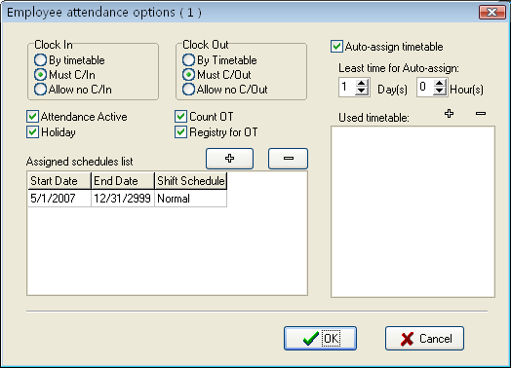
Employee temporary shifts
If one (or several) staff needs to change his/her work hours temporarily, his/her shift can be arranged temporarily, click "Staff temporary arrangement" button, pop up dialog box, window is following:
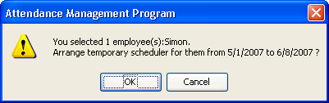
Click "OK" button, enter temporarily schedule, click "Cancel" button, return staff's schedule window. First definite schedule hour, select staff, if you want to select a lot of staffs, can hold down "Ctrl" key, simultaneously click staff or use all choice button, then click on "Add period of time" button, select to add period of time on the window of adding period of time, and what day or how many is to add. The operation method is the same in shift management to add period of time. Click "Save temporarily schedule" button, to save temporarily schedule or click "Cancel" to cancel the action.
Temporarily schedule is superior to shift schedule.
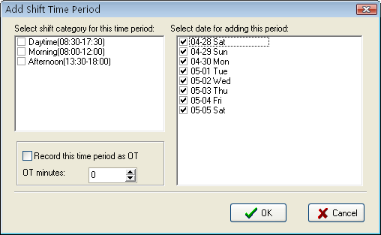
Choose a Time Period you want to add, click "OK" button to confirm, the Temporarily schedule will appear in the shift schedule list.
Before saving this Time Period, be allowed to choose this Time Period, press "" key to cancel it, Press "All Delete" to delete all Time Period, if this temporarily schedules you add have been saved, press "" button to cancel temporarily schedule.
Shift schedule regularly change
there shift schedule regularly change that exist in most company, how to arrange the shift schedule regularly change, To handle various Shift schedule regularly change is a software‘s strong function.
Here ,illustrate change shift method with four shifts three times change a week, example ,there are A, B, C, D four shifts, working hours schedule are divided into, morning shift, day shift, night shift, three Time Period, the application beginning date is 1.
As before instruction finish the operation, the following window appear
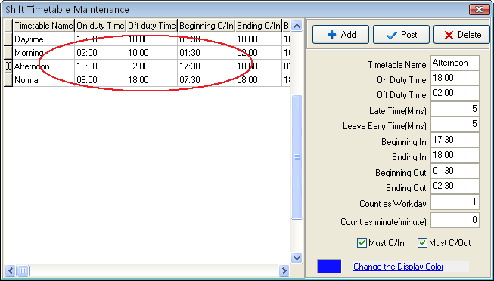
Staff working hours schedule list:
Date shift | Morning shift | Day shift | Night shift | Have rest
1 | A | B | C | D
2 | D | A | B | C
3 | C | D | A | B
4 | B | C | D | A
5 | A | B | C | D
6 | D | A | B | C
7 | C | D | A | B
From schedule list, the regular are fund, cycle of all staff work hour is four day. so, A, B, C, D four shifts' s four day working hours are divided into four shifts. Other shift follows the instruction.
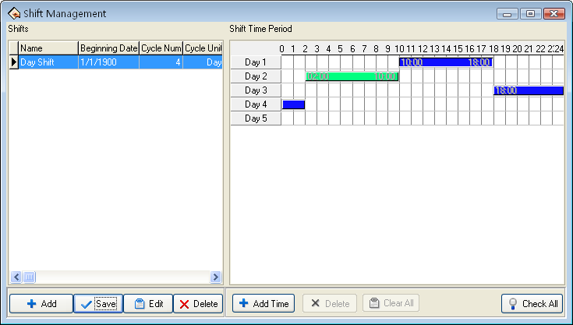
Beginning/Ending time: Refers to show all staffs schedule time which day start, and which day end Time Period in the below rolling region.

2.2.7 Holidays Maintenances
In the legal holiday, according to the related laws and regulations the staff will take the leave, the staff will be unable to Attendance for this period, in usually situation, if staff has not checked record, these staff will be regard as absent from work without an excuse by the system, moreover also the staff holiday working overtime will be unable to take effective in the computation, according to this kind of situation properly set management system. Choose the Holiday List under maintenance/Option menu, opens the Holiday List maintenance window
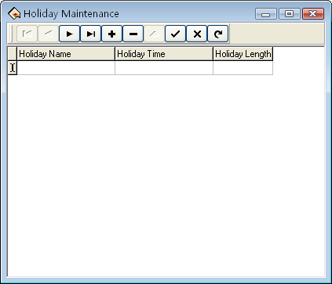
This interface is mainly divided into the Holiday List and tool column option of the Holiday List maintenance. May add, delete, and modify the Holiday List through maintenance tool column.
Add: Left-click "" a blank which is used to add information appears in the holiday list module. Put the holiday name, the holiday time, and the total of holiday into the corresponding blank. Following figure
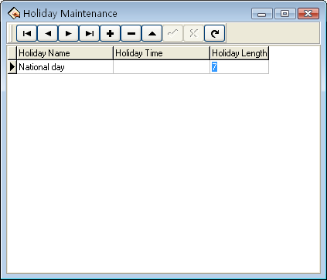
Note: when input holiday time, the format you input is 06- 05 - 01, after input, the default format 2006 - 05 – 01 by the system, must use English input method to input "-" this mark. Otherwise, the system prompts error.
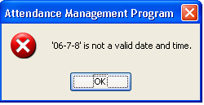
After correctly input the information that wants to be add, click "" button to save this information.
Delete: Click "" button to delete the holiday information which does not need to use.
Revision: When need to adjust to the holiday time which has been added, may click "", to revise holiday information. Then click "" to save the information which has been revised.
After adding the holiday, while assign staff shift, the system cannot schedule these Time Periods .Because assign staff shift record does not exist, therefore, set holiday period, in the Time Attendance report form, the system cannot count this period of time the Time Attendance. If in holiday period had the staff to carry on the Time Attendance registration, counted in the Time Attendance report form for this staff freely working overtime

2.2.8 Leave Setting
It is possible that when staff encounters the serious problem and needs to ask for leave, cause the different reason, asking for leave can be automatic statistic in the system. This system provides with the leave kind of maintenance function, click "Leaving Class" in down-drag menu, following window pop up.
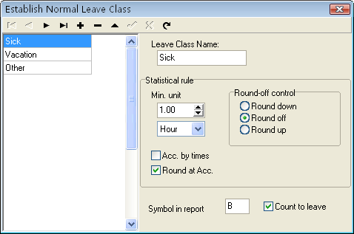
The system provides 3 kind of ordinary default leave: sick leave, leave, home leave, it is unable to delete and revise these 3 kinds of leave. If need more kind of leave, just click "" button to add the new common kind of leave.
Add: click "" button to add the new common kind. In the right side module May define a leaves name, statistical rule, as well as performance way of this leaves in the report and whether counts for asking for leave. After filling this blank, click "" to save above these the operation, if click "" button to abandon current operation.
While this process, the information which needs to add as follows:
Leave name: a name which takes for this kind of leave.
Statistical rule: the certain rule in the Time Attendance report for counting the leave.
The kind of leave statistics rule: Min-unit, round off control, accumulation by times, Round up after the accumulation, four kind of rules.
The min-unit is the smallest unit of measurement for leave. The common unit is the day, the hour, minute, there are several kind of units of measurement in the working day. Shown as following figure.
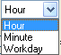
The round -off control refers to if the hour of the leaves is not integer in the attendance report while we calculate Time Attendance record , in order to get convenience in the computation of the Time Attendance statistics, provides with one computing mode. Round up, round off, Round down.
The computation by the number of times refers to this leaves statistics way in the Time Attendance report: The staff asks for leave in a period of time by the number of times which asking for leave takes the computing mode. If chooses this option, then the computation of the Time Attendance calculation does not comply with min-unit and the round control in the statistical rule. Shown as following figure
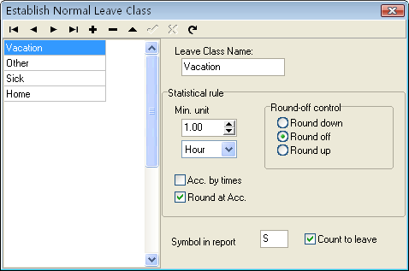
After accumulating, rounding off is to accumulate all time of this project and converts it into the corresponding statistical unit, then depending on the smallest unit to setup the method for rounding off. The identification sign in report is the symbolic representation way of this leaves appears in the report while print report.
Regard as asking for leave refers whether set this leaves for asks for leave. Attention, if put tick in this option, then the date of asking for leave which is newly added will statistic as the asking for leave in the this leave computation of Time Attendance report.
Deletion: Be allowed to delete a leaves. Selects a leave name which needs to be deleted, click "" button to be able to delete a leave which selects.
Revision: Revises a leaves. Selects a leave name which need to revises, click "" button to be able to revise the leave in the right side frame

2.2.9 Attendance Rule
All attendance computation of statistical comply with attendance rule,
1. Select Maintenance/Option menu, click "Attendance rules" option, and this window will pop:
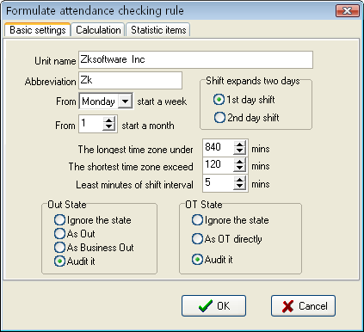
This interface consists of three pagination pages;
It is required to set the beginning day for each week or the beginning date for each month. Some companies calculate their attendance record from Sunday, and other from the 26th, after these setup, it is convenience for calculation to select time.
If a shift expires 0:00, it should be defined which workday this shift belong to.
How many minutes are the maximum shift Time Period no more than? How many minutes is the min shift Time Period no fewer than?
In order to determine attendance status, verify record correctly, grant smart schedule demanded, so that the valid attendance time is not litter a few minute. Otherwise the system will determine record as invalid
E.g. an interval of five minute, there is valid record at 8:10, so, among 8:10 between 8:15 records are invalid, it is valid record only after 8:15.
Out state: There are four methods to be selected to handle leaving status
★Ignore state: This status is ignored while attendance statistic to handle.
★As Out: This out status is signed Normal out.
★As Business Out: This status is sided on business out.
★Audit it: make verification for record by hand, examine staff whether go out.
Over time "OT" state: The over time consist of, counting over time, not counting over time, administrator allowing and count over time, three status
★Ignore the state: attendance statistic does not count over time；
★As OT directly: Over time does not need to be examined, count it directly:
★Audit it: make to verification for record by hand, in order to examine whether staffs have over time
Examine operation is sub-item which attendance exception require and record list other exception require.
2. Click Calculation pagination, account window appear, it is following:
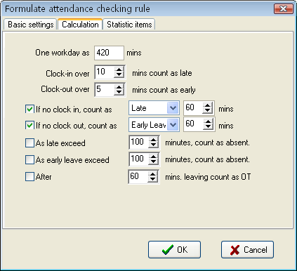
You need to set that the work hour account by minutes; this value should be the same with on-duty hour, because statistics result correct depends on this value.
In the step, how many minutes will be recorded as coming late after expire on-duty time, how many minute will be recorded as leaving early before near off-duty, the definition of time period must be the same with time period of the maintenance setup, otherwise the statistics result is Not correct.
For the clock-in record, how many minute means coming late of neglect work, for the clock-out record, how many minute means leaving early or neglect work.
If you’re coming late or leaving early is over to definite minutes, there will be regard as absent work
Can set overtime which are how many minutes it exceeds clock-off time, so this will be record overtime.
3. Click statistic item on the pagination, and following window will pop up.
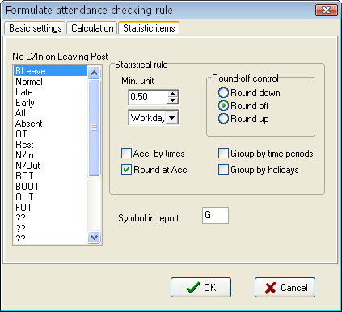
You can set statistical rules and symbols for staff leave on business, coming late and leaving early, etc, on the pagination label.
Freely over time: Over time work is not registered in schedule, staff attendance is regard as freely overtime.
Note: The system default setup only qualify with attendance situation which one day is divided into two Time Period, if one day is divided into more than three parts for attendance, please select all item and total them to ensure the accuracy of the calculation.
★Group by time periods: This item will define whether attendance record will be distributed into their corresponding shift Time Period. E.g., select all items that are without clock-in item and group them, then you will get the total of time without clock-in and clock-out item.
★Groups by holidays: only count the times, how many times are to display on the record list, No time record.
★After cumulate to round: select this item's all time to amount, which become into corresponding statistic unit, then according to min unit setting rule to round.
★Round up: when the statistic data have point, the system will make after point figure to carry upward as 1. For stance, the min unit is 1-work hours, so that the calculation result of 1.1and 1.9-work hour will be record 2-work hour.
★Round off: If the left value which after point figure excess 5, the value add 1, otherwise the left value is abandon
★Round Down: Abandon the value No matter how many it is.
E.g. min unit is 1 work hour, so that the calculation result’s 1.1and 1.9 count as 1 work hours

2.2.10 Database Option
The system adopts Microsoft ADO database interface, default single Access2000 database, filename is att2000.mdb, you can set up database link according with real situation.
When system appear following error prompt, you need modify you database link setup
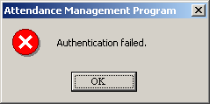
Connect Microsoft Access databases
Select sub-item "Maintenance/Option", click data option, the following window pop-up
1.）How to set Link Microsoft Access databases ,Select Microsoft Jet 4.0 OLE dB Provider；
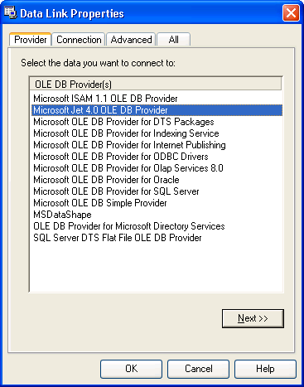
2) Click "Next" to enter next step, or create a link to enter following window.
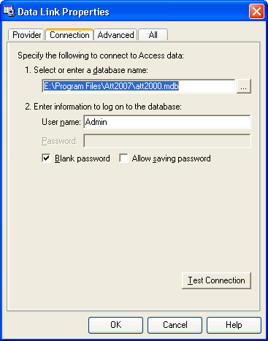
Click "" button, select database filename
A: For a single computer
Through the pop-up menu of File Manager, attach it in the attendance database file. The default file path is C:\ProgramFiles\Att2007\Att2000.mdb
Click test connection, if the prompt inform you the connection is successful, that means that the software have been create link between databases, shown as following figure:
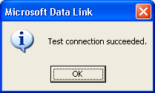
User may use the password to guarantee databases security, if you do not want to input password, please remove tick from "blank password", put the tick in the password input box, click "Confirm" to enter next, Shown as following figure
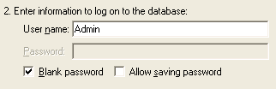
B: For a Network
For instance, three Time Attendance systems are linked together, with their computers labeled with Computer1, Computer2, Computer 3 respectively and Computer1 is the host. First, make the installation directory of the attendance system on Computer1 to share with other computer, and grant Computer2 and Computer3 to read-write and access Computer1 is available. The Database link on Computer1 is pointed to the local Time Attendance database, and database link on Computer2 and Computer3 is pointed to the database on Computer1. Thus the three machines are able to share data.
Link to SQL Server
If you want to use a network database, first you should establish the Fingerprint Attendance System database on the database server. In the installation directory of this Time Attendance system, you can find a file with the name of sqlserver.sql, which is the SQL script for establishing the Fingerprint Attendance System database on Microsoft SQL Server 7.0 . If you are using other database server, please refer to this document to establish the Fingerprint Attendance System database.
Provider Select Microsoft OLE DB Provider for SQL Server click "next" or "Connection" to enter the following window
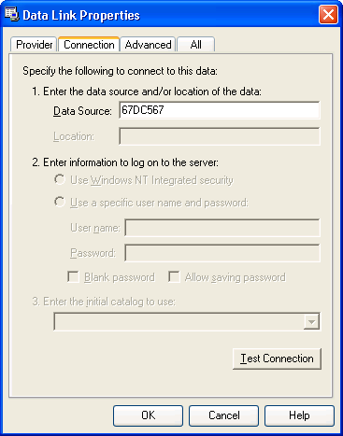
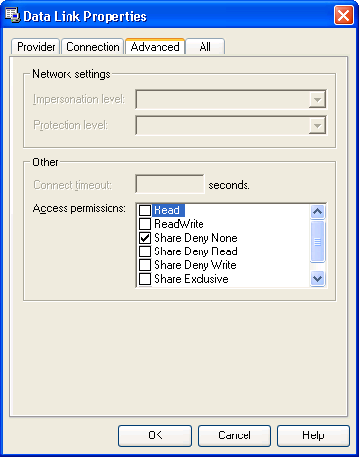
Defined Name of the server which store up the database severs information and database you login. Click button to complete setting

2.2.11 System Option
Set system auto-monitor, function configure, and mainly window display.
Normal
User can change the display mode and the style of some interfaces depending on his/her favor a. Only need to put tick in front of item.
Polling
provide administrator with convenience to view Time Attendance record or open the gate the condition in the first time. After the system connect with the device, when through the device the user verification is successful, its transaction will real-time transfer to software, and display in the demon region of the software main interface
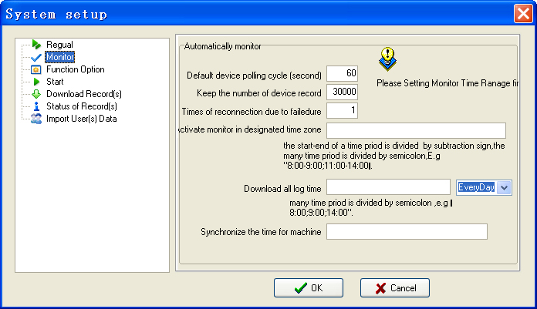
when program start up, activate the automonitor: Start up all device this program connect with, cyclically poll , if this option does not is selected, after starting this program, the device is unable to cyclically polling the automonitor.
Default the periodicity polling: while the device continually and cyclically the monitoring, because all sorts of reasons can cause some device disconnection temporarily , here be able to set a cyclical second number while the device cyclically auto- inquire (generally decide as 120).
Retention recording number in device: total of device record, refers to the user data record which each device download from, may input a general number to deposit record in here, after surpasses over the definite value, automatically clear user data record in device. For instance here set is 1200, when the recording number downloads to 1201, in the device user recording number will be able the automatic cleared, the number to be able to become 0.
Total of failure to connect: try connection again, the number of times (generally to decide as 3), in order to restores the normal; the device will automatically reconnect with in the situation.
Assigns monitoring Time Period: May define some the Time Period to start the monitoring. If the polling is uninterruptedly, then the entire monitoring network will bear very big load, so define a Time Period to begin using the monitoring, like this can reduce the load for the monitoring network. Attention writing format, for example: 06:00-22:00.
Images taken into machine
U will be preserved after the attendance photos downloaded to the software (download only the attendance by the photo, that is, after the U pass in a folder of all the photos). Attendance blacklist photos (bad folder of all the photos) can only be read after the U.
Import machine photographs: U session will be kept by the attendance through the photos, download software to view.
U-Data: delete U intraday attendance through the preservation of the photos.
Note: The software supports attendance cameras can use this feature.
Sync device: May define time to complete the computer synccronize up all devices which has been added. When this time arrived, the auto-synchronize the entire device those connect with the system, Attention writing format, for example: 10:00.
Function configuration
Time Attendance: The Time Attendance function is must select. USB Manage: it is option, under data menu, USB flash disk management is available.
Short message: Under the data menu, short message management is available.
Access Control: add the function of Access Control software, Time Period and group setting and so on, in this software, when machine mainly is used in Time Attendance field and it with Access Control the function, may use this function. After selecting this option, Access Control the management menu will appears in the software main interface, single-click "" to show the detailed menu of Access Control management. For detailed setting, please see also "Access Control Software Manual".
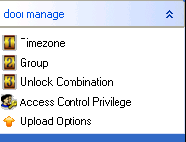
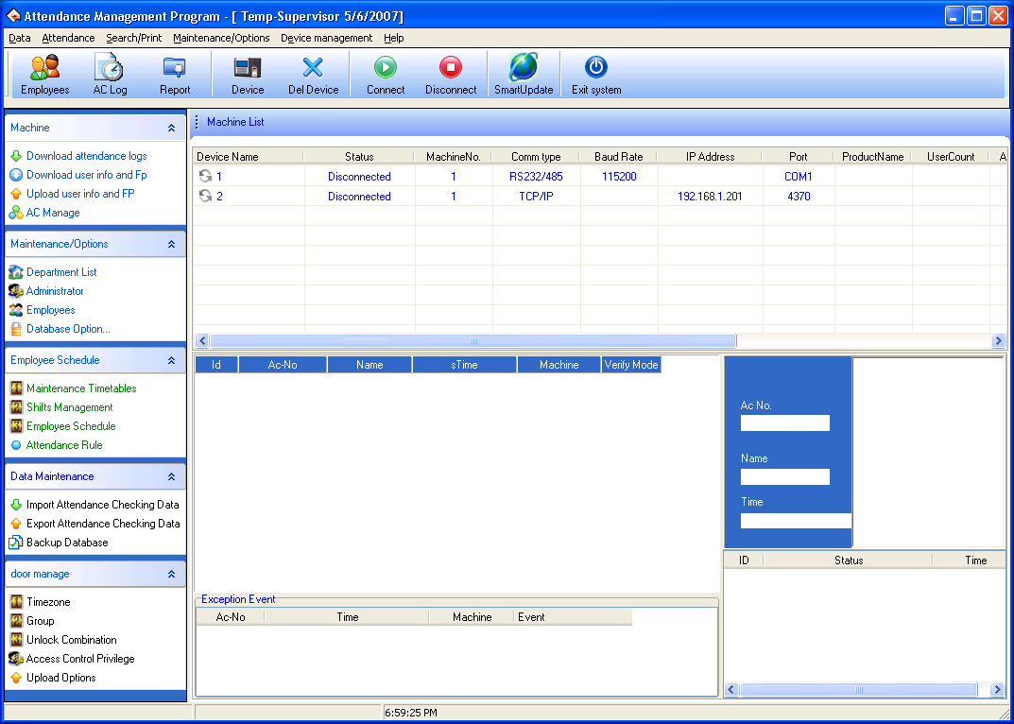
Write the card by the fingerprint machine: after this option is selected, able to write the card and eliminate the card button under the staff maintenance, after it connects with PC, the device is available.
Support 9 digital PIN: When software connects with the machine that support 9 digital codes, put tick in this option, then this software will support 9 digital codes.
Start option:
When start up window, starts up this program: put tick in front of the option, when next time windows will start this program will automatically will start up.
When start program, activate auto -monitor: Put a tick in the option, when next time windows will start this program will automatically will connect to device that has been added
Download Record:
Download all Record/Download new record: select any one option, when anyone item is selected, press here to download record.
Downloads the record the progress indicator strip appears: When downloads the data from the device the downloading progress indicator strip appear.
When downloading simultaneously save file: When chooses this item, download the record at the same time save the data record to file which has been assigned.
State of showing records show
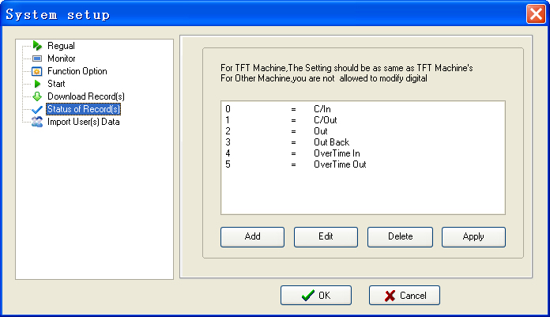
If the device connect with FTF screen machines, assign the meaning of state to the number of symbols, here the setting information must be same with the definition of TFT screen machine (that is the definition of the workcode), otherwise the confusion record arise ;
If the device is connected to other machines, do not allow changes to the the number before "=".
Import user data:
set some parameters for Import of user data.
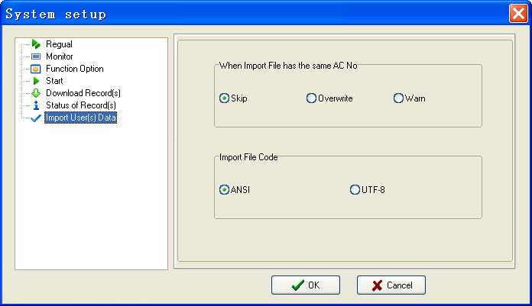
When there is a duplicate registration number, three choices of ways are available: 1) Skip, 2) coverage, 3) warned.
Import file coding: Set the encoding format to import user data files used by.

2.3 Handle Attendance

2.3.1 Employee Leaving on Business / Asking for Leave
When a staff business trip or ask for leave are unable to attend Normal attendance, in order to ensure end statistic result is correct, it is required that utilize the function to set. Click "Staff leaving on business/ asking for leave" command on menu, the window is following
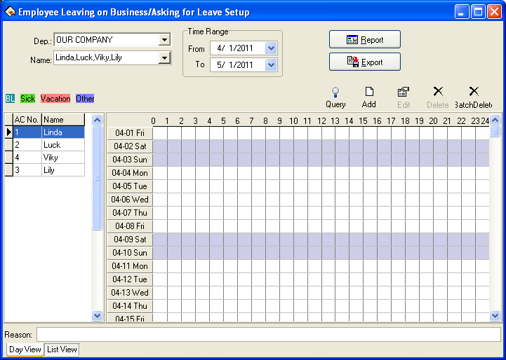
the option page of the staff business trip/asking for leave may be divided into two pages that is the daily view and list ,The situation of staff businesses trip/asking for leave is able to be set in the daily view page .
Department: through this drag–down box user can examine and to choose each department, the default department in the system is the main corporation.
Staff: through this drag-down box user can examine and choose the staff from each department, default staff by the system is "Completely". When view the lot of record, may set option for staff business trip staff/ ask for leave by a department.
Note: the staff is in "Completely" by default, be unable to add the staff business trip /asking for leave.
Employee list: The employees selected from the Employee option box are displayed in the employee list.
Leaves view: through the view all leaves name which exist this system will be shown. Double-click name of leaves, may choose the color to distinguish the leaves.
Beginning and ending time: Is same with the majority module in beginning and ending time, all is used to determine some Time Period, provide user with convenient to inquiry.
Production report: Determined beginning and ending time, click this button to produce the staff business trip /asking for leave data sheet which display by the report.

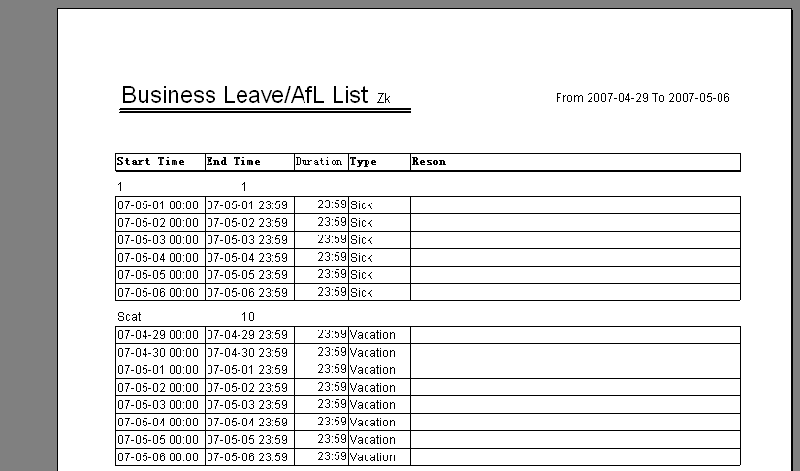
Export: Export the related record of all asking for leave in period of time into a folder by the text or the list, for detailed operation, please sees also 3.7 to export the data.
Inquiry: This inquiry way is to demonstrate the record of all staffs asking for leave by the list in period of time, this function link with "List" page label, when click this button, system will automatically jump to the page label, display the record of asking for leave by list. Shown as follow
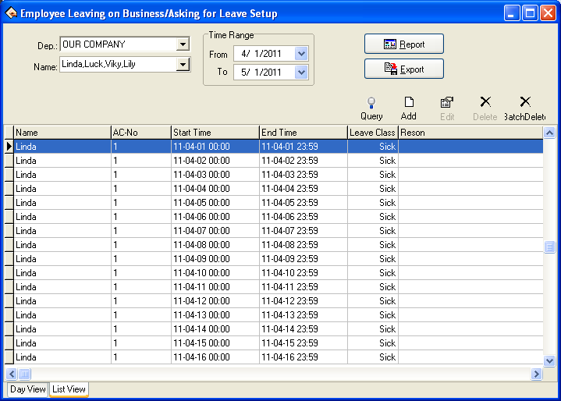
Add: Add a record of business trip/ asking for leaves for a staff, there are two methods to add leaving on business or asking leave
1) One way: After selecting departments, staff and date/time, left-click on the box of Select Set Asking-for-leave Time, and hold, drag to draw a time period bar, and then loosen the left button of the mouse, and the following dialog box of Select Leave Types will pop: B
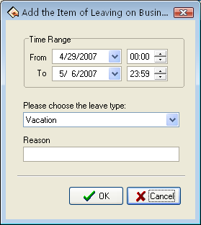
Choose asking for leave from the selected style box, type reason in the cause box, or not to do, click "OK" button to save adding leave, click "Cancel" button to cancel all action , after, the window is following.
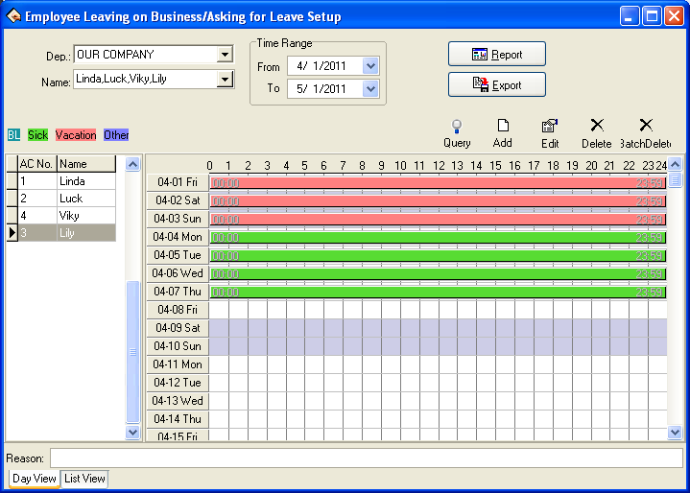
. 2) Another Way : select newly add from tools column, determine beginning and ending time, type correct time into time box, and reason in the cause box, click "OK" button to save modify, click "Cancel" button to abandon the operation, the pop-up window is following
Modify:You can modify one asking –for leave time period on the window, You may move the cursor of the mouse to one end of the asking-for-leave time bar, and when the cursor changes to "", right-click and hold, drag the mouse to modify asking-for-leave time.
You may also move the cursor to the asking-for-leave bar, and when the cursor changes to"", right-click, hold and drag to move the asking-for-leave time as a whole.
★If you want to modify accurate time, and when the cursor changes to, double-left-click or click "" button on the setup window. The following dialog box will appear.
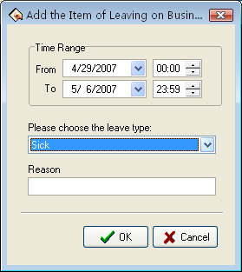
Choose the date, time, leave style, then type into asking leave reason, click "OK" button to save setup , click "Cancel" button to cancel the action. After saving, the window appears as before way
Delete: If you want to cancel one item setup, e.g. just Click"" asking-for-leave will be canceled, Shown as following figure
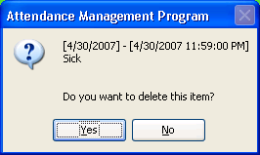
Click "Yes" key to cancel the setup, click "No" key to abandon the action.
you can left-click on the "Asking-for-leave" bar, which wants to cancel, then click "Del" key to cancel. Or you can drag mouse cursor to end of asking-for-leave time, when cursor become "", left-click, hold and drag mouse till all asking-for-leave time bars disappear, by the time the caution box will appear, You may select any asking for leave utilize cancel setup to left-click "Cancel" button on the setup window, after click, the following prompt box appear;
Batch deletion: Delete the leave records of employees in batches. Click this button, and the system displays a dialog box about the time range of batch deletion. Select a time range for batch deletion, and click OK.

When you add leaving on business time period, and if this time period overlap exited time period, the following caution box will appear
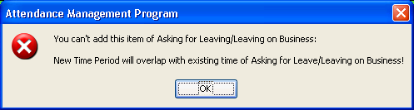
Click "Yes" key, the operation is invalid.
After click "Confirmed", the added asking for leave/ business trip is invalid currently. After you add the record of business trip/asking for leave successfully, then the shift detailed situation will belong to the exceptional case in the Time Attendance report, the situation of business trip /asking for leave will display in other unusual situations, default business trip/asking for leave take effective, system can directly compute the Time Attendance record , be allowed to business trip and asking for leave in here the verification, verifies for invalid, then does not count in the report has verified for is invalid the time which business trip/asks for leave.

2.3.2 Handle Staff’s Forgetting to Clock In/Out
Handle Staff’s Forgetting to Clock In
If one staff forgets to check in due to some cause, this function of Handle Staff’s Forgetting to Clock In can be used to add a clock-in record. Click "Handle Staff’s Forgetting to Clock In" under the menu of Handle Time Attendance, and the following dialog box will pop-up
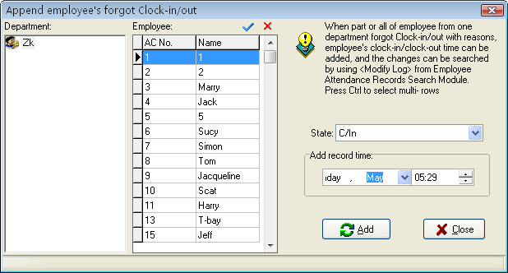
You first select department and staff, and choose the record style you add, Set record the date and time, click "Append" to add a new clock-in record
When a new record has been added, the "Add" button becomes gray and invalid. But it will become bright and valid again after the employee has been changed to another one, or the clock-out time has been changed.
Click the close button to close this dialog box and return to the main menu.
There are many select statuses of not only clock-in and clock-out, but also other option in select box, the window is following.
This module not only may individually add staff's time &attendance record, but also may choice all staff, also may carry on option, if must carry on option, only needed to hold down the "Ctrl" key to left click the key.
Single-click "Close" button to close dialog box, returns to the main menu.
The type of choice box is allowed to choose the condition that not only has clocking in and clocking out, but also includes other options, if had to operate other types only to need to choose the different type , other types step of operation and handle the staff forget checking the sequence of operation to be same, interface as follows:
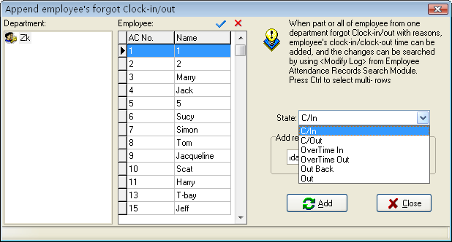
If need to handle all staff to forget clocking-in, click "" all choice button, shown as following figure:
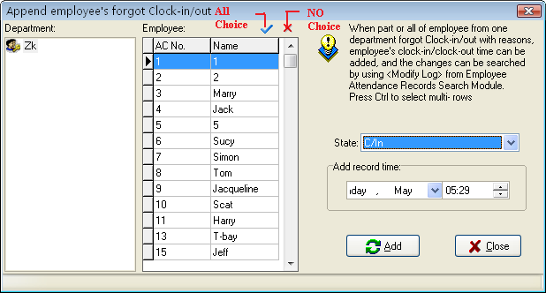
Press "No choice" button, the cursor to return to the previous condition click all choice with mouse. If there are lot of staff, this module has provided with the function to inquiry to the staff, the operating procedure is in the staff view directly input staff's register number, the name, the name Pinyin as well as the name Pinyin first letter, press the "Enter" key or left click "" with the mouse. If want to inquiry staff named Simon, with name Pinyin first letter method inquiry, shown as following figure:
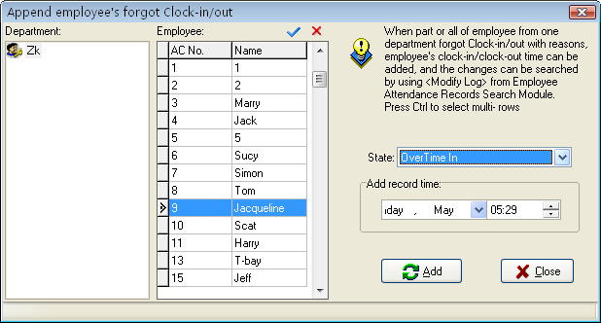
The goal which after press the enter key or the left key click on inquiry symbol "" appears must search.
Handle Staff’s Forgetting to Clock In
If one staff forgets to clock- out due to some special reasons, this function of handle staff forgetting to clock-out can be used to add a clock-out record, the operation process is the same with operation of to staff forgetting to clock-in. See up part.

2.3.3 Coming Late /Leaving Early Collectively
1. Coming late collectively
If part or all of the staff of one department come late, this function can be used to modify staff clock-in time, click "Coming late collectively" on the down drag menu, and the following dialog box will pop up:
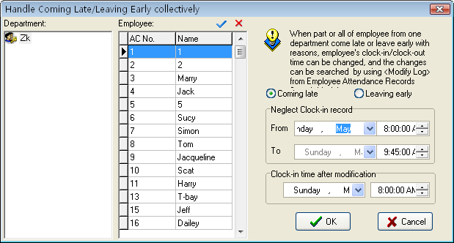
In the department option, select the department to which the staff who come late collectively belong and then click the staff of your choice in the staff option box, if you want to choose staff more than one, you can click the mouse while press "Ctrl" key. Click "All choice" buttons to select all staff, click "Cancel all" button to call off all selected staff.
Selected style consists of "Coming late collectively" and "Leaving early collectively", when you select, only lift-click on item you select.
Neglect clock-in record means to neglect selected staff all clock-in record during the time period is defined by the from time box and the to time box, clock-in time after modification means the time of the clock-in records to be adds in.
Click "OK" button to delete all neglect clock-in records or add clock-in record after modification, and to return the main menu.
Click "Cancel" to abandon this action and return main menu.
2. Leaving early collectively
If part or all of the staff of one department leaving early with reason , this function can be used to modify staff clock-out time, the operation process is the same with to handle coming late collectively , it is only to select leaving early collectively.

2.4 Search/ Print

2.4.1 Attendance Record
This module is used to inquiry all staff attendance record which is download from the device, the computation of all attendance statistical base on this record.
Click "Search/Print" on the main menu, pop up menu is following Click "Attendance record" sub-item on the main window of "Search/print", and the following window will pop up
1. Search
1）only search attendance record
Department: Display all departments in this unit.
Staff: Display all staffs in this unit; through drag-down box choice needs to inquire sub-item.
Beginning and ending time: determine time scope that needs to inquire.
Inquiry: choose the department, staff, and determine the beginning date, the time, the ending date, time, single-click "Inquiry" button, the inquired result in lower part the window to show the staff's of your choice attendance record in period of time will display in result box in low side of windows.
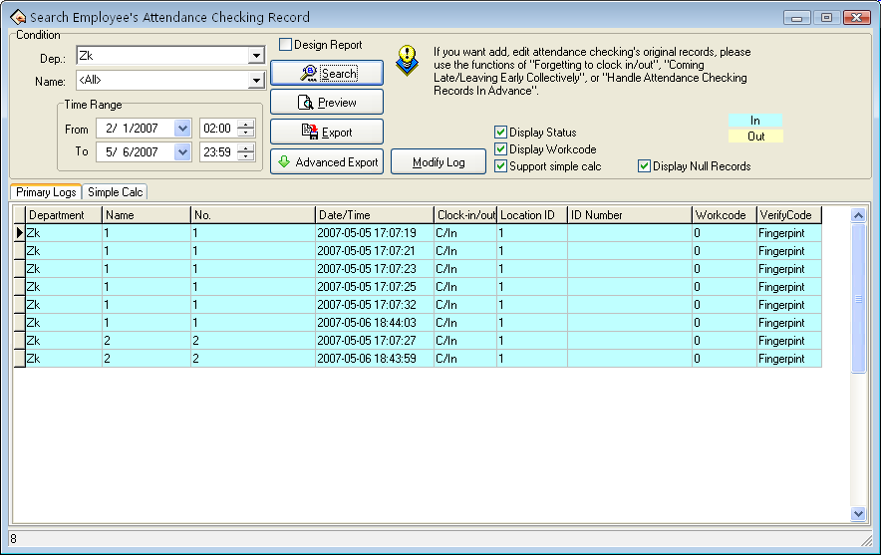
List has the department name, the register number, the serial number, the name, the date time, the machine number has six fields. The user also may choose the attendance statue, and the working code.
The display statue: The attendance statue will display in list . "Clock –in/out so on"
In order to distinguish the clocking in and clocking out, this module give clocking-in and clocking-out with the different displaying color
Note: When device does not have the condition key, then attendance condition completely display as clock-in.
If needs to revise the displaying colour for the clocking –in and the clocking out record , with the mouse single-click left -key on the colour code block, pop up choice box of the color, choose the properly color, save it .
Show working code: Display working code in this row.
Note: The work code is a symbol to differentiates the staff different classes of working, only the device has the work code function the machine (need to custom-made) only able to demonstrate the corresponding symbol.
Simple analysis historic record: After selecting a interface,be allowed to see that some software simply class process the original record in this interface ,completely show staff's record by the day
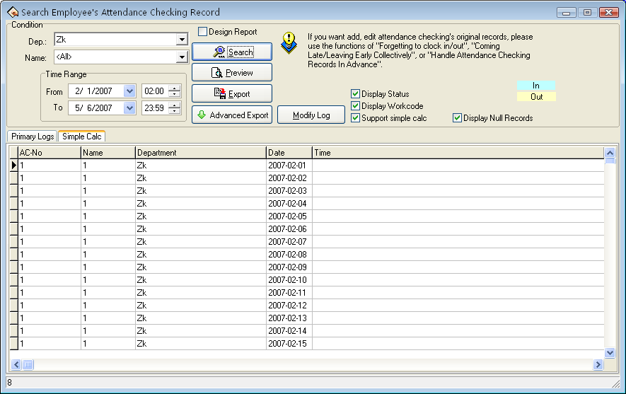
- Attendance for photo
If the software features is designed to support for attendance photos function, when search staff attendance checking records, employee’s the attendance photos is available to see at the same time in View the attendance records interface
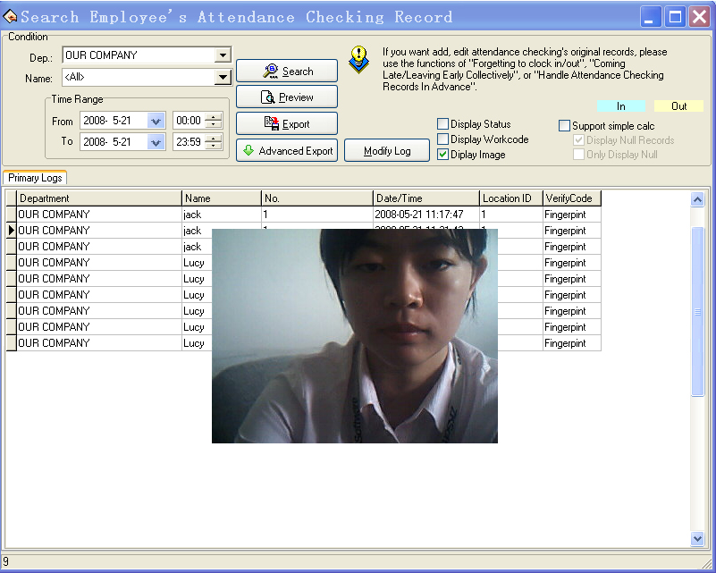
If the options Display Images is taken by tick in the Application List click on an attendance record, if there is a the corresponding attendance photos, the system will be displayed.
2. Preview and print
The module provide user with convenience to view the time &attendance report , print,save and so on . operation step as following
Click "View" button to view report in user’s favour, shown as following:
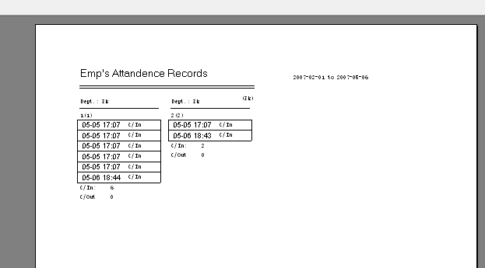
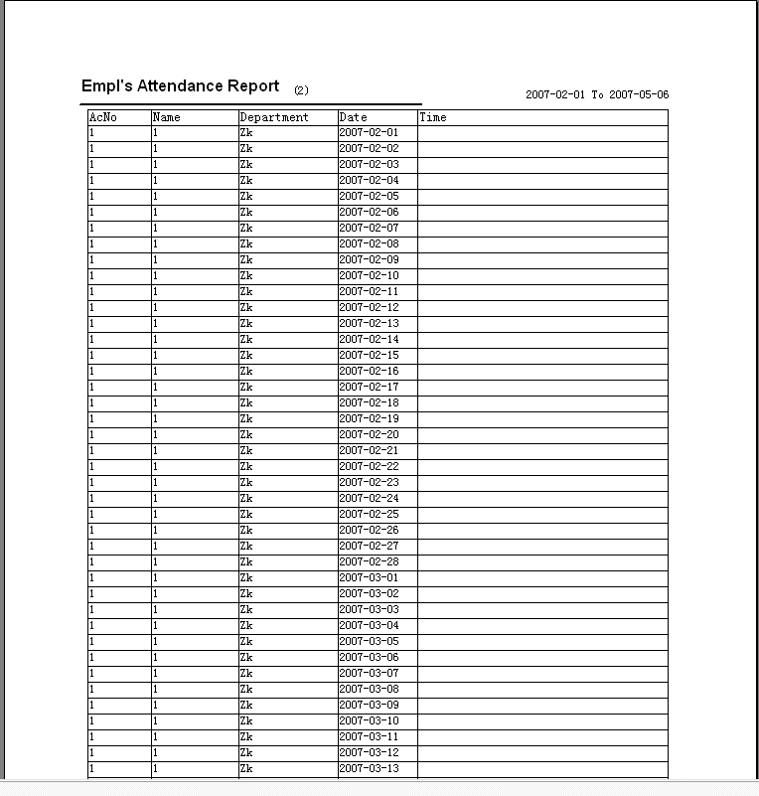
For printing report, only need to left click on the the "Printing" button in report left side.
3. Export
(please refer to appendices 3.6 Export Data)
4. High-level exports
This function is equipped with exporting data that has the strictly requirement , here will be allowed to export attendance record depending on the user setting . For detailed operation please see appendix 6.1.8 high-level to export
5. Modify the diary log
If the use has revised the original Time Attendance record , the system provide a convenient way to inquiry the Time Attendance record which has been revised , and reverse the misoperation.
Click "Modify Log" button, enter "Record changing Logs" window, shown as following interface:
1) Inquire
The inquiry method and to inquiry the record of user’s attendance is similar. after choosing the department, the staff, determined the beginning date, the time, the ending date, the time, single-click "Inquiry" button, the inquired result in lower part the window to show the staff of your choice the modified attendance record in period of time will display in result box in low side of windows.
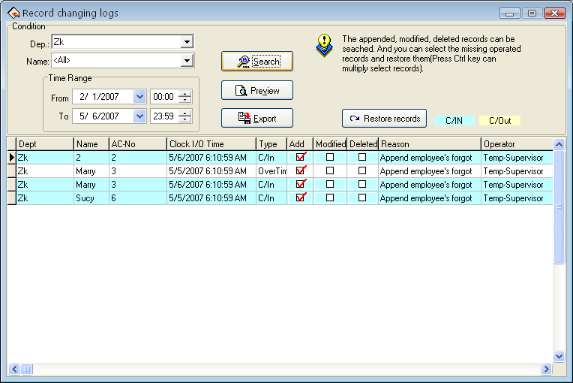
2) Preview:
the content of list to preview and print is available. Click "Preview" to view the report style, shown as following
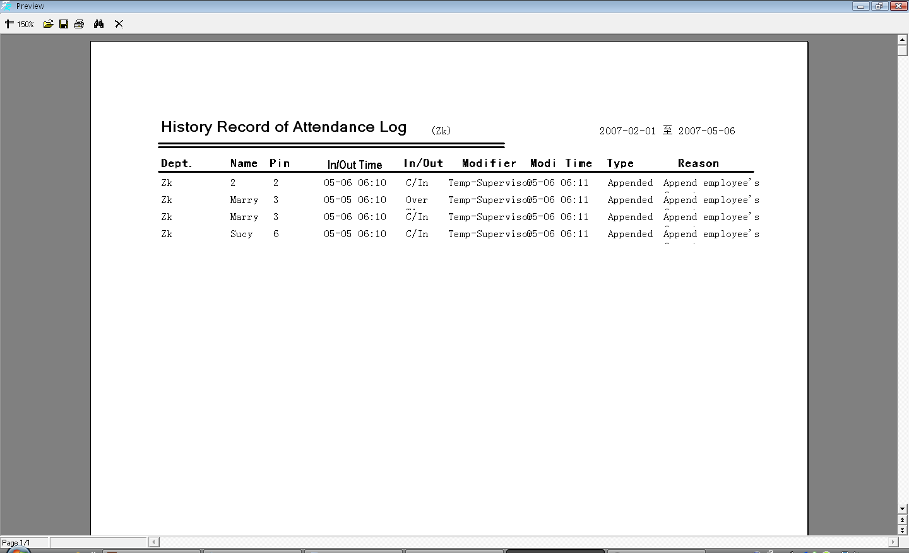
3) Export:
Single-click "Export" button, may search result to export file, the operating procedure and the attendance record to export are completely same.
4) Restore record:
Some times, as a result of the misoperation or the actual situation change, user has to abolish modified to the Time Attendance record, by now through function to restore record the to realize. Only select the record list which must be restored, single-click the restore record to completes, then inquire it again, may get this record of attendance

2.4.2 Attendance Exception Searching and Record List
In attendance management, we usually need to search exception situation and to print various attendance record.
Through the Attendance exception searching and record list, to modify attendance exception and record list is available, there are four operation windows which are attendance record exception situation, shift exception situation, other exception situation and attendance statistic .
Click exception search on the main window, or exception search sub-item under "Search/print" and the following window will appear
Select department firstly, choose the staff who is your choice, determine beginning/ending time, click "Search" button to view the statistical record of time & attendance
A) View the department through drag-down box
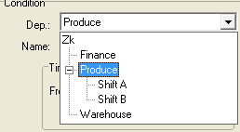
B) Select staff
there are two way to select staff, one way is to select staff through drag-down box, another way is to search staff by enrolling number, name, if you need to search a lot of staffs at same time, you can put tick in front of staff of your choice, click "Inquiry"
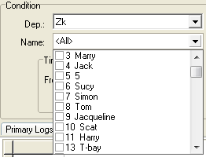
C) Determine the date scopes of your choice
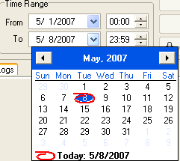
D) after selecting , click "Inquiry" , the record of attendance is available.
Shift Exception
The Shift Exception mainly view coming lately, leaves early, the absent no cause and the working overtime, working on/off hour and Clock-in/clock –out time, may relaxed carry on the computation of each month statistical, checkup and calculates whether has error. And handle staff business trip / forgetting the clocking out in this page setting, Shift Exception shown as following interface:
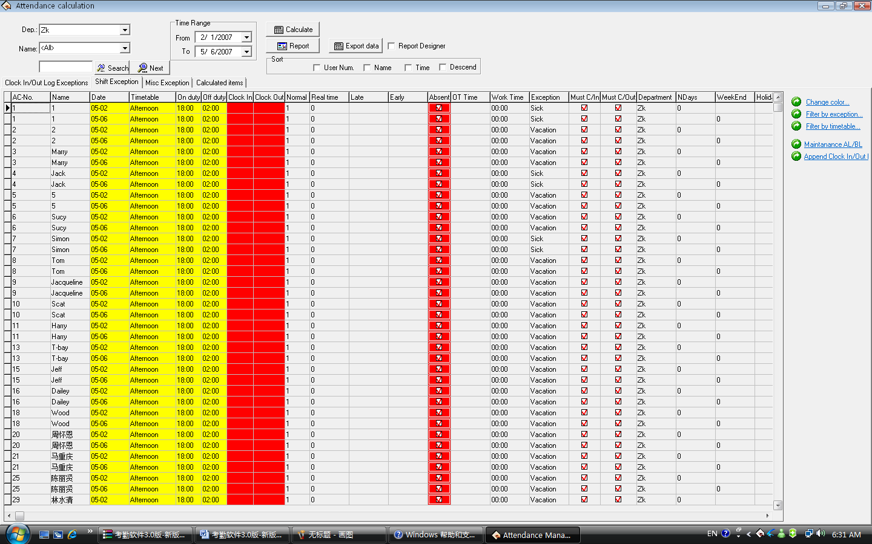
the defaults data in the shift exception list include the register number, name, date, corresponding Time Period, working hours, working off time, clocking in time, clocking out time, should arrive, coming lately time, leaves early time, whether absence no cause ,overtime, the running time, exceptional case, should the registration, be supposed to clocking out , department, working day, weekend, holiday, on duty time, working day overtime, weekend works overtime, holiday working overtime. If wants to display more, may right-click "Data row" item in the table, after choose other rows that need to be show , put tick in front of the row that will be cancel.
1) Item explanation
Corresponding Time period: The staff Clock-in/clocking-out time corresponds Time Period name.
Coming lately hour: the difference value between working hours and actual clocking –in time, if did not clock in, and the time when staff go to work without clocking-in record will be regard as coming x1 minute late in the Time&Attendance rule asking, its item will be able to corresponding display. If has set option in the Time Attendance rule, the coming lately time is bigger than a x2 minute time will be regarded as absence from work, when x2 is smaller than x1, coming lately time will not display, record it as absenting from work on cause; When x2 is bigger than x1, coming lately time correspondingly show the x1 minute.
Leaves early hour: the difference value between the working off hour and the clocking out time, if did not clock out, and the time when staff gets off work without clocking-out record in the Time Attendance rule , the record time will be regard as leave early x1 minute, then the leaving early time correspondingly display. If has set option in the Time Attendance rule, the leaving early time is bigger than a x2 minute time will be regarded as absence from work, when x2 is smaller than x1, leaving early will not display, record it as absenting from work on cause; When x2 is bigger than x1, the leaving early time correspondingly show the x1 minute.
Overtime: in the Time Attendance rule option, put a tick in front of item that clocking–out after getting off work xx minute will recorded as working overtime, then difference value between after getting off work xx minute to clock out time in clocking-out record and the working off hour record is the overtime. If the shift has a period of time to count as working overtime (in the shift schedule management while add shift Time period, just put a tick in front of this Time Period , and record it as working overtime), also setup has counted a working overtime minute; total of working overtime minute is the overtime.
Attendance time: the difference value between check in time and the check-out time
Work hour: the difference value between Work on work off, if there are coming lately or leaving early time, use the difference value to reduce the coming lately or leaving early time.
Exceptional case: Record exception; Sick leave, business trip and so on. For other item, please refer to item explanation about Time Attendance statistical table
2) Tool column;
Change indication color : In order to better distinguishes each kind of displaying statue, Be able to change various statues appearance.
Filter Exception: Single-click the here, the choice menu appears, which exception may be selected to demonstrate, which didn't display, Put the tick in the item which is selected.
Filter Time Period: Single-click the here, the choice menu appears, may choose the Time Period will display, which Time Period is in exception, when there is tick "" in front of the Time Period name , that the express this Time Period is selected, and in exception
Asking for leaves /business trip option: the operations of Asking for leave/Business Trip are same with to handle Time Attendance.
Statistical result detailed list
The page of statistical result detailed list mainly is to examine original record statue which download from the equipment and revise to the Time Attendance record states.
1) View the Time Attendance record
After inquiring and computation, chooses the statistical result detailed situation, Shown as the following figure:
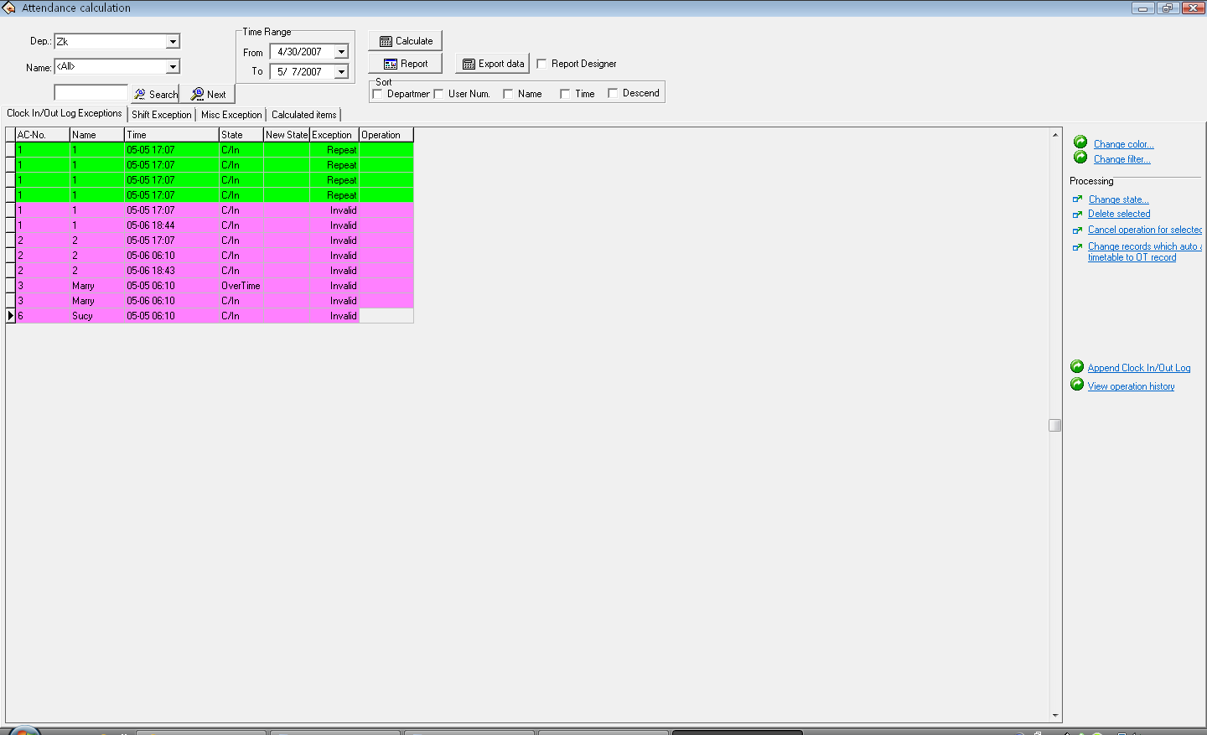
In the statistical result detailed list the default data row includes the name, the register number, Attendance time, the working statue, the correction statue, the exception and operates 7 items, if wants to display more, may right- click "Data row" the item in the list, put a tick in front of the row that needs to be demonstrated . Shown as following figure:
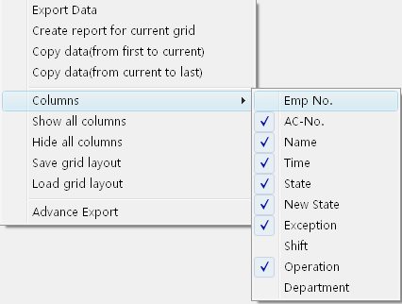
After change the setting of data row displaying, save the data row setting, later directly write down the data row setting is available.
Staff serial number "EMP-No": in staff maintained option, every time add a staff, the system will assign a number to the staff.
Register number "AC-No": number which manager assigns to the staff.
Checking time "Time": The staff clock in or clock out by fingerprint the time.
Checking Status "State": there are six kinds of status: check-in, check-out, overtime check-in, the working overtime check-out, business trip, Business returns.
Note: If the device has the status option, the checking status will show corresponding statue in the Time Attendance record; If the device does not have the statue option, all show as "checking-in" in attendance this row, the system depend on the Time Period setting in management program to judge the Time Attendance statue, display in the correction status.
Correction Statue: When the Time Attendance machine has option setting, this rank is in empty; Otherwise, in the correction statue system depend on the assigned staff the shift Time Period and the fingerprint verification time to judge whether the staff is in checking-in, checking-out, the overtime -in or the overtime out, system computation of the statistics by this status.
Exception: there are 8 kinds of situations: The normal record, the invalid record, the duplicate record, the statue is wrong, free working overtime, working overtime, business trip, the auto-assign staff shift.
Invalid record: the clocking-in, clocking-out beyond shift Time Period the time scope the record completely regard as invalid. The invalid record will be regarded as this record does not exist; during Time Attendance statistician it will not to be count.
Repetition of record: when the Time Period of the Time Attendance record is smaller than the effective interval of "Time Attendance rule", the record regard as repetition of record.
Free overtime: The staff has checking-in/out record within the Time Period which has not been assigned to staff, and maintains this staff's Time Attendance setting page in the staff "to count working overtime" the item to select.
Overtime: there is a statue setting in the device, the Time Attendance record the attendance statue as the overtime-in, the overtime -out, the demonstration is working overtime in the abnormal state column.
Business trip: there is a statue setting in the device, the Time Attendance record the attendance statue as business trip, the demonstration is approval absence in the abnormal state column.
Auto-assign staff shift: Staff's checking–in/out record does not exist in the Time Period that has been normally assigned to the staff, but the record is in the staff auto-assigned the Time Period, then this record show as auto-assign abnormal state column.
Corresponding Time period: Is one kind of sign in the software interior (do not display it, has nothing to do with user operation)
Operation: show the operation for record of your choice.
Department: The staff is at department.
2) Revises the Time Attendance record
Choose the corresponding operation to revise the Time Attendance record with tool column in the right side page.
Tool column: change color: May change each kind of condition that express color, single-click the here the following interface appear
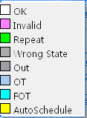
Single-click colorblock in front of each kind of condition, may choose the color which you needs in this interface, after selecting, Be sure to single-click "OK" button to save.
change filters condition: definite that status record in displaying box, click "Change filter" the following window will appear:
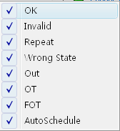
Make a check it to show it selected status, appear on the display box, utilize clicking "√ " to switch status between selected and unselected.
Modify it as new status: able to make a present status of selected record to become a select status, after selected a record, click "Change state" the window is following:
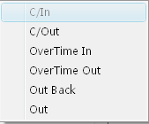
Because Attendance statue all is checking –in record, therefore this statue is impossible to use, may single-click other statue to select. Deletes this Time Attendance record: May sign the attendance record of you choice as deletion condition, after using this function, in the tool column can add two items:
Applies all the setting operation, After selected this item, all setting operation which display in operation column is valid before this,
Cancel all setup operation "Cancel all" : after select this item, all setting operation is invalid before this, all operation will disappear in operation column.
Cancel current record operation "Cancel operation for selected" : Only cancel current record operation.
Make all smart schedule record to become over time "change records which auto assigned timetable to OT record": Make system smart schedule record to overtime.
Handle forgetting check-in or clock-out "Append Clock in/Out Log": The process is the same as attendance handling operation.
Search modification record log clock-in operation history": The process is the same as sub -item of search/print attendance record operation. Right key menu:
Under the inquiring record window, right-click the sub-item the following menu appear
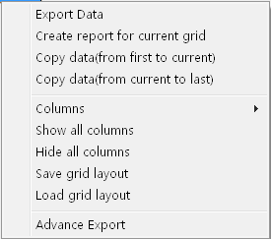
Export data: is same with "Export data" button function in the interface, for detail please see exporting data
Create report current grid: Is same as "Preview record list" to establish current data record list function, make searched attendance record as record list to export. Able to list prints to export, save, and search for in list, etc. operation
Copy Data (from beginning to current position): Searched record result copy directly, form duplicating to current position, and can patch in Excel list directly
Copy Data (from beginning to ending): searched record result copy from current copying position to ending, and can patch to Excel list directly.
Column "Data row": select item name on the searching window appearing, click pop up menu is following
Show all Column: All item name of data row display on search window
Hide all column : All item name of data row except surname and name hide on the search window, only show surname and name
Save grid layout: item name on which the search window appear can be saved, load data row setting to use.
Load grid layout: According to store data row to show item, Click "Preview". Following window appear
Other Exception
Other exception mainly is used to verify and appraise staff hour of overtime and business trip, default leave, sick leave, home leave are effective; overtime, free overtime, business trip, approval absence, are invalid by default, it need a calmer appraisal of whether effectively, writes down in the statistical report. Other exception interfaces show as follow:
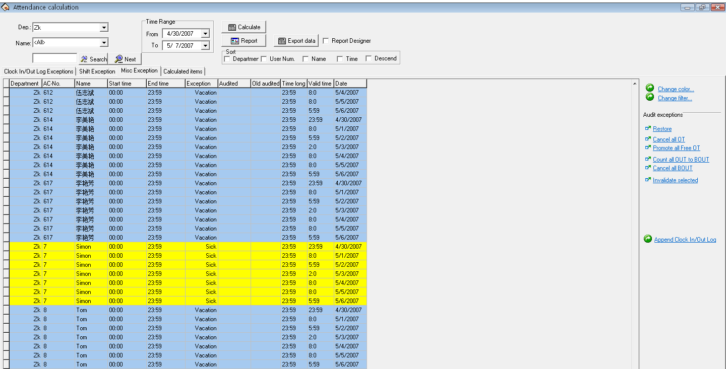
In other exception list , the default data include department, name, enroll number, start time, end time, exception, verified statue, the statue before verifies, total hours, effective hour, Time Attendance date, assignment staff shift, working day. If you want to show much more item, just right-click "Data row" item of your choice, if you want to show anther row, put a tick in front of the row you have selected.
Start time: start time for abnormal statue.
End time: end time for abnormal statue.
Exception: there are 8 kinds of statue: free overtime work, overtime work, business trip, approval absence, sick leave, leave, home leave.
Verified statue: After the verification, show that overtime work or is in invalid statue.
Before verifies statue: Verification statue.
Total hours: The difference value between end time and start time.
Assigned shift work day: The exception situation across the working day which has assigned shift.
Tool column:
If the Time Attendance rule limit the business trip and the overtime work statue must through verification, then verified statue column is empty, if has regulated the statue of verification, the corresponding statue column will appear in the verified column.
Returns to original state before the verification column: this operation does not take effective unless the record has been verified, return record statue to initial verification state. After the return to original status, be sure to re-inquire and compute.
All overtime work is invalid: Exception list shown that the overtime work record all regard as invalid record.
All free overtime work effective: The system regard personnel's ,who has not assigned to Time Period ,Time Attendance record (who must own clocking-in/clocking-out record simultaneously) as free overtime work , if this item in choice, systems judge all free overtime work will be showed as overtime work.
Save the verified record: make the confirmation to the verification which has carried on, change the statue of the record which will be verified to the statue which has already verified. After saving, be sure to re-inquire and compute.
Cancels this verification: Do not confirm the verification which you have already done, the statue which will be verified record save as the initial statue.
Record all egress record as business trip: staff all egress record regard as business.
Cancel all business trips: All the business trip record will be canceled, this record will be generally egresses or according to the actual situation handle it.
Set this record invalid: change the record statue of your choice to be invalid.
The displaying window for inquiring record: right-click to be possible to operate. Is same with the statistical result detailed page.
Time Attendance Statistic
The Time Attendance page is a page to which commonly used, count all item in the staff assigned time to produce report , is easy to examine and the settlement.
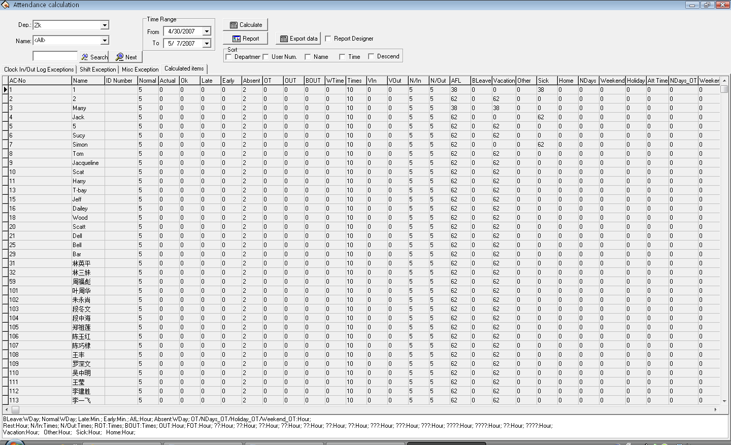
In the Time Attendance statistic table the default data include name, ID card number, enrolling number, should arrive, coming lately, leaves early, absence without an excuse, overtime work, no checking-in, no checking-out, egresses, business trip, hours of work, should sign the number of times, clock-in, clock out, business trip, sick leave, leave, home leave. If you want to show much more, may right click on "Data row" the option in the table, show other rows of your choice, there is a tick in front of the row.
Should arrive: Depending on the staff shift, count the staff’s working day which should go to work between the start and end time. The defaults unit is the working day, may change the statistical rule in the "Normal" of the Time Attendance rule calculation page
Actual arrive: According to The Clocking in/Clocking -out record , statistic the staff working day which actually goes to work between the start and end time. The Defaults unit is the working day, able to change the statistical rule in the "Normal" of the Time Attendance rule calculation page
Normal: According to The Clocking in/Clocking -out record , statistic the staff working day which actually goes to work between the start and end time. The Defaults unit is the working day, able to change the statistical rule in the "Normal" of the Time Attendance rule calculation page
Coming lately:
1) according to the "Coming lately "statistical rule in the Time Attendance rule in and the shift manages to record is late x time which in the time establishes to calculate, after namely if staff's registration time surpasses x time to record for is late, is late when the length is the registration time with the work hours bad value;
2) non- registration recording, according to Time Attendance in the rule Time Attendance computation to go to work, the non-registration recording time mark to be late xx minute; Result which obtains in the beginning and end time all situations statistics. The default unit is the minute, able to change the statistical rule the Time Attendance rule computation project page "Late".
Leaves early:
1) According to the statistical rule in the Time Attendance "leaves early" rule and the time setting in the Shift management record the leaves early time , after namely if staff's clock-out advance x hours to record as leaves early, hours of leaves early is difference value between the Clock-out time and the work off time;
2) if there is not the clocking-out record, according to the Time Attendance rule, in the computation of attendance statistical, when staff get off work without the clocking-out record the time regard as leave early xx minute;
Obtain result from all situations to statistic among the start and end time. The default unit is the minute, able to change it under the "Leaves early" statistical rule in the computation of Time Attendance rule page.
Absence without an excuse:
1) According to "Absence without an excuse" statistical rule under Time Attendance rule, if staff does not have the checking-in/out record, who’s attendance record regard as absence without an excuse;
2) According to the Time Attendance rule, in the computation of Time Attendance time , hours of late is bigger than xx minute, staff record as absence without an excuse, hours of leaves early is bigger than xx minute, staff - record as absence without an excuse .
Obtain result from all statistical situations between the start and end time.
The default unit is the working day, can not change it.
Overtime Work:
1) According to the "working overtime" statistical rule of Time Attendance rule, as well as the computation of the Time Attendance rule, staff gets off work after x minute, whose work is recorded as overtime work, obtain hours of overtime from the accumulation;
2) In the Shift management there is a Time Period which directly to be recorded as the overtime work, idea the minutes of overtime work is the hours of overtime;
3) According to the option situation in the Time Attendance setting/maintenance, the staff’s work record as overtime work, in other exception situation list the overtime work and the free overtime is verified as effective work to statistic; obtains two results among the start and end time all accumulation situations. The default unit is the hour, able to make a change under the "Overtime work" statistical rule in the computation of Time Attendance rule page.
Egresses: According to "Egress" the statistical rule in the Time Attendance rule, as well as the approval absence is effective in other exception situation list; carry on the computation of the statistics.
Obtain result from all statistical situations in the start and end time. The default unit is the hour, able to change it under the "Egress" statistical rule in the computation of Time Attendance rule page.
Business Trip: According to "Business trip" the statistical rule of it he Time Attendance rule, as well as the approval absence is effective in other exception situation list; carry on the computation of the statistics.
Obtain result from all statistical situations in the start and end time. The default unit is the hour, able to change it under the "Business Trip" statistical rule in the computation of Time Attendance rule page
Hours of work: the computation of attendance depends on the time of staff clocking –in/out. Obtains the result from completely accumulation between the start and end time.
Should checking-in times: According to the Time Period, total of the Clocking-in/out times between the start and end time.
Check-in: actual checking-in times between start and end time.
Check-out: actual checking out times between the start and end time.
No clock-in: between start and end time no clocking-in times.
No clock-out: between start and end time no clocking-out times.
Asking for leave: accumulate all kinds of vacation total sum, so obtain the result. The default unit is the hour, able to change it under the "Asking for leave" statistical rule in the computation of Time Attendance rule page.
Approval Absence: According to "Approval absence" statistical rule in the Time Attendance rule, as well as the approval absence take effective in other exception situation list, carry on the computation of the statistics.. Obtain result from all statistical situations between the start and end time. The default unit is the working day, able to change it under the "Approval absence" statistical rule in the computation of Time Attendance rule page.
Sick leave: According to the sick leave statistical rule under kind of vacation setting, as well as the sick leave take effective in other exception situation list by verification, carry on the computation of the statistics. Obtain result all from statistical situations between the start and end time, the default unit is the hour, be able to changes the "Sick leave" statistical rule under leaves setting.
Leave: According to the leave statistical rule under leaves setting, as well as for the leave is effective in other exception situation list to by the leave verification, carry on the computation of the statistics. Obtains Result from all situations statistical between the start and end time. The default unit is the hour, be able to changes the "leave" statistical rule under leaves setting.
Home leave: According to the leave statistical rule under leaves setting, as well as for the leave is effective in other exception situation list to by the leave verification, carry on the computation of the statistics. Which obtains Result from all situations statistical between the start and end time. the default unit is the hour, be able to changes the "home leave" statistical rule under leaves setting..
Workday: depending on the clocking-in/out record, statistic staffs’ actually work day from Monday to Friday beyond holiday between the start time and end time, the default unit is working day, ability to make a change under "Normal" statistical rule in the Time Attendance statistical rule page
Weekend: Depending on clocking-in/clocking-out record, statistical staffs actually from Saturday to Sunday beyond holiday between start and end time; the default unit is working day, ability to make a change under "Normal" statistical rule in the Time Attendance statistical rule page
Holidays: The holiday in which day staff actually takes work, the default unit is working day, ability to make a change under "Normal" statistical rule in the Time Attendance statistical rule page.
Working Hours: Depending on clocking-in/clocking-out record, total of staff’s hours of on duty between the start and end time, the default unit is hours, accurate figure inhere after point two digital
Overtime work: Depending on the "overtime work" statistical rule in the Time Attendance rule, as well as the overtime and free overtime is effective in other exception situation list; carry on the computation of the statistical working hours from Monday to Friday beyond holidays between the start time and end time.
Obtain result from all statistical situations in the start and end time. The default unit is the hour, able to change it under the "Overtime Work" statistical rule in the computation of Time Attendance rule page
Weekend overtime work: Depending on the "overtime work" statistical rule in the Time Attendance rule, as well as the overtime and free overtime take effective in other exception situation list; carry on the computation of the statistical working hours from Saturday to Sunday beyond holidays between the start time and end time.
Obtain result from all statistical situations in the start and end time. The default unit is the hour, able to change it under the "Overtime Work" statistical rule in the computation of Time Attendance rule page
Holiday Overtime: Depending on the "Overtime work" statistical rule in the Time Attendance rule, as well as the overtime and free overtime is effective in other exception situation list; carry on the computation of the statistical working hours in holidays between the start time and end time.
Obtain result from all statistical situations in the start and end time. The default unit is the hour, able to change it under the "Overtime Work" statistical rule in the computation of Time Attendance rule page
Preview report
Not only search and modify these Attendance Records in Clock –in/out log exception List, but also able to preview and print these Attendance records, these following list include, Daily Attendance statistical report, Attendance General report, Department Attendance Statistical Report, Staff’s on-duty/off-duty Timetable, Daily Attendance shift, Create current report for grid, click "Record list preview" button, pop up following menu:
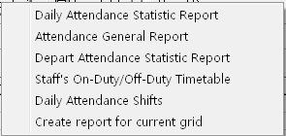
Daily Attendance statistical report:
Daily Attendance statistical report is used to list the definite staff daily attendance status in assigned period of time in the table, and the statistics absence without excuse, coming lately /leaves early, working overtime, asking for leave, business trip, convenience of the checking whether has the discrepancy with the actual situation.
Note: In the table it is only can show detailed attendance status from the inquiry time from the month time, the report form may count in the start and end time situation which the user chooses, the start and end time scope appear on the right cancer.
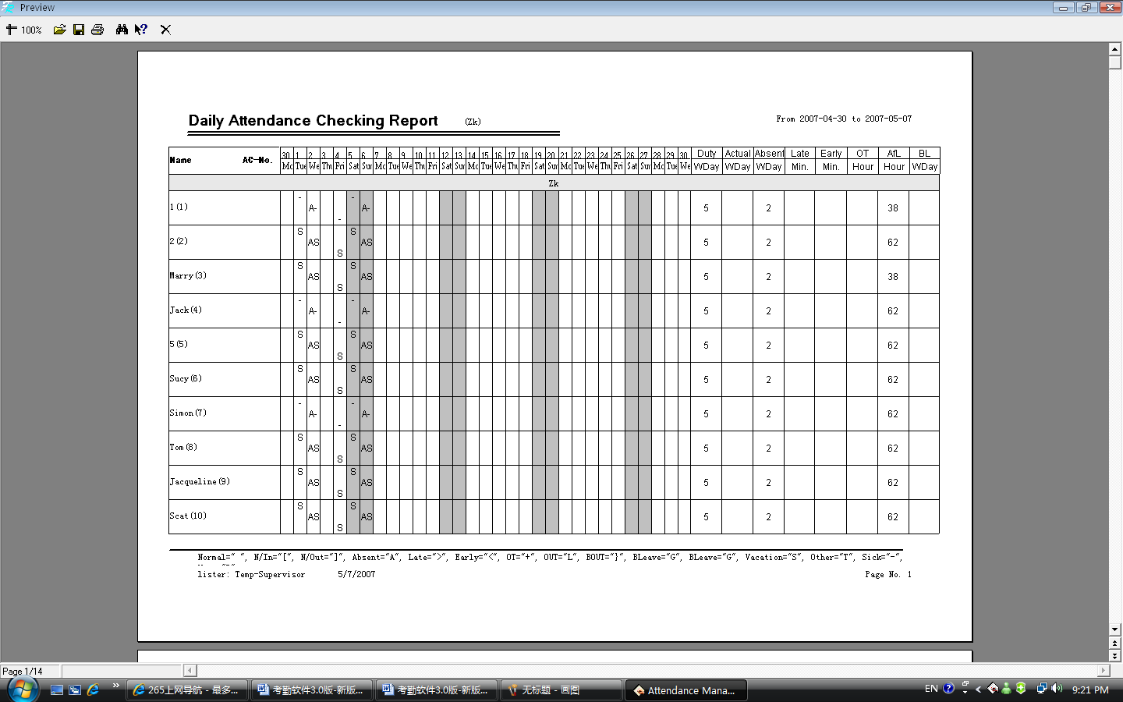
In the table all shifts Time Period which each person uses will be list, and illustrate attendance status in the corresponding time and shift with the mark, for mark explain, and please see at the end of each page (In identification mark setting in Time Attendance computation rule).
Should arrive "Working day": the working day of the staff should arrive in the assigned time. The working day is the unit of measurement "Recommend", able to make a change in the Time Attendance rule. According to result in Time Attendance statistical table, output this item.
Actually arrive "Working day": the working day of the staff actually arrive in the assigned time. The working day is the unit of measurement "Recommend", able to make a change in the Time Attendance rule. According to result in Time Attendance statistical table, output this item.
Absence without an excuse "Working day": the day of the staff in the assigned time, who is absence from work without an excuse. The working day is the unit of measurement "Recommend", able to make a change in the Time Attendance rule. According to result in Time Attendance statistical table, output this item.
Coming lately "Minute": Total hour of the staff in the assigned time come late. The minute is the unit of measurement "Recommend", able to make a change in the Time Attendance rule. According to result in Time Attendance statistical table, output this item.
Leaves early "Minute": Total hours of the staff in the assigned time leave early. The minute is the unit of measurement "Recommend", able to make a change in the Time Attendance rule. According to result in Time Attendance statistical table, output this item.
Working overtime "Hour": Total hours of the staff in the assigned time overtime work. The hour is the unit of measurement "Recommend" able to make a change in the Time Attendance rule. According to result in Time Attendance statistical table, output this item.
Ask for leave "Hour": Total hour of the staff in assigned time ask for leave. The hour is the unit of measurement "Recommend", able to make a change in the Time Attendance rule. According to result in Time Attendance statistical table, output this item.
Really until "Working day": The staff business trip in the assigned period time. The working day is the unit of measurement "Recommend", able to make a change in the Time Attendance rule. According to result in Time Attendance statistical table, output this item.
Report upper tool column
1) Zoom: choose the displaying proportion, preview report form.
2) Opens the report: click on here to open the report file which is saved before.
3) Save: save the current report to the directly of your choice.
4) Prints the report: Connect with the printer, prints the report form.
5) Searches the text: Click on the here pop-up the search text dialog box, input the text you look up , click "Confirm", the cursor will locate to the text which you search.

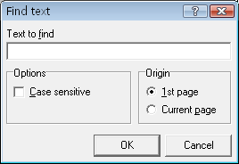
6) Closes preview
2nd: Attendance General Report
Attendance General Report "The sum total of the Time Attendance statistical result table" is used to show the definite staff attendance statistical status in the assigned time, carry on the sum computation of staff attendance status, convenience of paying wages depending on the Time Attendance situation.
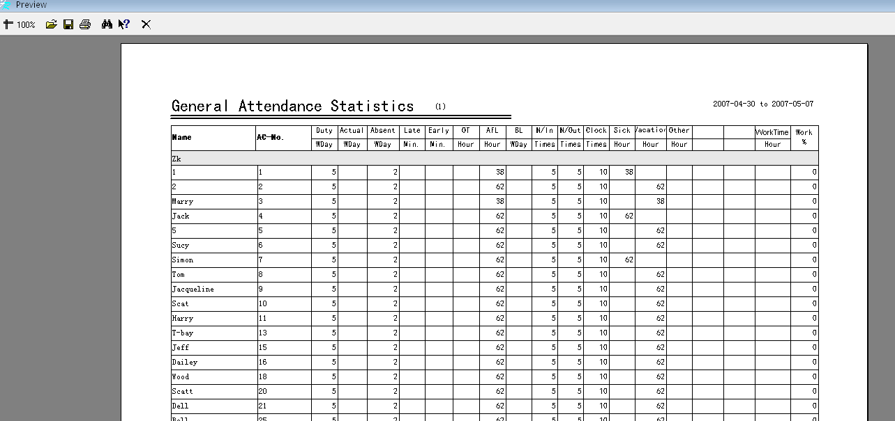
the computation of should arrive, arrive , absence without an excuse, come late, leaves early, working overtime, asks for leave, business trip, the sick leave, leave, home leave same with daily calculating in the Time Attendance statistical table.
Working hours: Depending on daily staff clock-in/out time. Count the staff working hours Obtains result from all accumulation between the start and end time
Attendance rate: divide the staff actually goes out on duty the number of times by staff should go out on duty the number of times. Above the report tool column is same with the Time Attendance daily statistical table.
3rd, Department Attendance Statistical Report
Department Attendance Statistical Report "The sum total of the Department Time Attendance statistical result table" take the department as the unit, sum total of all staffs in the assigned department and period of time attendance status , may know the sum attendance of department ,facilitates reduces the scope, carries on the detail inquiry.
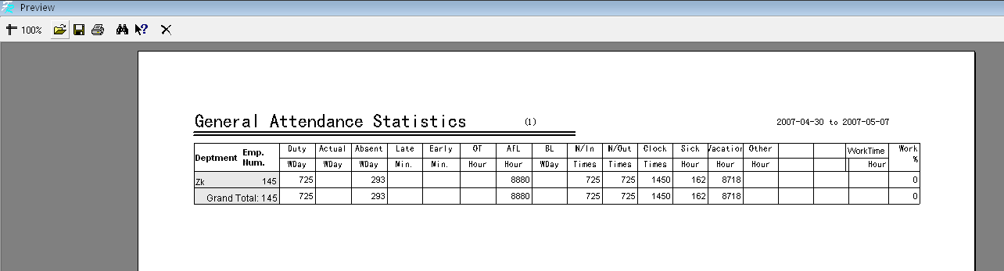
The computation of should arrive, actually arrive, absence without an excuse, coming lately, leaves early, working overtime, asking for leave, business trip, sick leave, leave, home leave same with daily Time Attendance statistical table. Only completely accumulate each department's personnel's situation.
Above the report tool column is same with daily Time Attendance statistical table.
4th, staff clock in/out timetable
The time in which each staff actually come and go to work produce report, corresponding date and shift. Convenient for the administrator viewing, and may print.
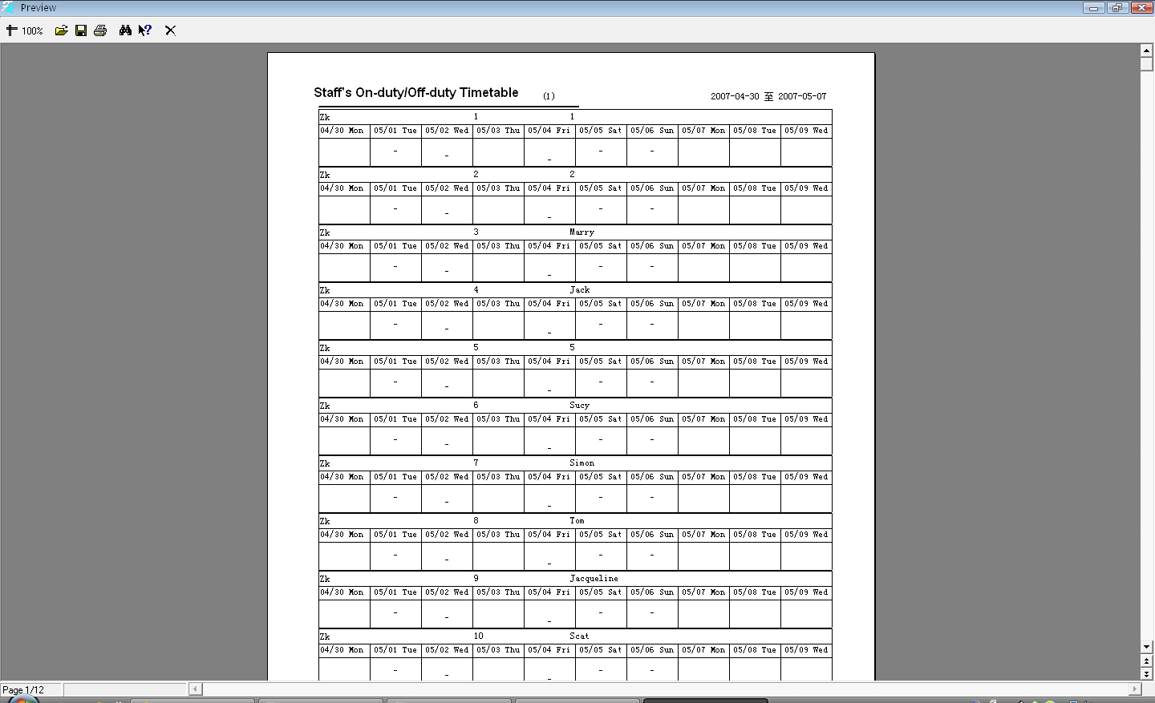
The most right side row corresponds the shift, list the all staff shift, which correspond date, the time of clocking-in /out display in the table.
Above the report tool column is same with daily Time Attendance statistical table.
5th, Daily Attendance shift table
List the staff’s shift which is used in Time Attendance every day, corresponding date, provide convenient for the administrator viewing shift, and printing.
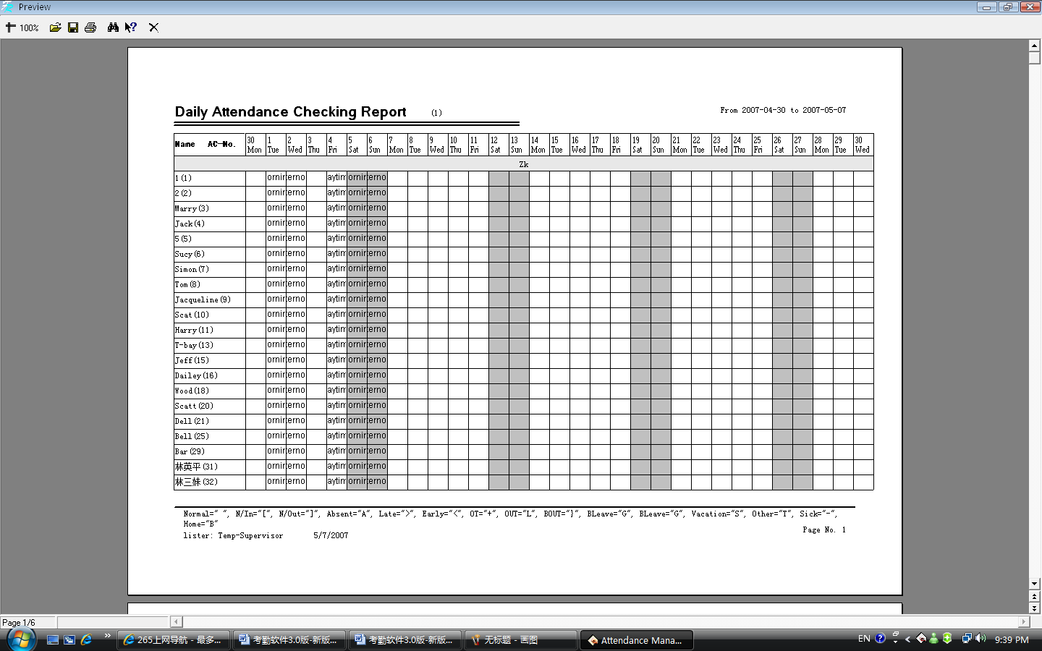
Above the report tool column is same with daily Time Attendance statistical table.
6th, Create current data report
The create current data report refers to produce report according to the current screen demonstrated format, provide convenient for the administrator reading, and printing
Statistical result detailed situation page current data report form:
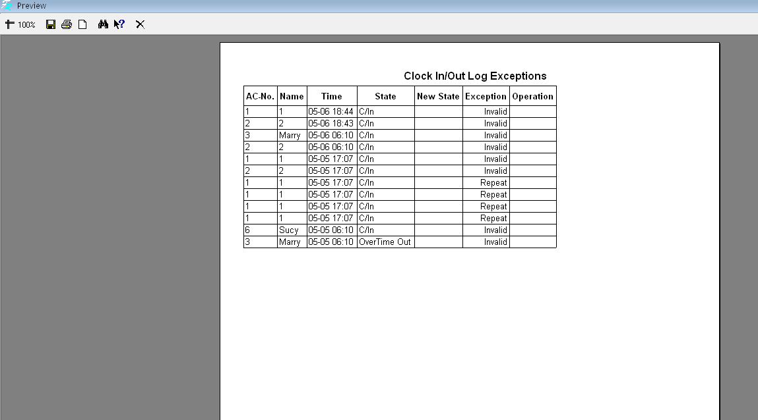
If need to show much more rows, may right-click the data row of your choice in the statistical result detailed situation page .
Shift detailed situation current data report page:
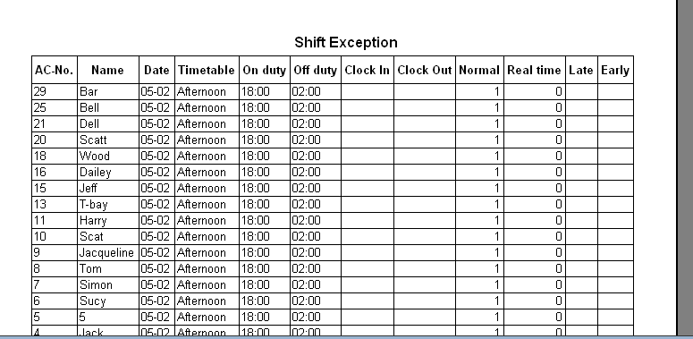
If need to show much more rows, may right-click the data row of your choice in the statistical result detailed situation page .
Other unusual situation pages current data report pages:
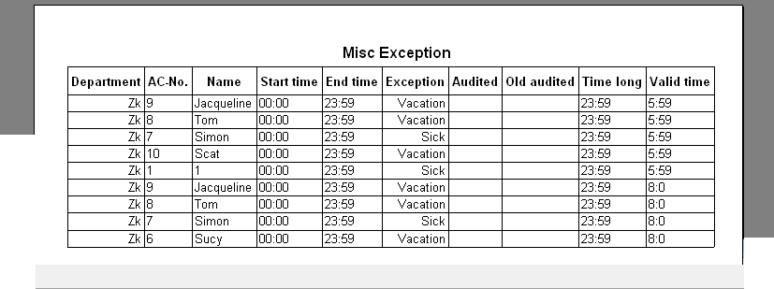
If need to show much more rows, may right-click the data row of your choice in the statistical result detailed situation page
Time Attendance statistical current data report page:
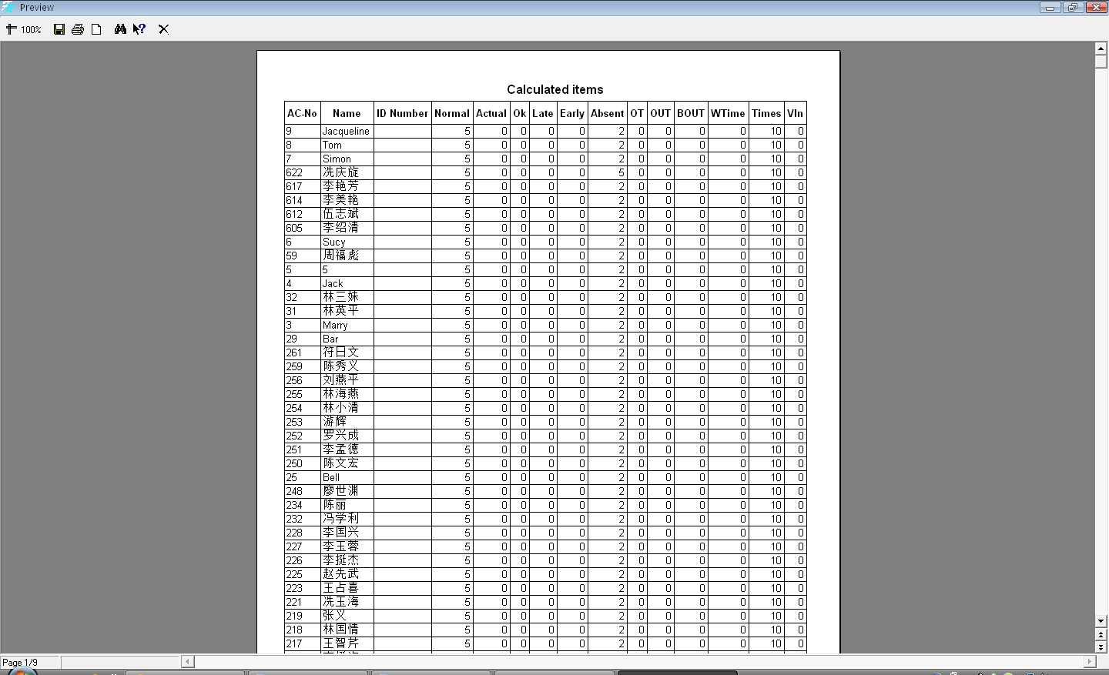
If need to show much more rows, may right-click the data row of your choice in the statistical result detailed situation page.
Export data
Export the data you inquire to Excel or the text file, backup and save it, in order to consult in the future. For detail operation please see also appendix 6.1.7 to export the data

2.4.3 System Operation logs
There provide with complete record about all operator operate trip and event when this software is apply to, maybe view the log in the future
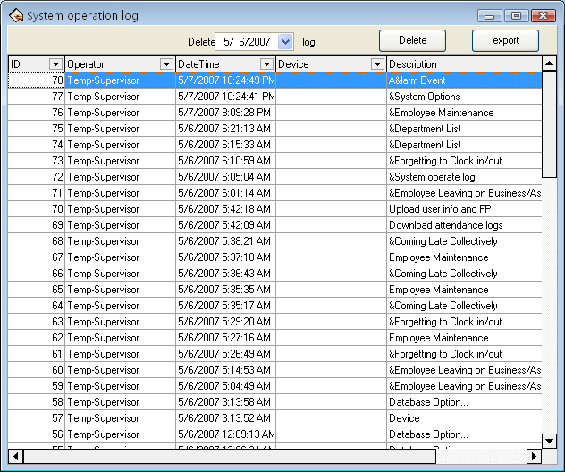

2.5 Data Management

2.5.1 Initialize System
This function can restore system to original installment status, the follow is detailed step:
Click "Initial system" menu, this pop-up window is follow
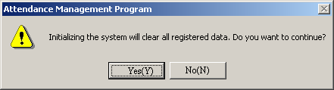
Caution: if confirm your selected, the system will clear all staff's data and all attendance data. Before this operation you must be carefully.
Click "Yes" button, the system will clear all data, and return initial status just system install.
Click "No" button, the system return main menu without clear data.

2.5.2 Clear Obsolete Data
After your system has been used for a period of time, a big amount of obsolete data are saved in the database, which not only occupy hard disk space but also affect operation speed. Then you can clear these useless data by using this function
Click this item on the menu, this pop-up menu will appear.
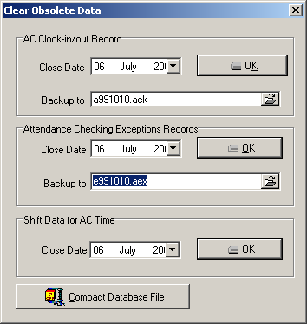
When clearing attendance clock-in and attendance exception records, you are required to back up clock-in data to files. You can click corresponding input box to type file name, and click "" button to save your data file's saving path and file name, notice that you should choose a new filename, if the name has existed in the system ,it will reminder you to define a new filename.
Note: you must choose the new name of file, if the file exists in the system, the system will inform you select a new name of file.
Shift data for AC Time: Delete the expired employee shift data, select the cut-off date for deleting such data, and click OK. For example, the time range of a shift record is 1999-01-01 to 2011-12-12. When the cut-off date for deleting such data is 2011-01-01, the record is not deleted. The employee shift data is deleted only when the cut-off date is later than 2011-12-12.
Input the close date of the data that you want to clear in close date box, and the close date should be ten days before the current day you will clear the corresponding data after clicking "OK", and prompt messages will display’
Attendance time setup data means to clear obsolete staff's shift schedule data, select close data for clearing record, click "OK" and you will clear obsolete staff's shift schedule data
In the terms of Microsoft Access database, can click "Com click attendance database file" button to compact the database.
After clearing data, click "" to return the main menu

2.5.3 Back up Database
In order to make sure data security and to restore, we suggest you back up database in regular time, click command on the menu, pop-up following window.
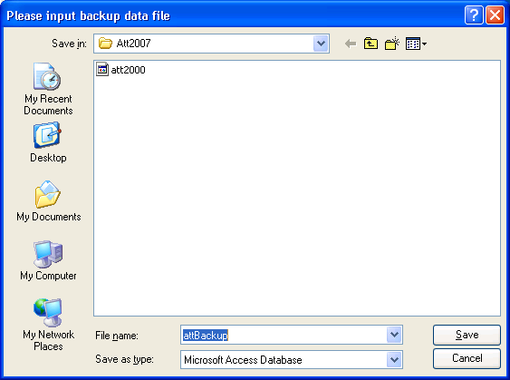
Select position to save file, input filename (maybe defined filename), click "Save" button. When original database was damage, it need to restore, you should change back up filename as ATT2000.mdb, copy the file under attendance install directory to cover same name file, but the action only restore these data to before back up. E.g. you back up data in 31.3, so that these data be restored are only one before 31.3.

2.5.4 Import Attendance Data
To import attendance record to another machine or old record to the current attendance software, click this command on the menu and this operation window will pop up:
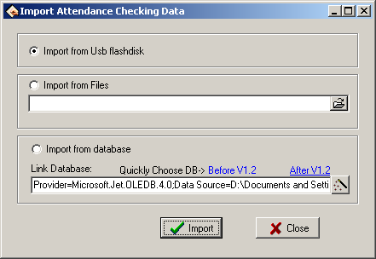
1. Import from USB Flash disk
All information of original database can be import to Attendance system database file; to import attendance clock-in staff attendance data is imported.
Select import from USB flash-disk, click "Import" following windows pup-up:
2. Import from database means to import attendance data from attendance database backups, and the data include staff information, shift information, clock-in records, etc. You can import the data from databases of previous version, or databases of the same version. For the data format of database files of versions previous to 1.2 differs from that of Version 1.2X, if the version of the database file that you want to import is below 1.2 (Not including 1.2), please select versions before1.2 option；Otherwise please select 2.2 x options.
Note: Before importing data, if it is unnecessary to remain the data in your system, please first select initialize the system. This is because if some data remaining in the current system overlap with the data that will import, errors will appear when importing data, and data’s importing speed will slow down.
Click versions1.2 or version 1.2x button, and a file manager will pop up. Enter the path and file name of the database to import, and click "Open", the system will import data automatically.
If your database is SQL Server database, you can click button to begin settings. For detailed information please refer to Database Setup.
After importing data, click "" to go back to the main menu.

2.5.5 Export Attendance Data
This function is mainly used to back up all attendance data in the current attendance system or clock-in data, click this command on the menu and the following operation window will pop up
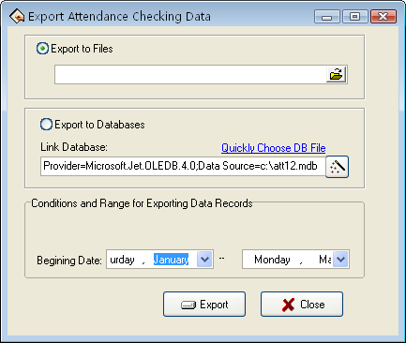
1) Export to Files
Export four file style: secret attendance data (*.abt), attendance clock-in data (*.txt), back up attendance data (*.attbackup.mdb) and attendance system database file (*.mdb). Click "" button, a file manger menu will pop up confirm the path and file name for the back file and click "Open".
2) Export to Databases
This option means to back up all data, such as staff information shift information and clock-in record to a database file. Click quickly selects database file button and you will open a file manger menu. Confirm the path and file name for the back up and click "Open".
If your database is SQL Server database, click "" button to begin setting, for detailed please see Database setup
Note: you must choose a new filename if the file has existed the system will suggest you to define new file name.
Exporting record will not lead to clean data in database. After finish to export data, click "X" up-right screen , return main menu.

2.6 Access Control Setup
Access control setting is to set unlock time and assign privilege for registered users. Settings of each user consist of three period time settings and one group setting. Relationship between period time and period time is "OR". Group also consists of three period time settings and by the same token, relationship between these three period time is "OR".
Simply put, if you want to keep a registered user in unlock status. Firstly the group that this user is in should be defined in unlock combination (one group can be defined in one combination together with other group, but these groups are required to unlock door together). Second, current unlock time is in any availability range of user time period and period time of its group.
Under system default, a new registered user is in Group 1 and group combination is Group 1. So new registered user is in unlock status under default. If a group that user is in is not defined in group unlock combination setting, then the use can only record attendance and cannot unlock door.

2.6.1 Period Time
Time period is the smallest time period unit in Access control setting. In whole system, you can define up to 50 time periods. Each time period defines 7 time intervals, i.e. one week. Each time interval is valid time period in 24 hours everyday. Each use can set up to three time periods and the relationship between these three time periods is "Or", which means the user is valid as long as identification time satisfied one of these three time periods. Each time period format of time period is HH: MM-HH: MM, i.e. in term of 24 hours format and precision to second.
End time less than start time "23:57-23:56" means all day forbidden. End time larger than start time "00:00-23:59" means valid in the time interval.
Valid time period for user unlocks: all day open "00:00-23:59" or time period with end time larger than start time.
Click "Time period" from Drag-down menu of Access Control Setting, window of adding Time period will pop up. Click "Add" button and system will pop up a timetable from Sunday to Saturday. Here, you can define any time period you may use. Then click "Confirm" to save the time period automatically. If you want to use several time periods, continue to click "Add". In addition, time period can be edited and deleted.
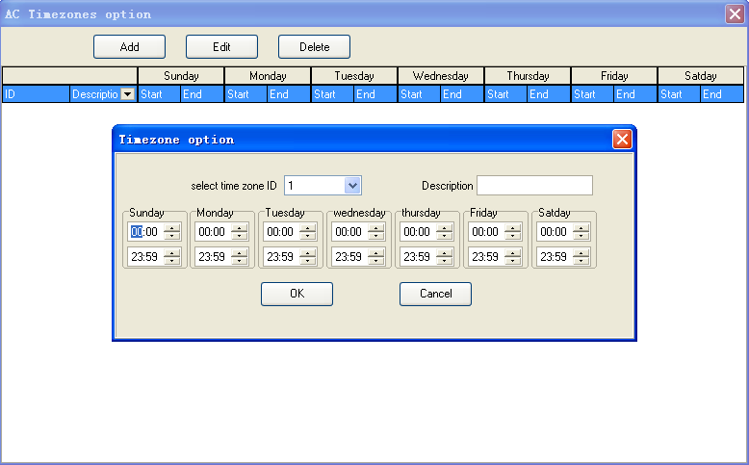

2.6.2 Group
Group function can divide users into groups and combine different groups to different unlock combinations, which make group management of Access control more convenience. So user can define many unlock combinations. System has defined 5 groups: Group 1, Group 2, Group 3, Group 4, and Group 5. Under system default, new registered user is in Group 1 and can be re-assigned to other group.
Under system default, a new registered user uses time period of Group 1. After the user is re-assigned to other group, the user uses default time period of the corresponding group. So please make sure to define default time periods for each group.
Group Setting
Entered the "Group" setting ,there are two ways to enter:
1) Through bar options of the system menu: Access Control Settings -> Group, set up group access interface.
2) Through shortcuts button options of the system : Time Period, Enter the group setting interface.
Enter the "Group setting" interface, shown as following figure.
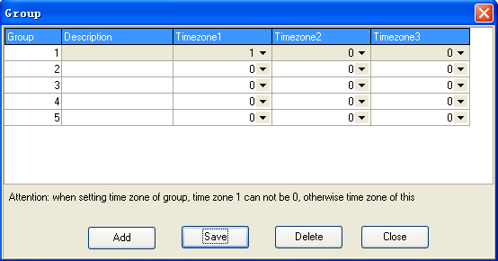
Group editing. left click item that need to edit with cursor to enter the editing state.
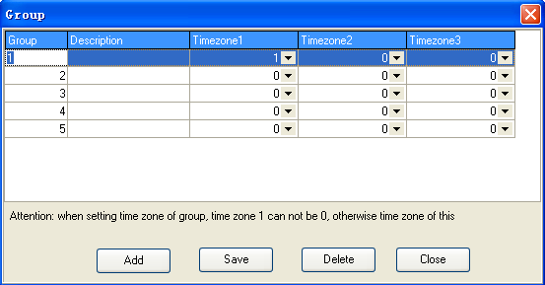
Through drop-down box to choose the Time Period .
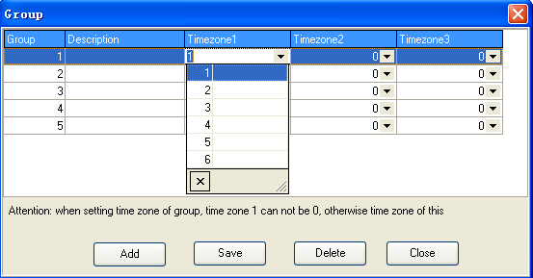
Set up is completed, click on "Save" to save

2.6.3 Unlock Combination
Definition of unlock combination function
Unlock combination is the direct expression for controlling unlock. For example, if you want that all registered users cannot unlock door, then set Unlock Combination to null.
Definition of unlock combination is defined to different combinations that can unlock door, and each combination consists of different groups. Unlock combination directly uses group number and does not consider order for identifying user between each group. For example, "123" means door will only be unlocked when at least one user in each group of Group 1, Group 2 and Group 3 passes identification together with other two users. "4" means door will be unlocked when one user in Group 4 passes identification together with other two users. System can define up to 10 unlock combinations at the same time and door will be unlocked as long as one of these 10 unlock combinations passes identification.
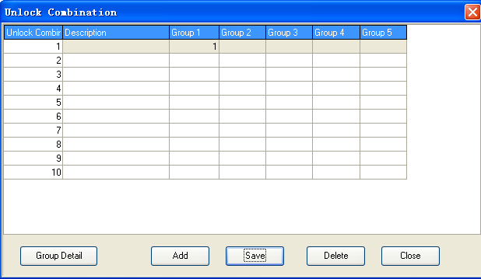

2.6.4 User Privileges
User privilege mainly applies to user access control setting: if a user whose personal No. is assigned as 1, 2, 3, 4, and is distributed to No.1 device in the default period time, likes as follow, add user to right list first, then add device to right side list. Click "Allows passing".
Set up the Access Control Privilege when a user belong a group
1. Entered the "Access Control Privilege" setting there are two ways to provided:
Through the system menu bar options: Access Control Settings -> Access Control Privilege, enter Access Control Privilege interface.
Through directly shortcuts button of the system : Access Control Privilege, enter Access Control Privilege interface.
2. Enter the "Access Control privilege" interface such as shown.
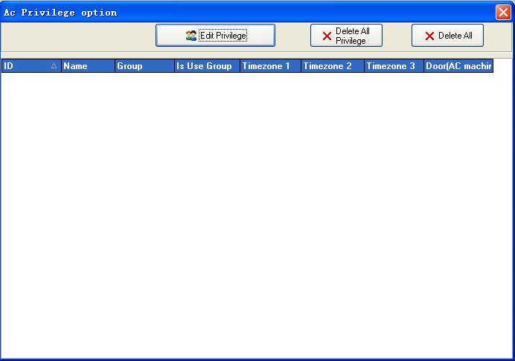
3. Click on "Edit Privilege" button and enter the Access Control Privilege to edit the interface, shown such following.
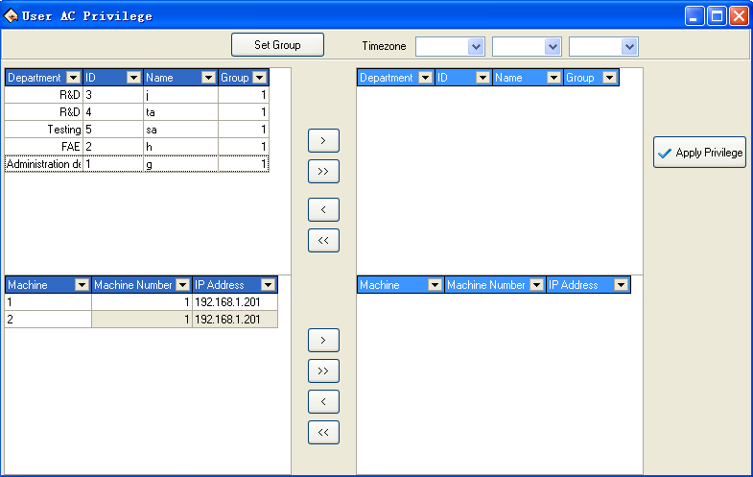
4. Default users belong to Group 1, if need be assigned to other user groups, the need for users to re-allocation group. Here we illustrate: No. 1 users assigned to Group 1
First selected No. 1 users, shown as following.
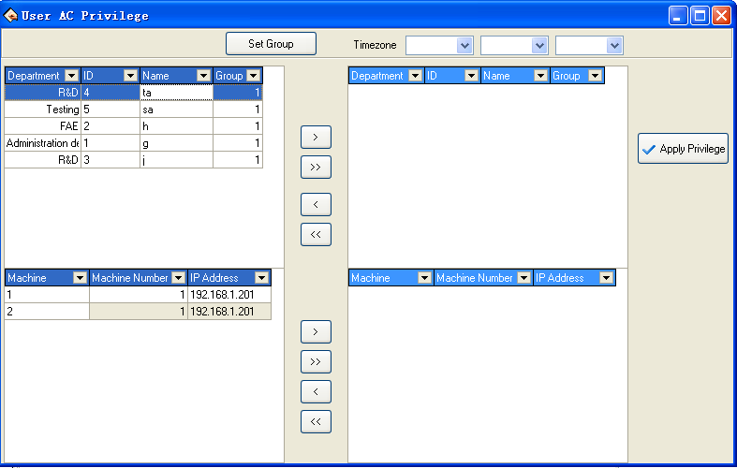
5. Click on the "Set Group" button and enter "the group setting" interface, select group 2.
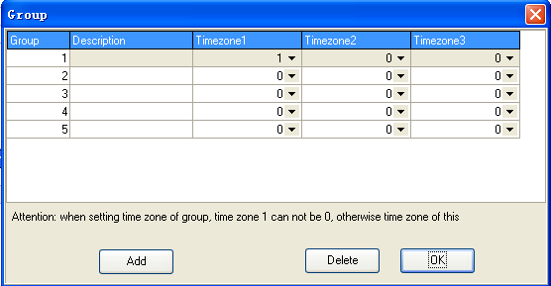
6. Through the above steps, the users will be assigned to the second group, shown as following.
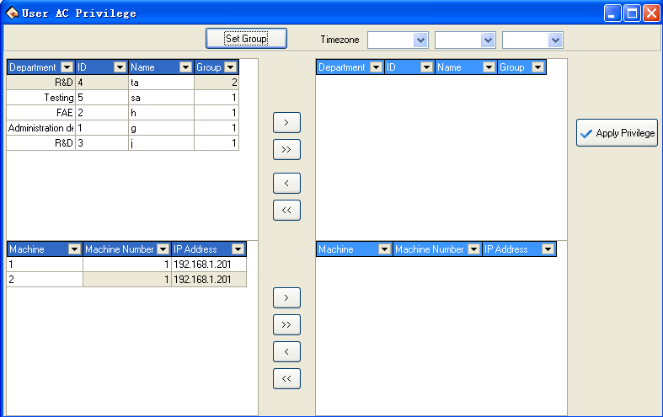
7. Follow the 4-6 steps, set up the group those users respective. After the setting completed, through ">/>>" button, a single or all of users will be moved to the right critical areas, waiting for the Privilege setting. Shown as following
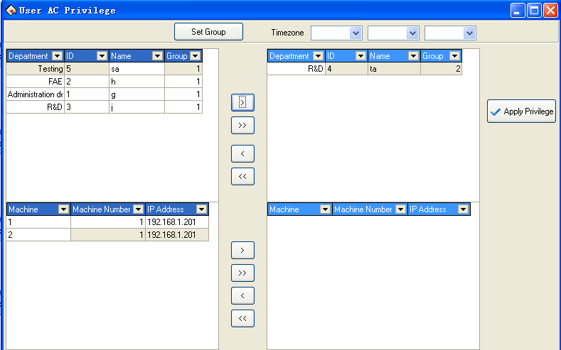
8. In the equipment list choose the equipment that need to upload Privilege.
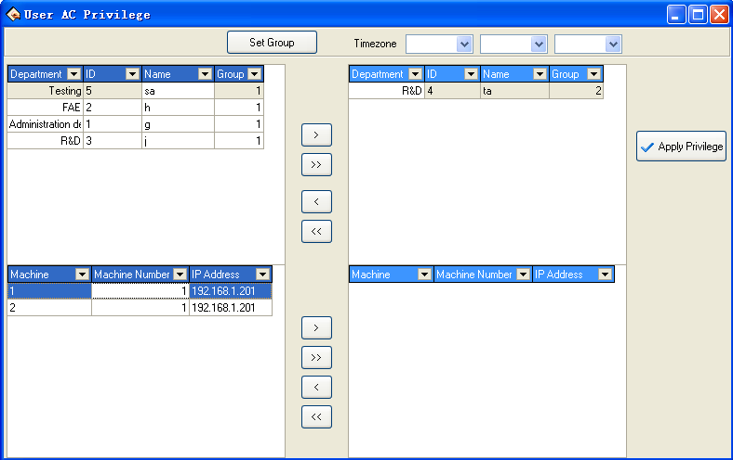
9. Through ">/>>" button, single or all of the equipment will be moved to the right the critical region, waiting for Privilege setting. Like following equipment known as the NEW UNIT_1 , the equipment has been moved to the critical region, waiting for Privilege setting
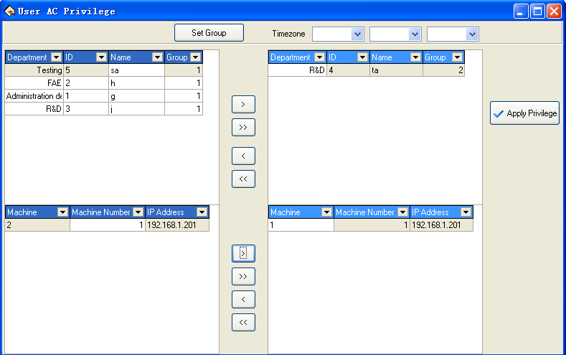
10. After users and equipment is selected, click on "" button, the group Time period which is used by user in the critical periods will be assigned to the selected devices. After distribution is successful, prompt will appear shown as following
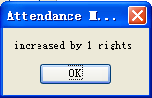
11. In the "User Access Control Privilege" interface, click "" button and enter the "Access Control Privilege Setting" and synchronize set up information of user groups will display in the list. Shown as following, NEW UNIT_1 in the No. 1 user group 1 Time Period.
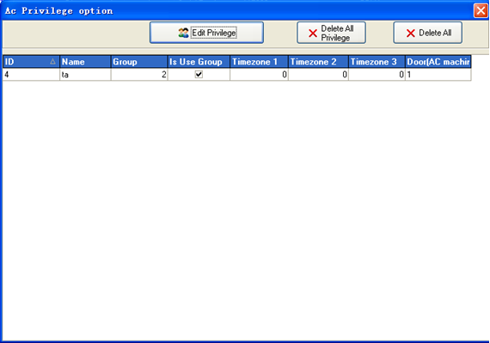
Set up the Access Control Privilege when a user do not use group
1. If a user belongs to the group, but she/he does not use group Time Period, then in the "User Access Control Privilege" setting interface, select the Time Period to be used, shows as below, No. 10 users belong to the third group, but he/she does not use group Time Period, and use the 1,2,3 Time Period
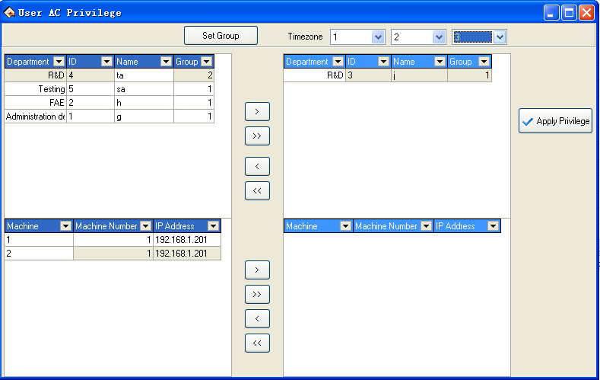
2. After completing, in the "User Access Control Privilege" interface, click "" button and enter the "Access Control Privilege Setting" and synchronize set information of user groups will display in the list. shown as following, in the NEW UNIT_1 the No. 1 user use the 2 group Time Period. in the NEW UNIT_1 the No. 10 user use group 3 Time Period, the non-use group, but use 1,2,3 Time Period
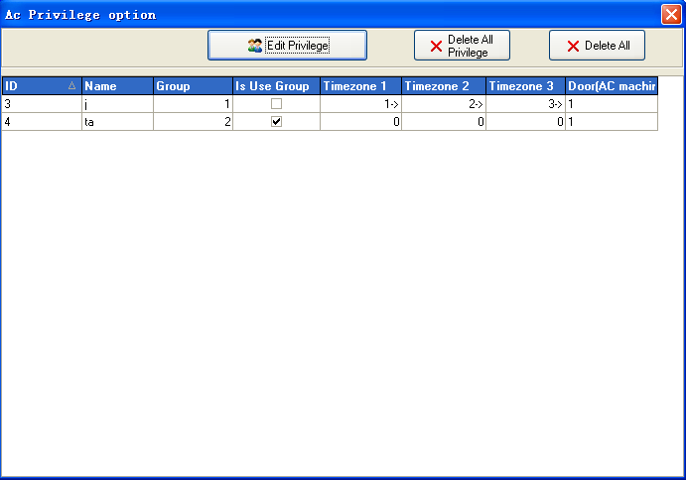
Delete the User Access Control Privilege
1. After choose the user who will ready to be deleted and his group , move their to the critical areas, and moved equipment whose the Privilege will be deleted to the critical, shown as below, delete the No. 2 users in NEW UNIT_1 , who use the Group 2 Time Period .
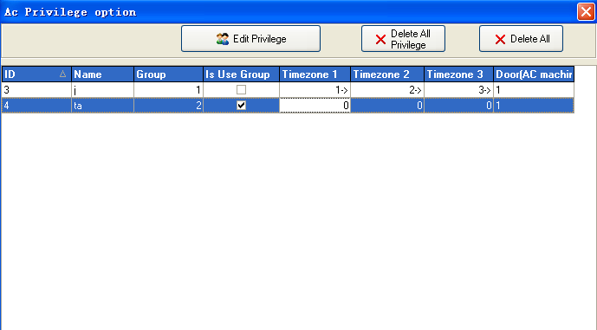
2. Click on the "" button, the group Time Period the user use will be deleted in critical area from the selected equipment. After deleted successfully, the system will prompt shown as following.
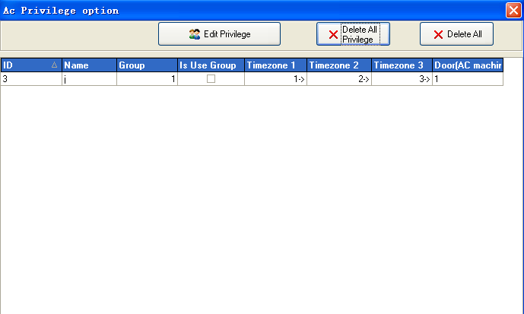
3. After assigned the privilege, ability to automatically produce a privilege table, click "Exit" to exit, the following figure will appear
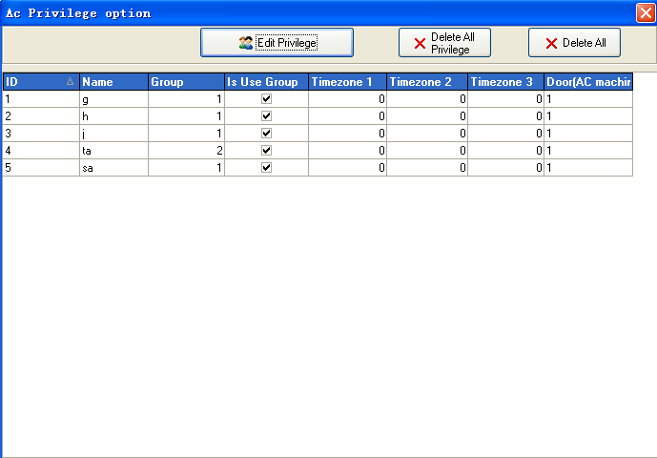
4. Through shortcuts delete user privileges. in the Access Control Privilege setting interface, select the user to be removed , and then right click this item, the pop-up "Delete" button. Click this button to delete users.

2.6.5 Upload Setting
1. Choose operation device ,
Choose upload equipment. click icons to choose the equipment with mouse, selected this equipment.
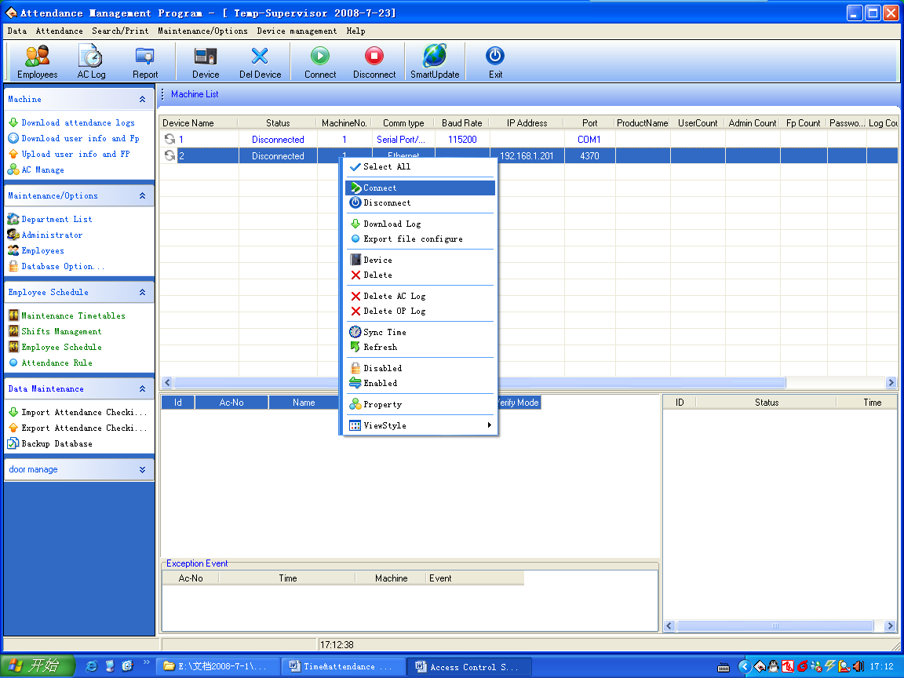
2. Upload information
Click "Upload Device", show as following interface :
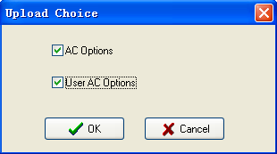
Select the Access control option which you want, the two kind of option could to be selected at the same time.

CHAPTE 3

Appendices

3.1 Set Date
In the box of Date/Time click "" button to select the date, and in the box of Time click "" button to select the time or directly change the time. In the drop-down box of Date, click "" or "" button to move the date one month upward or downward:
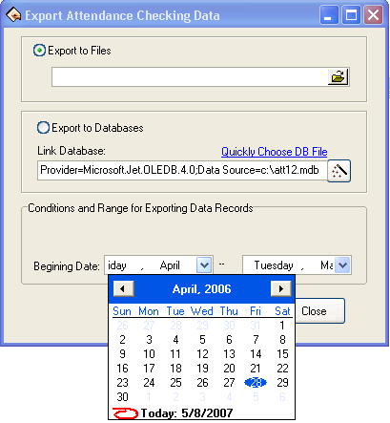
Click the year number to change the year directly, or click "" button to move the date one year upward or downward. Click on the date you want to select the it.

3.2 Select Employee
The option box of Employee is like this:
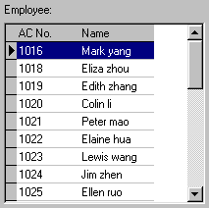
Move the mouse to the row the employee to select is in, left-click the mouse, and this row will turn blue.
To select more than one employee, hold down "Ctrl" key to select.

3.3 Select Department
The option box of Department is like this
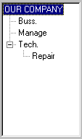
With the mouse left-click the department name, Wait for the department name to change blue. It shows chooses successfully.
Choice department staffs
Single-click department, open a drag-down box, chooses department which the staff is at, then single-click the staff box

3.4 Select Employee in Department
Click the department box to extend the tree-type framework, and select the department where the employee is, then click the employee box to extend the drop-down list box and select the employee.

3.5 Data Table Tool Bar
The Data sheet Process Tool Bar contains the following operation buttons:
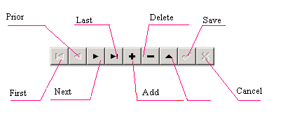

In the data sheet, the row marked with symbol is the current row and all operations for he sheet is conducted in the current row.
Click button to carry out corresponding operation for the data sheet.
First: To move the current row to the first row.
Previous: To move the current row one row upward.
Next: To move the current row one row downward.
Last: To move the current row to the last row.
Add: To add a new row in which new data can be entered in and the current row is the new row.
Delete: To delete the current row.
Edit: To modify the data in the current row.
Save: To save the data after edition or in the newly added row.
Cancel: To cancel the result of adding a new row or editing the data.
Under the status of adding or editing, the result of moving data will be automatically saved.
In the data sheet, click on the row to select it, and select multiple rows by pressing "Ctrl" and clicking at the same time when possible. The selected rows will change to blue.

3.6 Export Data
Following take staff attendance inquiry as example, explain to export data function:
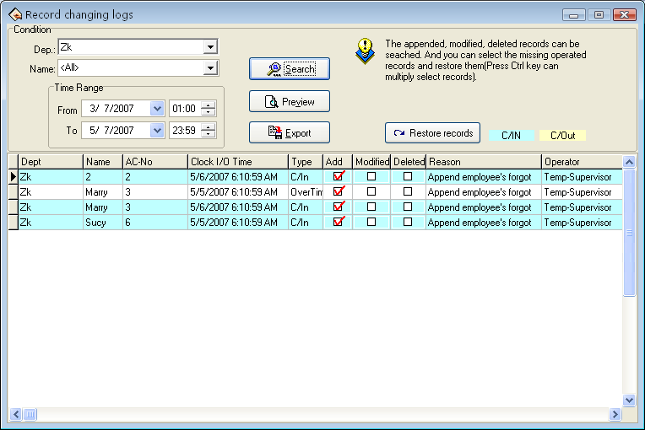
As shown in the above picture, click "Export" button to pop up the following window:
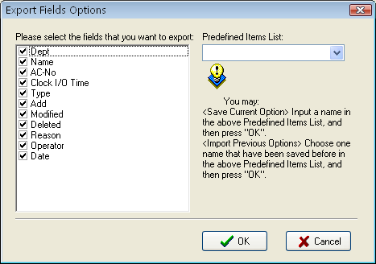
Pre-definition item: The current definition of your choice will be a name, when the next time export will be allowed to directly select and save name but not need to choose the field to export in the right box.
Put tick in font of the fields to export. If next time you want to select the same fields to export data, you can input an item name in the box of Predefined Items, and click "OK" to save the selected fields in this item. If you want to call your previous choices, select a name saved in the box of Predefined Items, and click "OK" to enter the following window
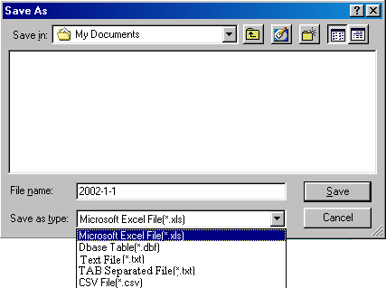
Enter a filename for this file to save in the column of Filename, select the type to save this file, and then you will export the selected data to this file. You can save a file in five formats: Excel files (Microsoft Excel File (*.xls), DBF formed database files, right justified text files, text files separated by TAB, and text files separated by semicolons.

3.7 Advanced Export
Advanced export is mainly used in secondary development to transfer the data in our software. When needs to export the data, choose in here need to export the data the item and its setting attribution. Single-click Advance Export attendance interface, shown as following figure.
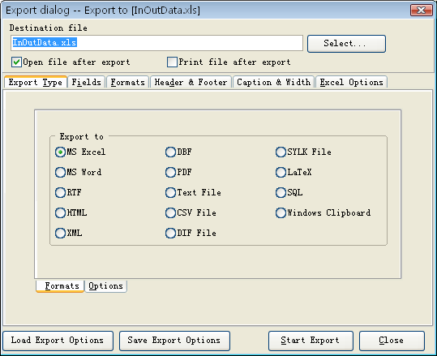
Here we take the Excel table to export as the example, explain advance export the function.
1st, choose Export file format in the "Export the file format and the option" in the page.
2nd, set the parameters in the option page.
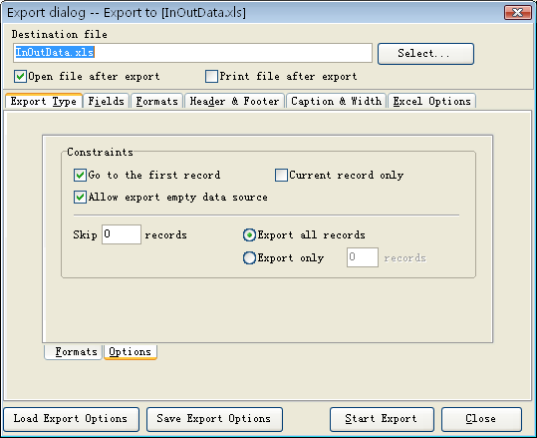
3rd, input the filename and choose the saving position..
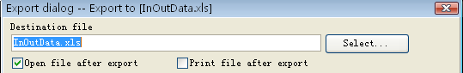
4th, start to set the field, the format and so on
A. Field
Chooses field which want to export, There are seven fields: PIN, SSN, Name, CHECKTIME, SENSORID, deptname, wokecode; separately expresses enrolling number, serial number, the name, date time, machine number, department name, work code.
B. Format
Set export the field form, there are the general format and user self-definite form two formats.
C. Page head and page foot
Here may add the page head /foot page for file which Export, input the explanation writing in the page head/foot, these writing will be able to display in the start and the ending of exported the file.
D. Title and width
There are seven fields which Export: PIN, SSN, Name, CHECKTIME, SENSORID, deptname, workcode, label it with the easy memory the title and defines each field the display width.
E. Excel option
May set typeface of the text demonstration and the style to export.
5th, after setting the field, the format and so on, for provide the convenience to export next time, will be allowed to save this setting in the file, next time will export this setting instead to set again.
6th, import the setting
Directly import setting file before save, then was allowed to transfer the setting before you setup, directly export the data again.
7th, export the data
After all options set finished.
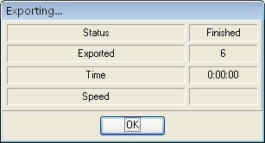
Click "Export data": When indicator inform you completes download data, then may confirm and gets down the data to directly which the examination Export.

3.8 Downloading Photos Automatically
When the PC is connected to an 8-inch color-screen device, set the server on the 8-inch color-screen device and connect the 8-inch color-screen device to the Internet. Start the attendance management software on the PC, and the software automatically detects the device and downloads the photos taken on the device. The detailed operation is as follows:
1．Connect the PC and the device to the Internet respectively, or ensure that both of them are in the same LAN.
2．Choose Menu > Communication device > Other settings on the device. Set the Web server to the IP address of the server where the photos will be saved.
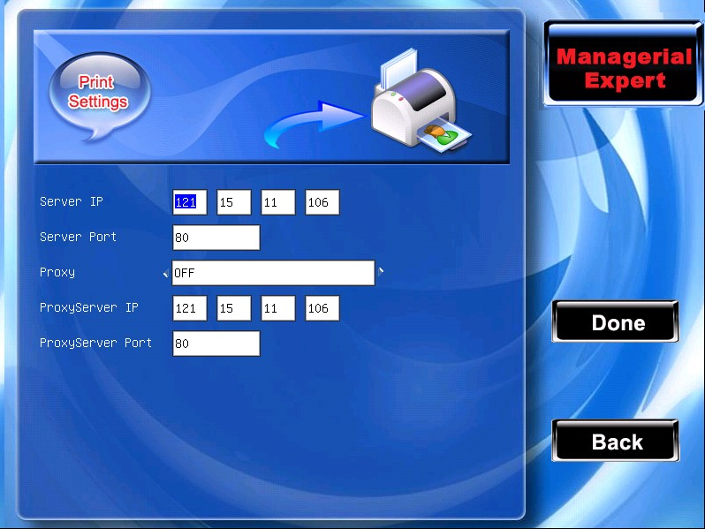
3．Open the attendance records on the device (Note: The device must be configured to take photo of and save the attendance records) and take photo of the attendance records.
4．Start the attendance management software, choose Maintenance/Setting > System Setting, and select Display the Photos in the Normal box.
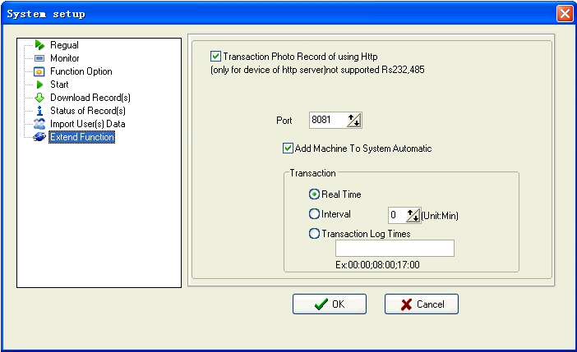
5．Select Support the Http record transfer function in the HTTP data transfer box. Ensure that the port settings are consistent with Web port settings on the device. Finally, click OK, as shown in the following figure.
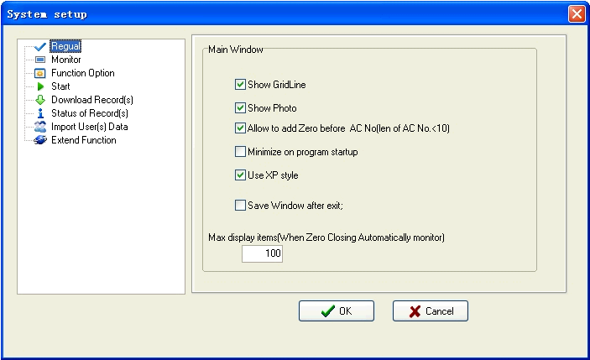
6．The attendance management software automatically detects the online device, and displays the latest attendance records and photos in the main interface, as shown in the following figure.
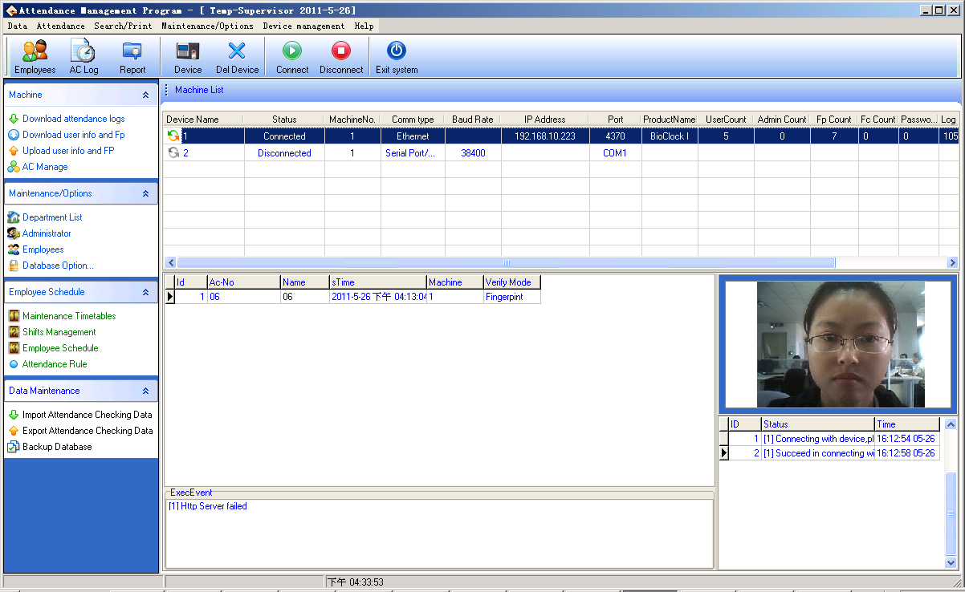
7．You can also query the latest records and photos from the attendance records: 1) Connect the device first, 2) Download the attendance records, 3) Open the attendance records, 4) Finally select Display the images photographed by the device. Then, you can see the details of each record, including the images. In the image list, you can click an image to view the enlarged image.
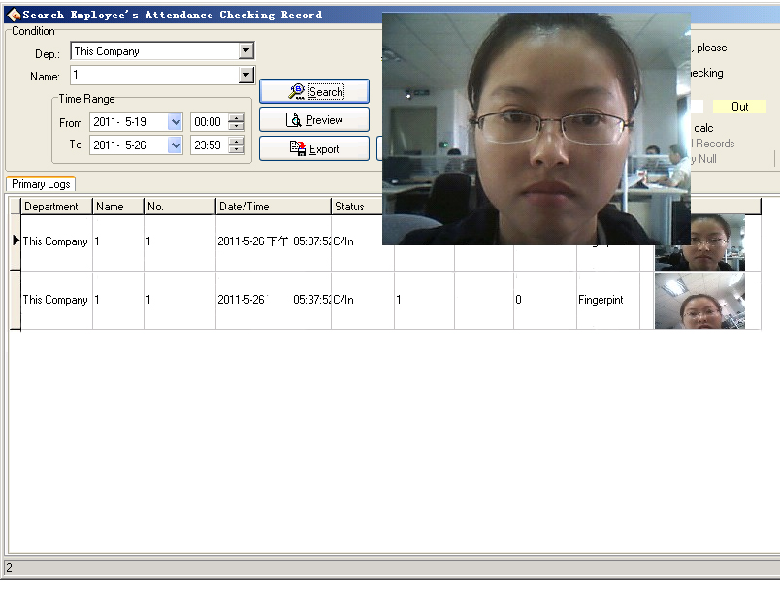

3.9 How to Generate License Files
There are two algorithm version to enroll the user fingerprint in employee maintenance: ZkFinger9.0 and ZkFinger10.0.
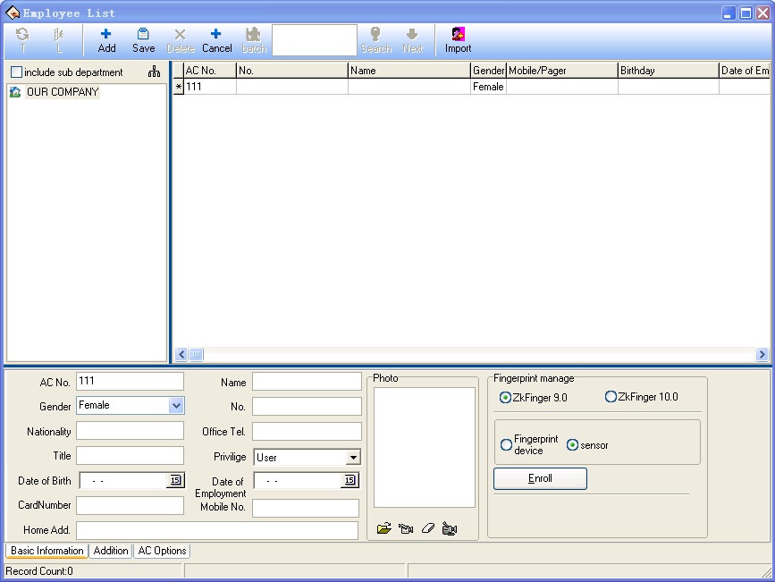
How to choose ZkFinger9.0 or ZkFinger10.0
1. Enroll with a single color LCD fingerprint sensor, choose ZkFinger9.0 algorithm version.
- Enroll with a TFT fingerprint sensor, you can choose both options. Each algorithm version provides corresponding FP sensor to enroll.
Note: View the device algorithm version in the "system parameters".
How to generate ZkFinger10.0 verification license:
If choosing the ZkFinger10.0, you need a license to conduct fingerprint sensor enrollment. Click on the "Registration" button, it will automatically created "id.txt" file in the software installation directory, you need to send this file to ZKSoftware.Inc to get the license file "zkfinger.lic", then put the license file in "system32" folder under the system disk, such as C: \ WINDOWS \ system32 directory.

CHAPTE 4

4. End-user License Agreement fir This Software
Important - read carefully:

This End-user License Agreement ("EULA") is a legal agreement between you (either an individual or a single entity) and the mentioned author of this Software for the SOFTWARE PRODUCT identified above, which includes computer software and may includes associated media, printed materials, and "Online" or electronic documentation ("SOFTWARE PRODUCT"). By installing, copying, or otherwise using the SOFTWARE PRODUCT, you agree to be bound by the terms of this EULA. If you do not agree to the terms of this EULA, can not install or use the SOFTWARE PRODUCT.

SOFTWARE PRODUCT License
The SOFTWARE PRODUCT is protected by copyright laws and international copyright treaties, as well as other intellectual property laws and treaties. The SOFTWARE PRODUCT is licensed, not sold.

1. Grant of License. This EULA grants you the following rights: Installation and Use. You may install and use an unlimited number of copies of the SOFTWARE PRODUCT.

Reproduction and Distribution. You may reproduce and distribute an unlimited number of copies of the SOFTWARE PRODUCT; provided that each copy shall be a true and complete copy, including all copyright and trademark notices, and shall be accompanied by a copy of this EULA. Copies of the SOFTWARE PRODUCT may be distributed as a standalone product or included with your own product.

2. Description of Other Rights and Limitations.

Limitations on Reverse Engineering, Recompilation, and Disassembly. You may not reverse engineer, decompile, or disassemble the SOFTWARE PRODUCT, except and only to the extent that such activity is expressly permitted by applicable law notwithstanding this limitation.

Separation of Components.
The SOFTWARE PRODUCT is licensed as a single product. Its component parts may not be separated for use on more than one computer.

Software Transfer.
You may permanently transfer all of your rights under this EULA, provided the recipient agrees to the terms of this EULA.

Termination.
Without prejudice to any other rights, the Author of this Software may terminate this EULA if you fail to comply with the terms and conditions of this EULA. In such event, you must destroy all copies of the SOFTWARE PRODUCT and all of its component parts.

Distribution.
The SOFTWARE PRODUCT may not be sold or be included in a product or package which intends to receive benefits through the inclusion of the SOFTWARE PRODUCT. The SOFTWARE PRODUCT may be included in any free or non-profit packages or products.

3. Copyright.
All title and copyrights in and to the SOFTWARE PRODUCT (including but not limited to any images, photographs, animations, video, audio, music, text, and "applets" incorporated into the SOFTWARE PRODUCT), the accompanying printed materials, and any copies of the SOFTWARE PRODUCT are owned by the Author of this Software. The SOFTWARE PRODUCT is protected by copyright laws and international treaty provisions. Therefore, you must treat the SOFTWARE PRODUCT like any other copyrighted material except that you may install the SOFTWARE PRODUCT on a single computer provided you keep the original solely for backup or archival purposes.

Limited Warranty

No Warranties.
The Author of this Software expressly disclaims any warranty for the SOFTWARE PRODUCT. The SOFTWARE PRODUCT and any related documentation is provided "as is" without warranty of any kind, either express or implied, including, without limitation, the implied warranties or merchantability, fitness for a particular purpose, or no infringement. The entire risk arising out of use or performance of the SOFTWARE PRODUCT remains with you.

No Liability for Damages.
In no event shall the author of this Software be liable for any damages whatsoever (including, without limitation, damages for loss of business profits, business interruption, loss of business information, or any other pecuniary loss) arising out of the use of or inability to use this product, even if the Author of this Software has been advised of the possibility of such damages.

Acknowledgement of Agreement.

I have carefully read and understand this Agreement, Radiate, Inc.’s Privacy Policy Statement.

IF YOU ACCEPT the terms of this Agreement:

I acknowledge and understand that by ACCEPTING the terms of this Agreement.

IF YOU DO NOT ACCEPT the terms of this Agreement.

I acknowledge and understand that by refusing to accept these terms, I have rejected this license agreement and therefore have no legal right to install, use, or copy this Product or the Licensed Software that it incorporates.

CHAPTE 5

Trouble Shooting
The following is a list of typical troubles you may be annoyed of at the beginning of working with program and their solution as well.
1．Due to the personnel changed, fail to enter the management program, what will I do?
Answer: The PC needs to be configured with Office2000 or a later version, and the Access software at first. then enter the attendance program installing directory, look for the att2000.mdb file, double-click, and find the ‘userinfo’ list in the appear interface, double-click, to find ‘securityflags’ field, delete the identifier with the value as "15" under this filed.

2．I forget the password of database, how to do？
Answer: Enter ‘maintenance and setting’ of management program, click on the "Setting password of database", then have no need to verify old password, so can set up new password of database.

3．How to use the business check-in /clock-out？
Answer: When the staff need to go out, the staff should check -out on attendance device. When the staff come back, select business clock-in.

4．While inquire attendance record, selected the highest department, selected all staff, why cannot see record, but it’s true display that has been saved to downloading data？
Answer:
(1) It is maybe the data record time expire inquiring range, want to view the original record , open the attendance database (att2000.mdb), enter clock-in-out list, can see all original record, prove that original attendance record is in the range which you inquire, specifically pay attention year；
(2) It is maybe that add a highest department again after the general company name was canceled, installing finish, the default highest department general company can not be cancel, but it is able to be modify in the attendance rule.

5．I have assigned shift, why no the result of account and statistics indicate leave, come late, gone early？
Answer: First enter management to check the setup shift, in normal condition the name of shift corresponding time period display that appear in blue color in right time box, if there isn’t any problem, enter staff shift list, view the starting date of staff shift, the starting date is beyond the account and statistics time range, isn’t it?, if it isn’t, assign shift again, fix new starting date.

6．How to cancel the schedule which have been set up？
Answer: You can add a empty schedule firstly, then use the empty schedule replace the schedule which will be canceled in staff assignment, enter schedule management to cancel corresponding schedule, OK.

7．Why the data which is stored record is fewer than loaded down data while in the process to download all data ？
Answer: While loaded down and record, the attendance program can determine loaded down record, the repeat record will be cancel automatically, the stored record will not be store again.

8．Why the loaded record appear, but cannot find it while inquire it？
Answer: Confirm time range you inquire is accord with attendance time of loaded record, or it’s not. can check attendance record day, month, year, after loaded down record, or open database (att2000.mdb), enter check-out/clock-in , can see all origin record, confirm time of attendance original record is within the range of acquirement, pay attention years record specifically, some independence equipment set time is not real, result in attendance record time isn’t correct.

9．Why I attendance normally, but it is show I stay away from work without leave or good reason？
Answer: Examine your period time setting first, confirm your attendance record is among the range of clock-out time, example, you setup the clock-out time is from 17: 00 to 18: 00, you clock-out time record is16: 30, so that the record is invalid, system will indicate neglect afternoon (in attendance rule, no clock-out is neglect); next, examine you attendance time is correct, or it’s not.

10. Why there are come late and gone early in the attendance account and statistics shift, but there aren’t their records in inquiring record？
Answer: Please examine the setting of attendance account in attendance rule, see if ‘on duty clock-in record: come late/gone early’ have been sign or have not, if it has been labeled so that the neglect system will indicate come late/gone early.
11. Leaders of company don’t require clock-in-out, but their attendance demand account, how do it to set ？
Answer:
(1) Enter attendance setting under staff maintenance, cancel valid attendance；
(2) Set up a period time of unnecessary to clock-in-out, produce a schedule, the schedule is used to account with staff. OK

